

**Master Thesis**

**Machine Learning and classification of transport mode choice using Python**

**Marios Melachroinos**

**Supervisor**

**Thanasis Argyriou**

**Athens 2024**

Contents

2. Literature Review 3

2.1. Factors influencing transport mode selection. 3

2.2. Machine Learning essentials 4

2.3. Classification Algorithms & Techniques 5

2.4. Class imbalance and resampling strategies 9

2.5. Machine Learning applications in transport mode choice 12

3. Methodology 14

3.1. Python Libraries 14

3.2. Data collection for case 1: Thessaloniki 15

3.3. Data collection for case 2: Netherlands 18

4. Results 21

4.1. Results for case 1 - Thessaloniki 21

4.1.1. Data preparation and cleaning 21

4.1.2. Explanatory Data Analysis 24

4.1.3. Data Preprocess 34

4.1.4. Logistic Regression 39

4.1.5. Decision Tree 47

4.1.6. Random Forest 53

4.1.7. XGBoost 59

4.1.8. Stacked Model 66

4.1.9. Model Selection 67

4.2. Results for case 2 - Netherlands 70

4.2.1. Data preparation and cleaning 70

4.2.2. Exploratory Data Analysis 72

4.2.3. Data Preprocess 84

4.2.4. Logistic Regression 89

4.2.5. Decision Tree 95

4.2.6. Random Forest 103

4.2.7. XGBoost 111

4.2.8. Model selection 117

References 119

# 2. Literature Review

Forecasting an individual's choice of transportation mode has garnered significant academic interest in recent years. The field of transportation and behavioural analysis has primarily relied on the extensive utilisation of logit models in existing research. In general, logit models and logistic regression analysis have been employed, specifically to examine the connection between the likelihood of binary or ordinal responses and explanatory variables using the maximum likelihood estimation method (Trueck, 2009). According to Trueck (2009), the logistic function is given by the following expression:

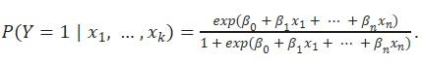

The above can also be rewritten as:

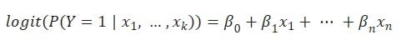

McFadden (1972, 1974) posed a significant challenge to the initial approach to comprehending travel behaviour. In his exploration of the analysis of transit behaviour, he advocated for the application of the multinomial logit model. Like binary logit models, the multinomial model adheres to the same principles and assumptions, with the notable difference being the presence of multiple alternative choices (Lee & Kim, 2023). Furthermore, because of the assumption of independence among the options, the total probabilities of all choices add up to 1 (Lee & Kim, 2023). Following the introduction of the logit model, subsequent research endeavours have sought to extend this model and investigate travel behaviour, thereby addressing certain constraints associated with the original logit model. Such examples are the nested logit model (Willis, 2014) and the mixed logit model proposed by McFadden & Train (2000). The nested logit model organises choices into separate nests and permits varying correlations between these nests. As a result, correlations are consistent within each nest, but for options situated in different nests, the unobservable elements are uncorrelated and, in fact, entirely independent (Willis, 2014). The mixed logit model is defined as a standard multinomial model, also called “latent class model”, where the coefficients are chosen from a cumulative distribution, introducing an element of randomness (McFadden & Train, 2000).

## 2.1. Factors influencing transport mode selection.

Since the appearance of logit models, numerous studies have surfaced with the objective of delving into the crucial factors that affect transportation mode selection, going beyond the conventional determinants like cost or travel distance. In a study conducted by Mayo and Taboada in 2020, they employed a hierarchy model to assess the factors influencing the choice of public transportation mode among respondents in the Philippines. Their survey results indicated that safety was the most significant consideration, followed by cost, comfort, and concerns about environmental sustainability (Mayo & Taboada, 2020). Another study by Donkor et al. in 2020 examined the role of emotions in transport mode selection, focusing on respondents in the city of Edinburgh. Their findings revealed that an individual's feelings and experiences related to public transportation, along with their socio-demographic characteristics, exerted a substantial influence on their transit behaviour (Donkor et al., 2020). Additionally, McCarthy et al. in 2017 conducted further research suggesting that the presence of young children in a family had an impact on transportation behaviour. Specifically, they proposed that families with children preferred car usage over other sustainable transit options, with psychosocial factors and household characteristics playing pivotal roles in the choice of transportation mode (McCarthy et al., 2017). The influence of various weather conditions in transport mode choice have also been explored in the literature. Bocker et al. (2016) delved into weather-related factors and their connection to transit choices. Based on their analysis of travel diaries in the Netherlands, their results indicate that individuals who opt for walking or cycling modes are particularly affected by weather conditions (Bocker et al., 2016).

Additional research in the field of transportation focuses on mode selection during the COVID-19 pandemic and its impact on individual transit choices. To elaborate, Mussone & Changizi (2023) conducted a study that utilised a multinomial logistic regression model to investigate the factors influencing transportation mode choices prior, during, and post COVID-19 lockdowns. Their research, based on data from residents in Milan, Italy, indicated that socio-demographic factors, as well as individual preferences and concerns related to public transportation, played the most significant roles in predicting transport mode choices during the pandemic (Mussone & Changizi, 2023). It is worth noting that, despite mandatory contamination control measures, many residents in various countries expressed heightened concerns about the spread of the virus within public transportation during and after lockdown restrictions. Those concerns led residents to shift from relying on public transportation to utilising private vehicles for their commuting requirements. The phenomenon is further investigated by Das et al. (2021), who employed a logistic regression model to examine travel behaviour and modal transitions. Their research findings indicate that demographic factors exert a considerable influence on preferences for switching transportation modes. Additionally, trip-related factors, including travel time and health conditions, demonstrate a robust association with the inclination to shift from public transportation to using cars (Das et al., 2021).

## 2.2. Machine Learning essentials

An alternative to the traditional logit models, comes with the introduction of machine learning. According to Zhou (2021), Machine learning is a method that enhances the performance of systems through computational learning from prior experiences. In the realm of computer systems, these experiences are embodied in the form of data. The central objective of machine learning is to create learning algorithms capable of constructing models based on this data. When the learning algorithm is supplied with experiential data, it yields a model capable of making predictions for new observations (Zhou, 2021). Based on the presence or absence of labelled training data, learning problems can be categorised into two groups: supervised and unsupervised learning. Supervised learning encompasses a training phase in which the algorithm is supplied with a dataset comprising pairs of input and corresponding output (referred to as labelled data). During this phase, the algorithm acquires the ability to make predictions or classifications by drawing insights from this labelled data (Zhou, 2021). In supervised learning, the primary tasks are categorised into regression and classification, depending on whether the prediction output is continuous or discrete. In the case of classification problems, when there are only two possible labels, it is referred to as a "binary classification problem" (Zhou, 2021). If there are multiple possible labels, it is termed a "multi classification problem" (Zhou, 2021). Common algorithms that aim to solve regression and classification problems include Naïve Bayes Classifier, K-Nearest Neighbours, Decision Trees, Ensemble Learning, Boosting, Support Vector Machines and Neural Networks (Kubat, 2021).

In contrast, unsupervised learning is a category of machine learning in which the algorithm is given input data but does not have access to predefined output labels. In this context, the algorithm's role is to autonomously identify patterns, structures, or relationships within the data, all without prior knowledge of the expected output (Zhou, 2021). The main task in unsupervised learning is clustering which involves the process of categorising data points by identifying their similarities (Zhou, 2021). The most common technique for such problems is K-Means Clustering.

There is also a third form of learning called “Reinforcement learning” (Kubat, 2021). In this domain, the objective differs significantly. Here, the agent's role is not to induce knowledge from a pre-classified dataset but to engage in active experimentation with a system. The system, in turn, provides feedback in the form of rewards or penalties in response to the agent's actions. The agent's primary aim is to refine its behaviour by seeking to maximise rewards and minimise penalties as it interacts with the system (Kubat, 2021).

## 2.3. Classification Algorithms & Techniques

The most common algorithms and machine learning techniques that aim to solve classification tasks in a supervised problem are presented as followed:

***K-Nearest Neighbour (KNN)***

Perhaps the easiest and most straightforward algorithm for classification is that of KNN. The algorithm involves determining the class of a sample by identifying its closest neighbours and utilizing their characteristics. The term "k-Nearest Neighbour" is used because, in many cases, it is essential to consider more than just a single neighbour (k) to classify an example (Cunningham & Jane, 2021). Identifying the nearest neighbour is accomplished through the application of "Euclidean Distance" (Akanbi, 2014). The process in the algorithm, as well as the equation employed, are outlined as follows:

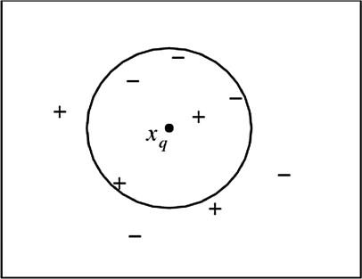

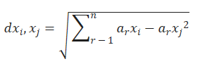

Source: Akanbi & Fazeldehkordi, 2014

***Naïve Bayes Classifier (NBC)***

NBC is a machine learning algorithm that relies on the Bayes probability theory. Through the examination of the input data corresponding to a specified set of features, the Naïve Bayes classifier can calculate class probabilities associated with a specific label (Souza et al, 2021). To classify the input data, it is necessary to calculate the probabilities associated with each existing class. The class with the highest probability is then identified as the one to which the input data belongs (Souza et al, 2021). Thus, the classification task is to locate the class with the maximum probability to occur. The Bayes theory along with the max probability equation are presented below:

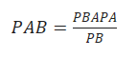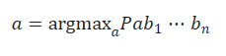

Source: Souza et al, 2021

***Decision Trees (DT)***

Decision trees serve as a versatile approach applicable to both regression and classification tasks. They stand out as one of the most employed algorithms, particularly suitable for classification tasks, offering numerous advantages over alternative classifiers. They are relatively easy to explain and interpret while requiring little effort for data preparation from the user (Benferhat & Elouedi, 2006). The structure of a typical decision tree can be observed in the figure below.

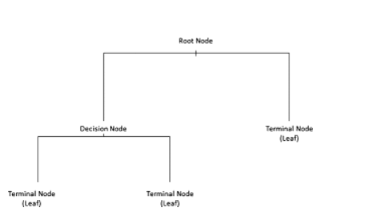

Source: Bellini, 2019

On a tree structure the root represents the starting point, the branches represent the splits/path of the root node, while decision nodes evaluate the features to split the data and which direction to follow.Lastly, the terminal nodes represent the outcome, or while in classification task, the class label (Bellini, 2019). A useful technique that is associated with decision trees is that of pruning, which is implemented in situations that the decision tree may grow too long so it is essential to reduce its decision nodes and avoid overfitting on the data (Bellini, 2019).

***Random Forest***

Frequently, it is crucial to construct more complex models by combining the predictions of several weaker models. This approach in data science is commonly referred to as the "ensemble" method. This procedure essentially combines different models that are trained to solve the same problem and get better results, making the final model more robust (Rocca, 2019).

Random Forest stands out as the most widely adopted ensemble method for classification tasks, a model that trains multiple decision trees through a process called “bootstrapping”, followed by another process known as “bagging” aggregation. Bootstrapping refers to the training of individual trees in parallel and on different subsets of the training set, utilising a diverse set of features. This process ensures that each decision tree in the random forest is unique, which consequently reduces the variance of the classifier. For the model to make the final decision, the predictions from each individual tree are aggregated leading to a more generalised method. Due to its robust nature, the random forest often surpasses other classifiers in terms of accuracy. Despite being more complex in structure compared to an individual decision tree, the random forest is generally simpler when it comes to hyperparameter tuning (Misra & Li, 2020). A typical structure of the model can be viewed in the following image.

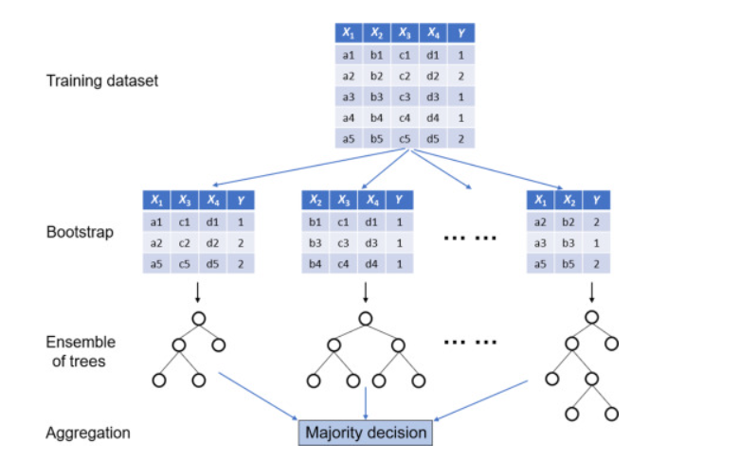

source: Misra & Li, 2020

***Boosting***

Another well-known ensemble method that combines numerous weak learners to create an enhanced model with improved accuracy and robustness. Comparable to the bagging technique of the random forest, boosting also involves aggregating predictions from each individual decision tree, resulting in a more generalised model. However, the primary distinction lies in the fact that, during boosting, the trees are trained sequentially, unlike the parallel training that takes place in the random forest. In this process, each model in the sequence is fitted with increased emphasis on observations in the dataset that were mishandled by the previous models. Essentially, each new model concentrates its efforts on the most challenging observations encountered so far. Consequently, by the end of the process, a robust classifier with reduced bias is obtained (Rocca, 2019). The process of boosting compared to bagging can be observed in the figure below.

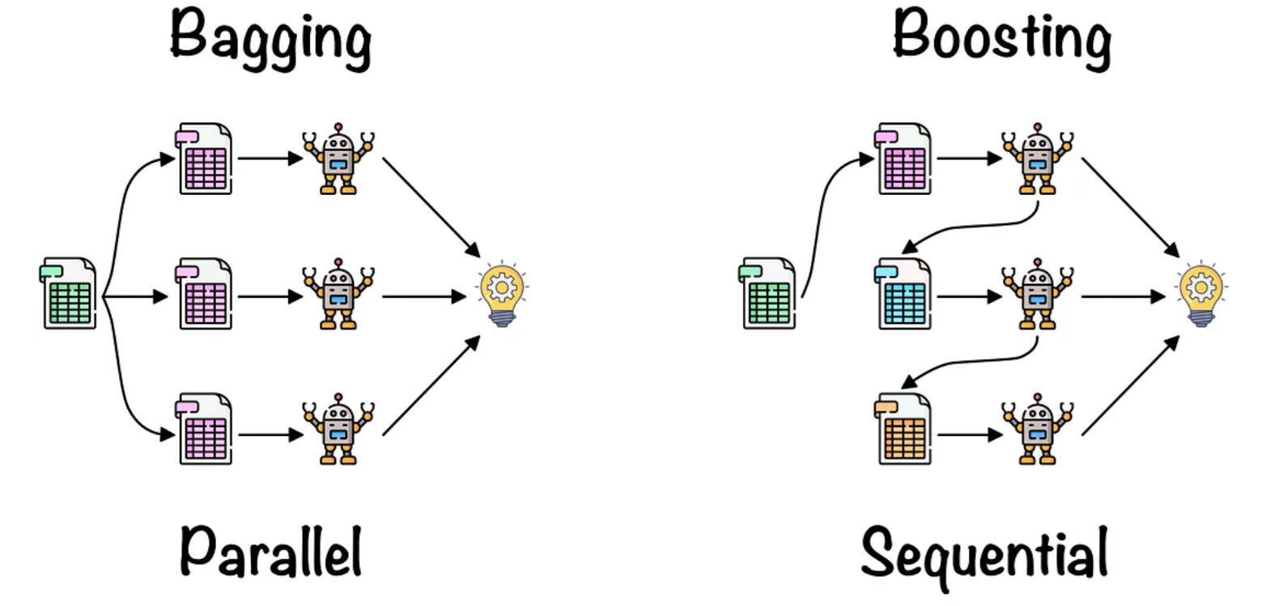

Source: Lopez, 2021

Contrary to bagging and random forest, boosting exhibits numerous variations in the form of various algorithms. Such examples are:

* ***Adaptive Boosting***: The concept of adaptive boosting is to train multiple weak classifiers to create a robust classifier. In each iteration, the algorithm trains a weak classifier on a weighted version of the training data. The weight assigned to each training example is adjusted based on the previous weak classifiers. Adaptive boosting is implemented by the Adaboost Classifier algorithm (Polamuri, 2023).
* ***Gradient Boosting***: The process starts by training a weak learner using the initial data. It subsequently calculates the residuals, and another weak learner is fitted to the residuals. This process is repeated for a set number of iterations, where each new learner aims to minimise, the residuals left by the preceding learner. The model's prediction is the sum of all predictions from the weak learners (Polamuri, 2023).
* ***XGB (Extreme Gradient Boosting)***: An optimised version of gradient boosting, this technique has emerged as one of the most widely adopted methods for boosting procedures. This algorithm facilitates considerably faster training by enabling parallel processing and is adept at handling very large datasets with minimal requirements for data preprocessing. Like other boosting principles, XGBoost trains multiple week decision trees to create a strong model with increased accuracy and robustness (GeeksforGeeks, 2023).

## 2.4. Class imbalance and resampling strategies

On many occasions, real world data comes with an issue called class imbalance. This occurs primarily on classification tasks when the distribution of the target variable is severely skewed, meaning that a certain class is underrepresented than others. Such situations occur often in disease detection and fraud transaction datasets where there are significantly fewer observations for diseased or fraud cases. This skewness often creates challenges for the models since they become more biassed towards the majority class, resulting in poor performance for the minority classes (Yang et al, 2024). To address this situation, resampling techniques are employed during the model training process, aiming to balance the distribution and minimise any bias in the model. The most widely used techniques are random **Undersampling** and **Oversampling**. In random undersampling, samples are deleted from the majority class until it matches the minority, though it can result in loss of information and underfitting. In contrast, with random oversampling, samples from the minority class are duplicated until it matches with the majority class. However, this considerably inflates the dataset size and increases the risk of overfitting in the training data. To mitigate such scenarios, methods like cross-validation, hyperparameter tuning, and regularisation are employed to minimise issues related to underfitting and overfitting. It is crucial though, that both of those techniques are only applied on the training set, since the test set serves as a genuine representation of the real-world problem and should always be left unaltered (Brownlee, 2021).

**Evaluation Metrics**

The ultimate objective of any classification model is to generate predictions for new and unseen data. Hence, to assess whether a built model is effective, various evaluation methods are necessary to make a concrete decision. Those metrics are presented as followed:

**Accuracy**

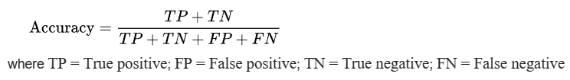

Typically, accuracy is defined as the ratio of correct predictions to the total number of instances. However, relying solely on accuracy as a metric can be overly optimistic, especially in situations with significant class imbalance. For instance, in a scenario with 1000 transactions, of which only 100 are fraud, a classifier could predict all cases as non-fraudulent, resulting in a 90% accuracy without detecting any of the fraud cases. To address this, additional metrics are considered that can emphasising on the evaluation of minority classes.

**Recall**

Also referred to as sensitivity, recall is a measure of how many truly relevant results are returned. It is defined as the number of true positives over the number of true positives plus the number of false negatives.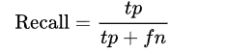

Recall is very used when you must correctly classify some event that has already occurred. It is frequently applied in scenarios such as fraud detection models or disease detection in patients. For instance, in the context of illness detection, it is crucial to identify individuals who are ill to prevent false negatives.

**Precision**

Precision is a measure of result relevancy. It is defined as the number of true positives over the number of true positives plus the number of false positives.

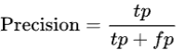

Precision is widely employed in marketing campaigns, particularly in the context of marketing automation. This is because a marketing automation campaign aims to initiate an activity for a user when the system predicts a successful response. In these scenarios, low precision translates to a financial loss as it entails reaching out to potential customers who are not interested in the marketing offer.

**F1 score**

F1 is the harmonic mean of precision and recall. It is often preferable in situations where there is class imbalance in the dataset, while both high recall and precision are desirable. The F1 score is expressed by the following equation. 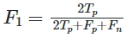

It can also be expressed in terms of precision and recall by the following expression.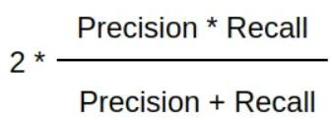

**Receiver Operating Characteristic (ROC) Curve**

The ROC curve depicts the balance between the true positive rate (Sensitivity or Recall) and the false positive rate (FPR) across various probability thresholds. AUC (Area Under the Curve) is a metric assessing the classifier's ability to discriminate between the two. Its value ranges from 0 to 1, with values nearing 1 signifying optimal classifier performance. While commonly employed for binary classification tasks, it is possible to generate the curve for multiclass problems as well. In this context, each class has its individual curve, while Macro-AUC represents the average of the class-specific AUC values.

**Average Precision (AP)**

The relationship of recall and precision is depicted by the precision recall curve, which illustrates the trade-off between the two metrics for different probability thresholds. The area under the curve is known as Average Precision (AP) and is given by the following expression (Kashifi et al, 2022).

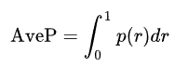

The area under the curve, like the ROC curve, has a value ranging from 0 to 1, with higher values indicating superior classifier performance. Precision-recall curves are preferred in scenarios with severe class imbalance since AUC in those occasions can be overly optimistic. Although commonly employed for binary classification, it is feasible to calculate curves for each individual class in a one-vs-rest (OvR) scenario. The micro-AP is then computed which is the harmonic mean of the class-specific AP values.

## 2.5. Machine Learning applications in transport mode choice

The adoption of machine learning in the modelling and prediction of transport mode choices has experienced a significant surge in recent times. In contrast to the prior logit models, the results indicate a notably improved ability to accurately predict transportation mode. This application is geared towards improving our understanding and predictive capabilities concerning individuals' decisions regarding the modes of transportation they choose. Numerous recent studies have sought to employ a range of machine learning models to predict transit behaviour. In 2015, Omrani conducted a study with the objective of forecasting the travel mode choices of individuals by applying machine learning techniques to national data from Luxembourg. His research outcomes revealed that artificial neural networks outperformed other alternative models in terms of predictive accuracy (Omrani, 2015). In their research conducted between 2010 and 2012 using data from the National Travel Survey in the Netherlands, Hagenauer and Helbich (2017) applied various machine learning classification models to predict travel mode choices effectively. Their results indicated that the Random Forest model outperformed the others. Nonetheless, they noted that while trip distance emerged as the most critical predictor, the importance of variables varied among different classifiers and class labels (Hagenauer & Helbich, 2017). In a parallel study using the same data, Kashifi et al (2022) set out to also forecast transportation mode choices. They extended the previous research by incorporating additional machine learning techniques into their analysis. Their results revealed that boosting and LightGBDT exhibited superior predictive accuracy for the different classes, especially when utilizing both under and oversampling methods to address class imbalance. Furthermore, their analysis underscored that age, income, and distance were the most influential predictors in the context of transport mode prediction (Kashifi et al., 2022).

Other applications of machine learning in the prediction of transportation modes can be characterised as more tailored to specific scenarios, as they are designed for modelling particular situations. In a recent study, Bhuiya et al (2022) focused on modelling transport mode choices for individuals with limited mobility in Dhaka. Their research findings indicated that multinomial logistic regression and linear discriminant analysis models exhibited superior predictive accuracy, particularly considering a smaller dataset (Bhuiya et al., 2022). Additionally, Zhao et al (2020) investigate differences between machine learning and logit models based on trip diary recordings. Their study findings from staff and students within the University of Michigan suggest that when deciding between machine learning and logit models for transport modelling, it seems there is a trade-off between predictive accuracy and the alignment with behavioural principles (Zhao et al, 2020).

Recent research developments in this field have introduced more sophisticated approaches, such as the adoption of artificial neural networks and deep learning methods. For instance, Zhang et al. (2020) introduced a deep neural network model for classification using data from Beijing, and their results demonstrate that this network model outperforms the random forest model in predicting transportation modes (Zhang et al., 2020). Furthermore, in a study based on national travel data from the UK, Bei et al. (2023) introduce a deep neural network model that goes beyond mere travel mode prediction, also addressing the purpose of the trip. Their research indicates that the model they proposed surpasses the performance of basic multinomial logit models and single-task neural networks (Bei et al., 2023). Additionally, Wang, Mo, and Zhao (2021) present a "theory-based residual neural network" model that integrates discrete choice models with basic neural networks, using three separate survey datasets. Their results indicate that the model they propose not only achieves superior predictive accuracy but also exhibits greater resilience compared to straightforward neural networks or discrete models (Wang, Mo & Zhao, 2021).

# 3. Methodology

The data collection process stands out as a critical component in constructing a classification model. To predict transportation mode choices and explore diverse features, two distinct datasets were collected, with each dataset undergoing separate application of various classification models. Due to variations in the datasets, an effective cross-dataset comparison is unfeasible. The assessment of different models and their efficacy in predicting transportation mode choices was conducted individually for each dataset, each representing distinct scenarios. Specifically, the data were derived from Netherlands, and Thessaloniki, respectively. The Netherlands dataset is used for predicting transport mode based on trip diary recordings, containing the travels of individuals across the country. On the flip side, the Thessaloniki dataset, derived from an online survey, delves into a more specific scenario by examining how respondents commute to work. Although both cases revolve around predicting the choice of transportation modes, they exhibit noteworthy distinctions. The Netherlands dataset, being considerably larger, encompasses any kind of trip. In contrast, the Thessaloniki dataset is comparatively smaller but emphasises on the domain of commuting to work. Notable differences also exist in terms of the data structure and the methodology procedure.

Furthermore, given the substantial differences in transportation infrastructures, as well as behavioural and demographic characteristics among countries and residents, a more effective approach involves studying and predicting transportation mode choices separately to address more generalised situations. In this section of the Thesis a description of the collection process for each dataset along with their characteristics will be provided. The data processing, cleaning and analysis was implemented using Python programming language and specifically within the virtual environment of JupyterLab.

## 3.1. Python Libraries

Below, the Python libraries utilised for the analysis of both datasets are displayed:

1. **Numpy**: It is one of the most implemented libraries, particularly in machine learning. This library is known for its support of matrices and multi-dimensional data. Numpy incorporates mathematical functions, among which the Array Interface that stands out as one of its most valuable features.
2. **Pandas**: It stands as a crucial library for data scientists, serving as an open-source machine learning library offering top notch analytical tools. It includes features such as sorting, visualisations, conversions and more.
3. **Matplotlib**: It is employed for visualising numerical data, making it a valuable tool in data analysis. It includes many unique charts such as pie charts, histograms, scatter plots and more.
4. **Scikit-learn**: A machine learning library that supports most supervised and unsupervised algorithms. The library works for many separate problems including regression, classification, clustering and more.
5. **Geopy**: A python library that enables users’ identification of coordinates for addresses, cities, countries internationally. It is also used for calculating distances between different coordinates (pypi.org, 2024)
6. **Seaborn**: It is used for data visualisation, offering a high-level interface to create visually appealing and informative statistical graphics. The library is built on top of the library of Matplotlib also functioning effectively with Pandas.
7. **Imbalanced-learn**: It is a library that offers various re-sampling techniques specifically designed for datasets with pronounced class imbalance. It is compatible with scikit-learn.

## 3.2. Data collection for case 1: Thessaloniki

Data for Thessaloniki were collected through an online survey using the Google Docs platform. While the survey was initially created in Greek, the analysis was conducted in English. The survey was distributed purely online through social media, emails and smartphones to residents in Thessaloniki. The following comprises the complete list of questions posed both in Greek and English

1. Διεύθυνση Κατοικίας - Home Address
2. Διεύθυνση Εργασίας - Work Address
3. Φύλλο - Gender
4. Ηλικία - Age
5. Έχετε δίπλωμα για οποιαδήποτε από τα παρακάτω: Αυτοκινητο, Μηχανη, Φορτηγό, Τίποτα - Do you have a license for any of the following: Car, Motorcycle, Truck, Nothing
6. Διαθέτετε κάποιο από τα παρακάτω: Ποδήλατο, πατίνι, αμάξι, μηχανή, τίποτα - Do you have any of the following: Bicycle, skates, car, motorcycle, nothing
7. Από πόσα άτομα αποτελείται η οικογένειά σας - How many people does your family consist of ?
8. Πόσα ιδιωτικά οχήματα διαθέτετε στην οικογένειά σας - How many private vehicles do you have in your family?
9. Μηνιαίο εισόδημα - Monthly Income
10. **Με ποιον τρόπο πηγαίνετε συνήθως στην εργασία σας - Mode for commuting to work (target variable)**
11. Αναφέρετε πόσα λεπτά στο περίπου χρειάζεται για να μεταβείτε από το σπίτι σας προς τον χώρο εργασίας σας - Indicate how many minutes approximately it takes you to travel from your home to your workplace.
12. Ποιές ώρες πηγαίνετε συνήθως στην εργασία σας - What time do you usually go to work?

Likert Based questions

Do you think the following factors affect your commute?

Use scale where:

1-Strongly disagree , 2-Disagree , 3-Neutral , 4-Agree , 5-Strongly agree

1. Άνεση Μετακίνησης - Convenience
2. Κόστος Μετακίνησης - Cost
3. Ασφάλεια μετακίνησης - Safety
4. Προστασία του περιβάλλοντος - Environmental concerns
5. Σωματική άσκηση και υγεία - Physical exercise and health
6. Καιρικές συνθήκες - Weather conditions
7. Διαθεσιμότητα χώρου στάθμευσης - Parking availability

The survey remained accessible from November 15 to January 15. A total of 409 samples were gathered, and after eliminating blank or erroneous responses as well as samples with unclear home or work addresses, 383 were deemed valid for subsequent analysis. Each question of the survey corresponds to a feature in the resulting dataset. Additional columns were generated for checkbox questions like 5, indicating binary values of either yes or no. For example the possible answers in question 5 are Car, Motorcycle, Truck or Nothing. Three columns were created: Car_licence, Motor_licence and Truck_licence that store whether the respondent has a licence for those or not. The same procedure was implemented also for question 6, creating four new features: Car_access, Bike_access, Motor_access, Skate_access. Additionally, two distance-related features were generated using the Home address and Work address. More specifically, distance in kilometres was computed between home and work address using Google Maps. An illustration of the procedure is presented in the figure below:

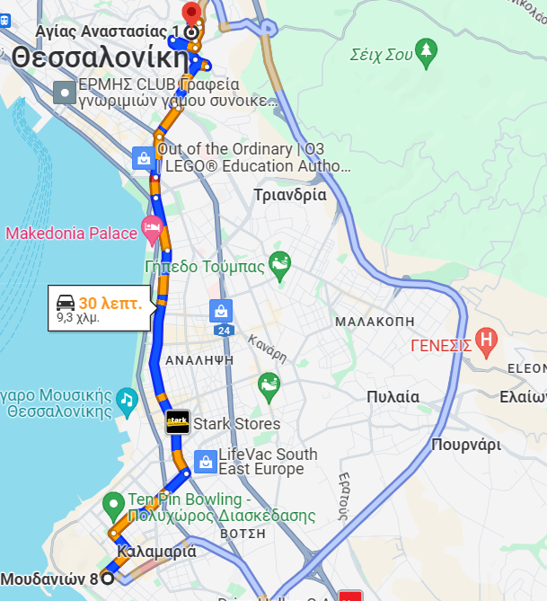

For samples where the mode of transportation was a car, the optimal distance for cars was chosen. If walking or taking the bus were the chosen modes of transport, the respective optimal distances were selected. Since optimal distances vary depending on the calculation time, the distances were computed during peak working hours: 06:00 - 09:00 and 14:00 - 17:00. Also, the corresponding time for each distance was used to validate the responses from the survey in question 11. Specifically, respondents were requested to indicate the duration of their commute to work in minutes. In cases where there was a substantial difference between their provided answers and the calculated time in Google Maps, the corresponding time from Google Maps was adopted. For example, if a respondent stated a 40-minute commute, but Google Maps suggested 25 minutes, the Maps estimate was used. In contrast, if a respondent implied a 30-minute commute and Google Maps indicated 33 or 34 minutes, the respondent's provided time was selected. This procedure was manually executed for all 383 samples.

The second distance-related feature was calculated in a more automated way using the Python library of Geopy. The library provides access in geocoding enabling users to find the geographic coordinates of a location based on the provided address. Based on those coordinates Geopy can calculate the distance between home and work address in a completely automated way. Though, the main difference from Google Maps, is that the corresponding distance is a geodesic one. Geodesic distance is the shortest distance between two points but on a curved surface like that of the earth (Kettle, 2014). This can be better understood for distances using the airplane, where in a 2D map the shortest path between two points seems to be a straight line, but the actual shortest path is the geodesic one because of the curved surface of the earth. This example is demonstrated in the figure below with the geodesic distance represented by the blue line.

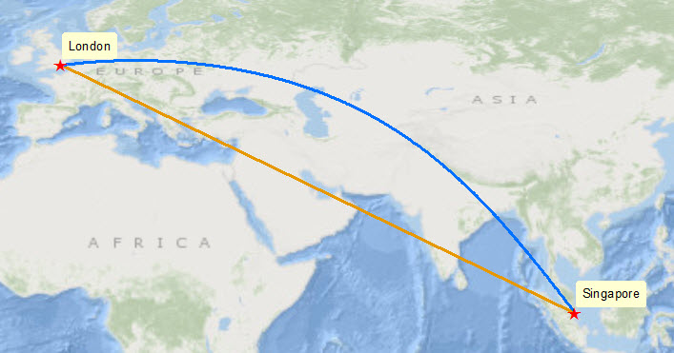

**Source: Kettle, S., 2014**

The purpose of calculating two types of distances is to use them individually as features in classification models and evaluate whether there are significant differences in the model outcomes depending on the use of separate distance metrics. The resulting dataset comprises 383 samples and 24 features. The analysis procedure that was followed for the dataset is illustrated in the figure below:

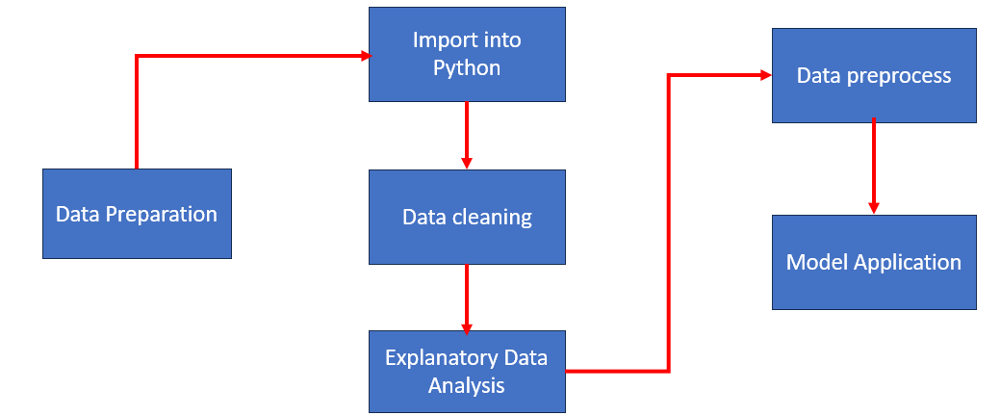

Four Models will be used in total: Logistic Regression, Decision Tree, Random Forest and XGBoost. The evaluation metrics include Precision, Recall, Accuracy and AUC scores from the ROC curves.

## 3.3. Data collection for case 2: Netherlands

The data for the Netherlands were collected from the official statistics service in the country. The data can be found at **https://ssh.datastations.nl/dataverse/root**. For data to become available to the user, registration to the website is required, while access to the datasets must be requested by the Data station of Social Sciences and Humanities for free. Data was collected for years 2018 - 2022. The datasets are trip diary surveys where people within the Netherlands record their trips and answer demographic questions. The survey is called “ODIN” and is conducted by the Central Bureau of Statistics in the Netherlands annually via the Internet (Statistics Netherlands, 2024). Features within the dataset are described in Dutch so it was required to translate them using Google Translate and following the Codebook Guideline also available at the same link as above. The original datasets for each year, as downloaded from the website, contain about 150000-200000 trips/rows and about 100 columns. From these datasets, trip related features were selected such as distance and duration of the trip and some demographic features such as household size and number of vehicles in the house. After the features were extracted for each year, the data were merged and a final dataset was produced. The resulting dataset contains 817126 samples, each instance representing a different trip. After removing rows with blank values, the dataset was imported into python for further processing. The features are illustrated below:

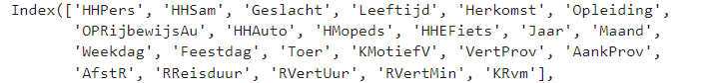

The features were then renamed so they could become clearer and more manageable. The rename process is depicted below.



The full list of features along with their description is shown below.

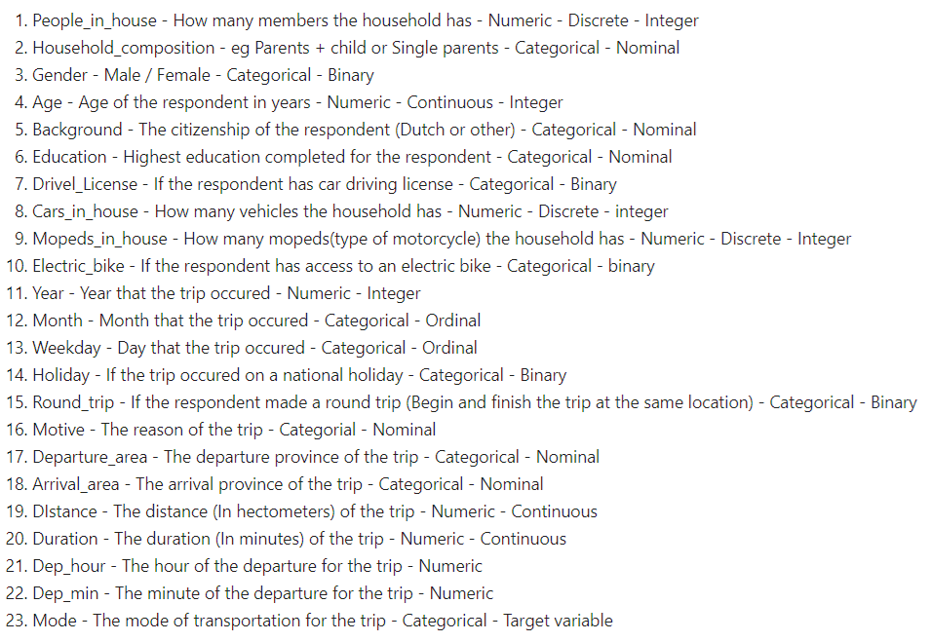

The resulting dataset comprises 817126 samples and 23 features. The analysis procedure that was followed for the dataset is illustrated in the figure below:



Overall, four models will be explored: Logistic Regression, Decision Tree, Random Forest and XGBoost. Due to class imbalance both undersampling and oversampling techniques will be explored to create the models. The evaluation metrics include mainly F1 score, and Average Precision (AP) area under the curve included in the Precision-Recall curves.

To assess the performance of the final models, the results from Kashifi et al. (2022) will be used as a benchmark. Their dataset, although originating from the same source, incorporates different features. Additionally, their dataset includes outdated data spanning from 2010 to 2012 while also their dataset is considerably lower.

# 4. Results

## 4.1. Results for case 1 - Thessaloniki

This section of the thesis will present the findings related to Thessaloniki and commuting behaviour. The initial part covers data preparation and cleaning, followed by exploratory data analysis and data preprocessing. The final segment focuses on model application, mode classification, and the selection of the best model.

### 4.1.1. Data preparation and cleaning

Out of the 409 samples obtained from the online survey, blank responses were excluded initially. Subsequently, responses with errors in home or work addresses (those unidentifiable in Google Maps) were eliminated. Lastly, a few samples indicated respondents working from home or concealing either of their addresses; these samples were also excluded. Consequently, from the initial 409 samples, 383 were deemed valid. Furthermore, as detailed in the methodology section, additional features were generated for the two checkbox questions, considering only "yes" or "no" values. Following the creation of these features, the data were imported into Python for further preparation and cleaning. Below are the columns of the dataset as imported into the virtual environment:

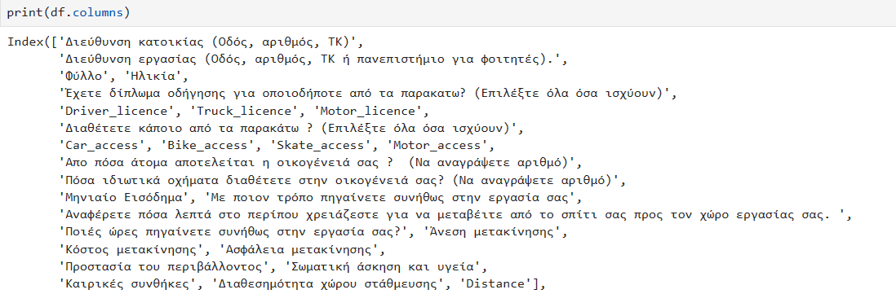

The column names, excluding those derived from checkboxes, essentially correspond to the questions posed in the online survey. For better management during the analysis phase, it was necessary to rename the columns. Following the renaming process, the complete list of features is presented below.

|  |  |  |
| --- | --- | --- |
| **Columns** | **Type** | **Description** |
| Home_address | object | Home address of the respondent |
| Work_address | object | Work address of the respondent |
| Gender | Categorical-Binary | Gender of the respondent |
| Age | Categorical | Age group of the respondent |
| Driver_licence | Categorical - Binary | Access to a driver licence? |
| Truck_licence | Categorical - Binary | Access to a truck licence? |
| Motor_licence | Categorical - Binary | Access to a motor licence? |
| Car_access | Categorical - Binary | Access to a car? |
| Bike_access | Categorical - Binary | Access to a driver bike? |
| Motor_access | Categorical - Binary | Access to a motorcycle? |
| Skate_access | Categorical - Binary | Access to a skate? |
| Hsize | Numeric - Discrete | Household size |
| Vehicles | Numeric - Discrete | Number of private vehicle in household |
| Income | Categorical | Income group of respondent |
| Mode | Categorical | Mode for commuting to work |
| Time | Numeric - Continuous | Minutes required for transit to work |
| Depart_time | Categorical | Time of departure for commuting to work |
| Convenience | Categorical - Ordinal | Degree of influence of convenience (1 to 5) |
| Cost | Categorical - Ordinal | Degree of influence of cost (1 to 5) |
| Safety | Categorical - Ordinal | Degree of influence of safety (1 to 5) |
| Environment | Categorical - Ordinal | Degree of influence of environmental concerns (1 to 5) |
| Health | Categorical - Ordinal | Degree of influence of exercise and health (1 to 5) |
| Weather | Categorical - Ordinal | Degree of influence of weather (1 to 5) |
| Parking | Categorical - Ordinal | Degree of influence of parking availability (1 to 5) |
| Distance | Numeric - Continuous | Travel distance (kms) between home and work address |

In total, there are 25 features, comprising 4 numeric, 19 categorical, and 2 object features. The next steps involved checking for null values using the **df.isnull().any()** command and identifying duplicates with **df.duplicated().sum()**. Given that blank samples were eliminated prior to importing into Python, there were no instances of nulls or duplicates.

Furthermore, erroneous samples were also removed. There were cases where respondents indicated commuting to work by car or motorcycle without possessing a licence for either of those or vice versa. After also removing those samples the dataset size was reduced to 374. Finally, a lone sample was excluded, where the respondent suggested a trip distance exceeding 80 kilometres, constituting an outlier within the dataset. Consequently, 373 valid options were retained to proceed with the exploratory data analysis phase. For those 373 samples the geodesic distance was also calculated using the geopy library and subsequently home and work address columns were dropped. The final dataset consists of 373 samples and 24 features.

### 4.1.2. Explanatory Data Analysis

In this section of the Thesis the descriptive statistics along with visualisation for each feature will be presented to better understand the dataset. The first feature is about the target variable and the commuting mode to work for the respondents. It is evident that there is a balance among car, walk and bus users with over 100 observations for each. The only notable difference is seen in respondents with a motorcycle, as they constitute the vast minority with fewer than 20 observations. Displayed below is the count plot of the feature, accompanied by the corresponding percentages for each mode.

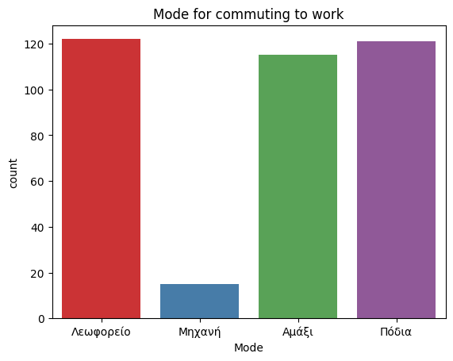

|  |  |
| --- | --- |
| **Mode** | **Percentage** |
| **Bus** | **32.7%** |
| **Walk** | **32.44%** |
| **Car** | **30.83%** |
| **Motorcycle** | **4.02%** |

The following feature refers to the gender of the respondents. It is apparent that there is a relatively even distribution among the responses. To be more specific, there are slightly over 175 observations for both men and women, with women having a slim numerical edge (51.75%). The grouped plot also illustrates that a higher proportion of women use the bus compared to men. In contrast, men tend to use private vehicles (car, motorcycle) slightly more than women.

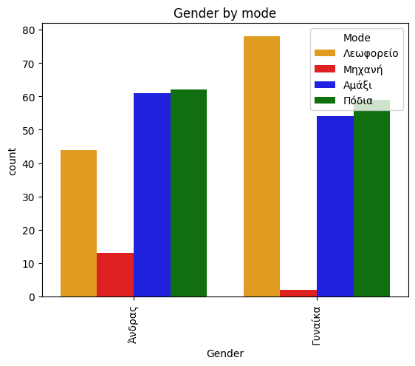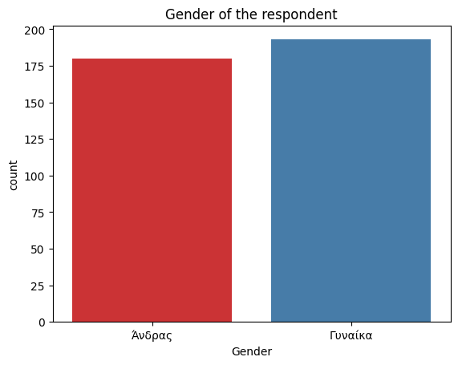

|  |  |
| --- | --- |
| **Gender** | **Percentage** |
| **Women** | **51.75 %** |
| **Men** | **48.25 %** |

The subsequent set of features pertains to whether the respondent possesses driving licences. The options for car, motor, and truck licences only allow for "yes" or "no" responses. The plots make it apparent that most respondents possess a car licence, while for the other two options, the majority indicates having neither a motor nor a truck licence.

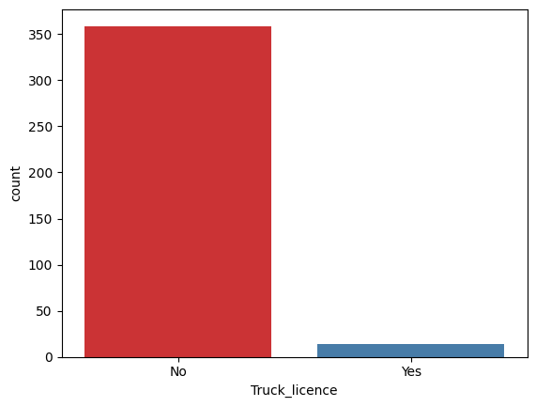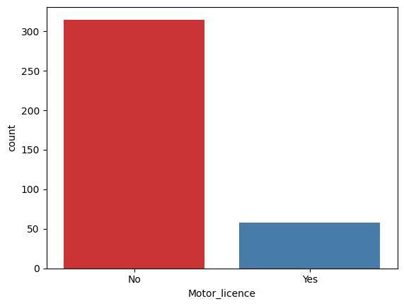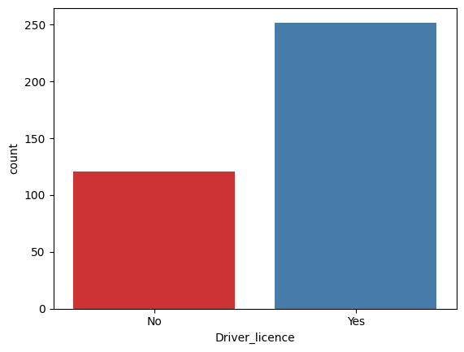

|  |  |  |  |
| --- | --- | --- | --- |
|  | **Driver licence (car)** | **Truck licence** | **Motor licence** |
| **Yes** | **67.56 %** | **3.75 %** | **15.55 %** |
| **No** | **43.44 %** | **96.25 %** | **84.45 %** |

The following group of features pertains to whether the respondent has access to any of the following modes: car, motorcycle, bike, or skate. Like the preceding set, these features only permit "yes" or "no" as possible answers. Regarding car access, the outcomes illustrate a notable balance between positive and negative responses. On the flip side, for any other mode, most respondents lack access to options such as bike, motor, or skate.

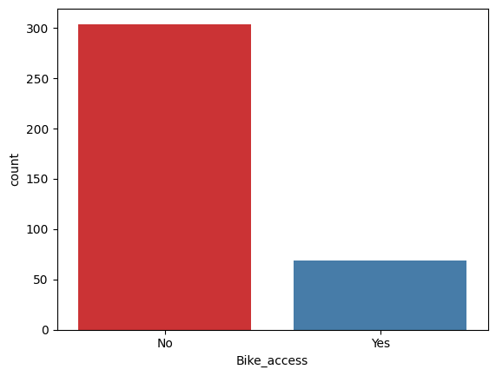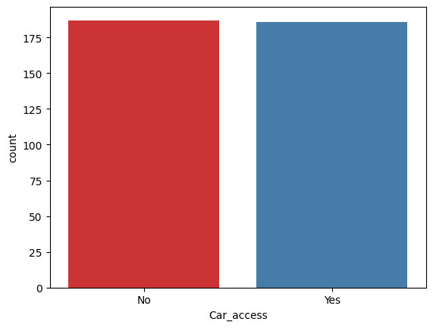

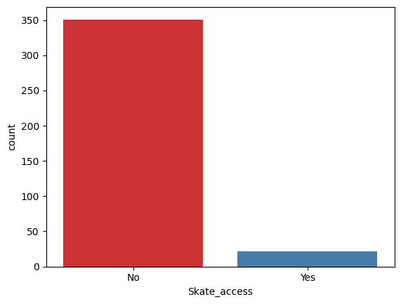

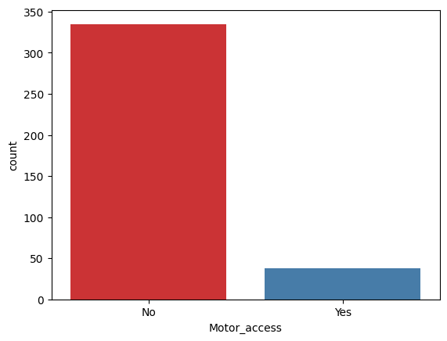

|  |  |  |  |  |
| --- | --- | --- | --- | --- |
|  | **Car access** | **Motor access** | **Bike access** | **Skate access** |
| **Yes** | **49.87 %** | **10.19 %** | **18.50 %** | **5.90 %** |
| **No** | **50.13 %** | **89.81 %** | **81.50 %** | **94.10 %** |

The next feature concerns the departure time of the respondent for their work commute. As depicted in the plot below, it is apparent that most respondents commute to work during the morning peak hours between 06:00 and 12:00. There are also a few instances where respondents commute during the evening hours between 12:00 and 18:00, while the minority proportion commutes to work at off hours during 18:00 - 21.00 and 00.00 - 06.00 past midnight. There are no instances where respondents depart between 21.00 and 00.00.

|  |  |
| --- | --- |
| **Depart time** | **Percentage** |
| **06.00-09.00** | **46.11 %** |
| **09.00-12.00** | **30.03 %** |
| **12.00-15.00** | **13.67 %** |
| **15.00-18.00** | **6.70 %** |
| **18.00-21.00** | **2.14 %** |
| **00.00-03.00** | **0.54 %** |
| **03.00-06.00** | **0.80 %** |

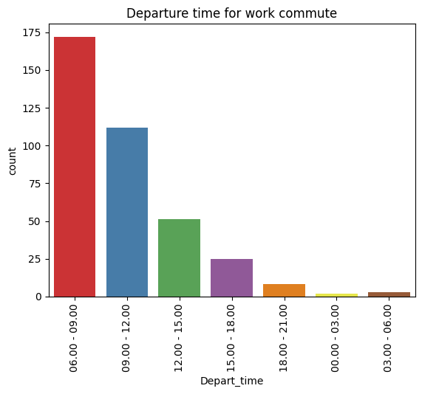

The following question refers to the monthly income of the respondent. As depicted in the graph, most respondents have a monthly income between 500 and 1000£, followed by those with incomes between 0 and 500£. Additionally, there is a substantial proportion of respondents with an income exceeding the 1000£ mark, with a few observations even surpassing 2000£.

|  |  |
| --- | --- |
| **Income** | **Percentage** |
| **0 - 500** | **22.52 %** |
| **500 - 1000** | **46.92 %** |
| **1000 - 1500** | **21.45 %** |
| **1500 - 2000** | **5.36 %** |
| **2000 and more** | **3.75 %** |

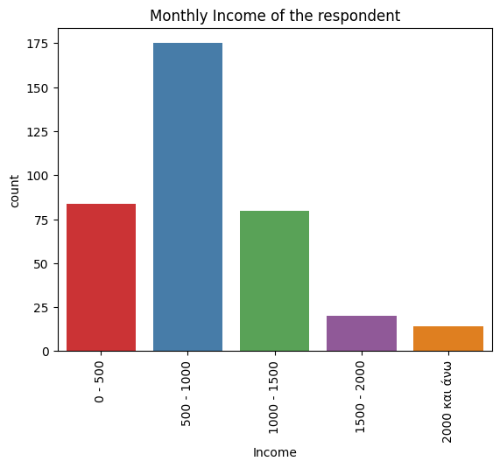

The next feature pertains to the age group of the respondent. The vast majority fall within the 21 to 30 years old category, followed by those aged between 31 and 40. For the remaining age groups, the observations are relatively more balanced. The sole exception is the age group of 61 and above, which has fewer than 5 observations.

|  |  |
| --- | --- |
| **Age** | **Percentage** |
| **Below 20** | **12.60 %** |
| **21 - 30** | **45.04 %** |
| **31 - 40** | **20.91 %** |
| **41 - 50** | **14.48 %** |
| **51 - 60** | **6.43 %** |
| **More than 61** | **0.54 %** |

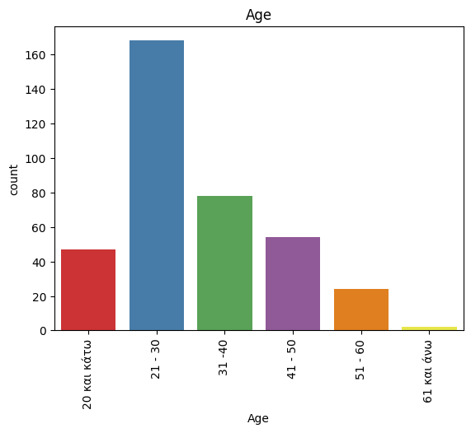

The following feature is about the household size of the respondent. The overwhelming majority indicates residing in households comprising between 2 and 5 members. In addition to this, a minority of respondents suggests living in larger families with 6 or more members, while a small proportion mention being part of a single-member family.

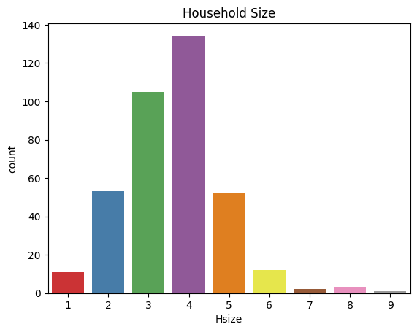

|  |  |
| --- | --- |
| **Household size** | **Percentage** |
| **1** | **2.95 %** |
| **2** | **14.21 %** |
| **3** | **28.15 %** |
| **4** | **35.92 %** |
| **5** | **13.94 %** |
| **6** | **3.22 %** |
| **7** | **0.54 %** |
| **8** | **0.80 %** |
| **9** | **0.27 %** |

The subsequent feature concerns the number of vehicles in the households of the respondents. Most respondents suggest living in a household with 1 or 2 private vehicles. Additionally, a minority of respondents mentions residing in a house with no vehicles at all, while a few observations suggest households with 4 or 5 vehicles.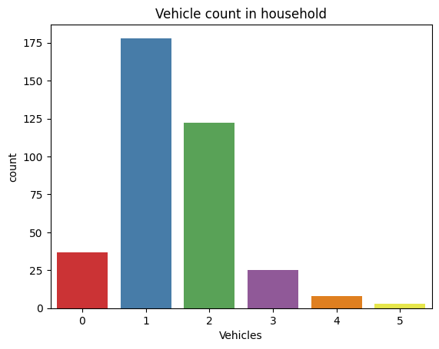

|  |  |
| --- | --- |
| **Number of vehicles** | **Percentage** |
| **0** | **9.92 %** |
| **1** | **47.72 %** |
| **2** | **32.71 %** |
| **3** | **6.70 %** |
| **4** | **2.14 %** |
| **5** | **0.80 %** |

The next series of questions addresses the impact of specific factors on the commuting behaviour of the respondent. Starting with convenience as an influencing factor, a significant number of respondents expressed either "agree" or "totally agree" that the convenience of transportation affects their commuting behaviour to work. Additionally, there is a substantial proportion of respondents indicating a "neutral" response to the impact of convenience. Fewer observations are categorised as "disagree" or "totally disagree."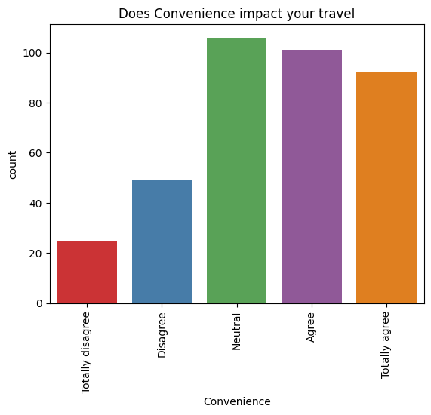

|  |  |
| --- | --- |
| **Impact of Convenience** | **Percentage** |
| **Totally Disagree** | **6.70 %** |
| **Disagree** | **13.14 %** |
| **Neutral** | **28.42 %** |
| **Agree** | **27.08 %** |
| **Totally Agree** | **24.67 %** |

The next feature refers to the impact of transportation cost in commuting behaviour. Most of the respondents also expressed “Agree” and “Totally Agree” that cost is a significant factor influencing their transits to work. Additionally, a significant portion expressed a "neutral" position regarding this aspect. In contrast, only a small number of responses suggested that cost does not impact their commuting behaviour, as reflected in the "Disagree" and "Totally Disagree" categories.

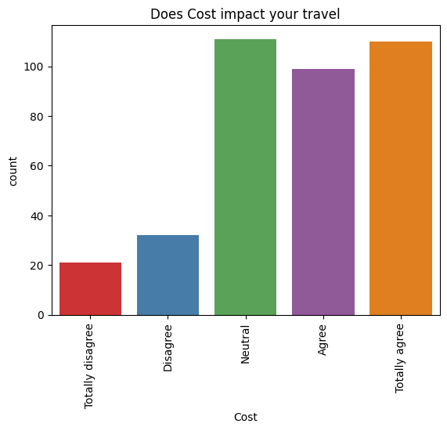

|  |  |
| --- | --- |
| **Impact of Cost** | **Percentage** |
| **Totally Disagree** | **5.63 %** |
| **Disagree** | **8.58 %** |
| **Neutral** | **29.76 %** |
| **Agree** | **26.54 %** |
| **Totally Agree** | **29.49 %** |

The following factor is about health. Specifically, it refers to how physical exercise such as walking and consequently health concerns in general affect the commuter’s transit to work. The results are quite balanced with respondents implying both negative and positive categories. Also, a significant number of respondents also indicated a “neutral” position regarding health impact.

|  |  |
| --- | --- |
| **Impact of Health** | **Percentage** |
| **Totally Disagree** | **9.38 %** |
| **Disagree** | **19.57 %** |
| **Neutral** | **29.56 %** |
| **Agree** | **24.93 %** |
| **Totally Agree** | **16.35 %** |

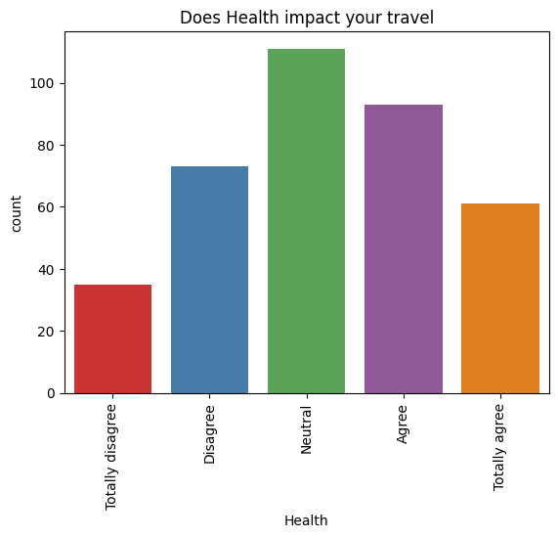

The next feature pertains to the factor of transportation safety. Once again, most respondents express a neutral stance regarding the impact of safety on their commuting behaviour to work. Additionally, a significant proportion reacts positively to the importance of this factor. A smaller number of respondents indicate that safety does not influence their transit behaviour.

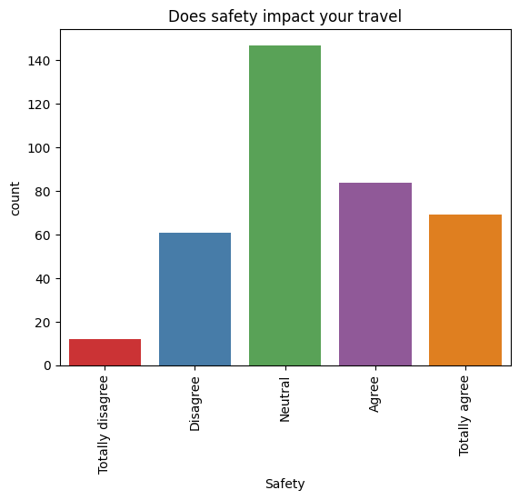

|  |  |
| --- | --- |
| **Impact of Safety** | **Percentage** |
| **Totally Disagree** | **9.38 %** |
| **Disagree** | **19.57 %** |
| **Neutral** | **29.56 %** |
| **Agree** | **24.93 %** |
| **Totally Agree** | **16.35 %** |

The subsequent feature focuses on the influence of environmental concerns. In a manner akin to health and physical exercise, respondents exhibit a balanced stance, with most observations equally distributed across positive and negative categories. Once more, many responses align with a neutral stance for this specific factor.

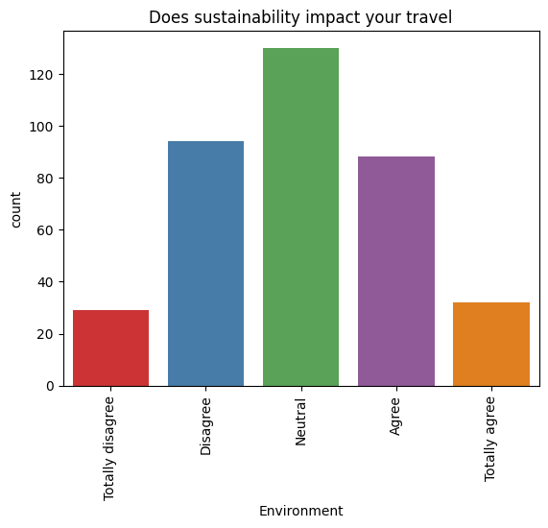

|  |  |
| --- | --- |
| **Impact of Environmental concerns** | **Percentage** |
| **Totally Disagree** | **7.77 %** |
| **Disagree** | **25.20 %** |
| **Neutral** | **34.85 %** |
| **Agree** | **23.59 %** |
| **Totally Agree** | **8.58 %** |

Transitioning to the next factor, it concerns the impact of parking availability on commuting behaviour to work. In this context, numerous observations fall into the positive categories, particularly the "totally agree" option, with the "neutral" category being the second most common. The negative categories encompass fewer observations regarding the impact of this factor.

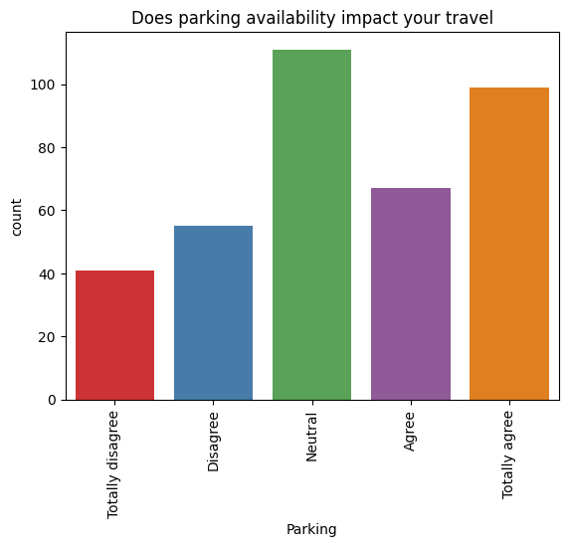

|  |  |
| --- | --- |
| **Impact of parking availability** | **Percentage** |
| **Totally Disagree** | **10.99 %** |
| **Disagree** | **14.74 %** |
| **Neutral** | **29.76 %** |
| **Agree** | **17.96 %** |
| **Totally Agree** | **26.54 %** |

The final factor concerns the impact of weather conditions on commuting to work. In this aspect, there is a notable contrast between positive and negative responses, with most respondents falling into the "agree" and "totally agree" categories. A substantial proportion also indicated a neutral stance on the factor, while both the "disagree" and "totally disagree" categories represent vast minorities.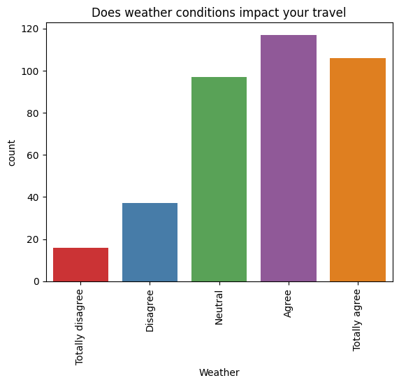

|  |  |
| --- | --- |
| **Impact of weather** | **Percentage** |
| **Totally Disagree** | **4.29 %** |
| **Disagree** | **14.74 %** |
| **Neutral** | **29.76 %** |
| **Agree** | **17.96 %** |
| **Totally Agree** | **26.54 %** |

The subsequent set of features pertains to the distance metrics calculated between the home and work addresses. The "Distance" feature signifies the optimal travel distance manually obtained from Google Maps, whereas the "Geodesic Distance" represents the distance automatically calculated by the Geopy library in Python. Both distances are expressed in kilometres. The histograms for both metrics, along with their descriptive statistics, are depicted below.

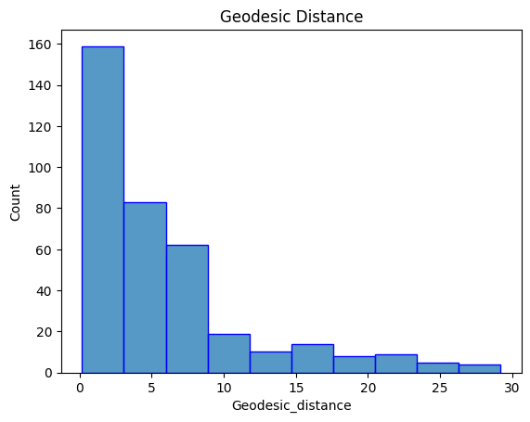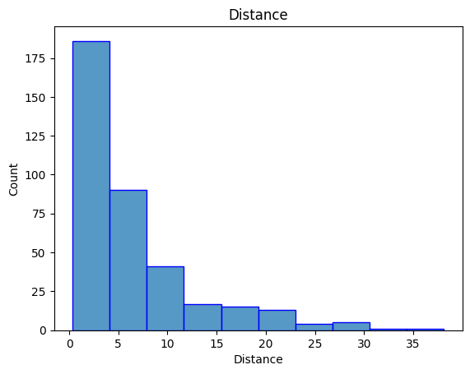

|  |  |  |
| --- | --- | --- |
|  | **Distance** | **Geodesic Distance** |
| **Mean** | **6.36** | **5.91** |
| **std** | **6.42** | **5.98** |
| **min** | **0.35** | **0.16** |
| **25 %** | **1.8** | **1.72** |
| **50 %** | **4.2** | **3.98** |
| **75 %** | **8** | **7.34** |
| **max** | **38.1** | **29.2** |

The graphs reveal that most observations are concentrated in the initial classes, ranging from 0.1 to 12 kilometres, regardless of the distance metric calculated. Furthermore, both distributions exhibit positive skewness while all the descriptive statistics for geodesic distance appear slightly lower when compared to optimal travel distance.

The final feature concerns the time required for respondents to commute to work, measured in minutes. It can be observed that it follows a distribution like the distance features, indicating a positive skew, with many commutes occurring in the initial classes of approximately 3 to 45 minutes. The histogram, along with the descriptive statistics, are depicted below.

|  |  |
| --- | --- |
|  | **Time** |
| **Mean** | **25.88** |
| **std** | **13.3** |
| **min** | **3** |
| **25 %** | **17** |
| **50 %** | **23** |
| **75 %** | **34** |
| **max** | **72** |

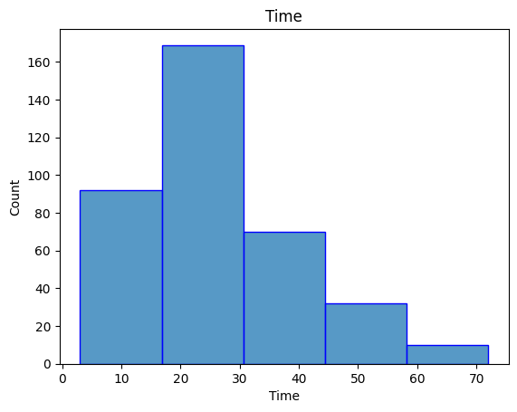

### 4.1.3. Data Preprocess

To prepare the data for the classification model, a crucial preprocessing step is necessary to ensure the models function effectively. It is crucial to encode all features into numerical form, as models can only process numerical data. The initial step involved grouping motorcycle and car samples into a single class termed "private vehicle." The primary reason for this grouping is mainly because: the motorcycle category has a limited number of observations, and due to the dataset's relatively small size, experimenting with oversampling or undersampling techniques is impractical. Consequently, the classification task aims to predict three class labels: private vehicle, bus, and walk. Subsequently the classes were encoded into private **vehicle - 0, bus - 1 and walk - 2**.

Additionally, the impact factors (cost, convenience, safety, health, environment, parking, weather) were encoded into an ordinal scale of 1-5. More specifically the encoding is illustrated below:

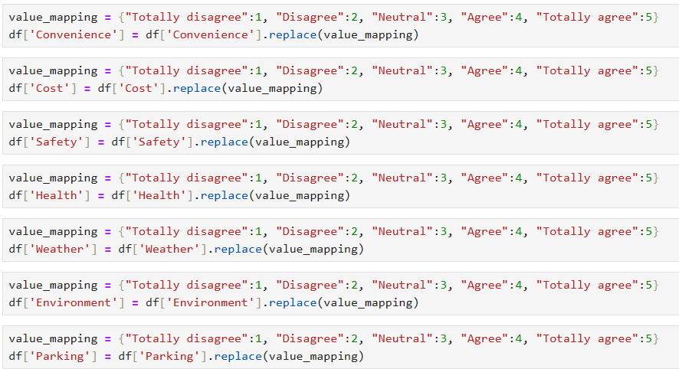

Moreover, the label encoder was applied to all binary features, indicating those with values limited to yes or no. This process essentially assigns 0 for "No" and 1 for "Yes" observations. Gender is also part of the label encoder process with 0 assigned to "Males" and 1 to "Females". The encoding for these features is illustrated below.



The last features that require encoding are Age, Income and Depart_time. However, as these features are not ordinal like the impact factors, they were encoded using the one-hot encoding process. This procedure essentially generates new binary features for each potential answer, assigning values of 0 to indicate the absence of that value in the specific row and 1 to imply the presence of that value in the row. However, before the encoding process, it is important to address the issue of low-frequency answers. Referring to the percentage tables for Age, Income, and Depart_time, there are categories with very low counts. For instance, in the Age category, "61 and more" constitutes approximately 0.54%. Similarly, in Departure_time, the categories "00.00 - 03.00" and "03.00 - 06.00" are at 0.54% and 0.80%, respectively. To mitigate the resulting dimensionality, these categories need to be initially grouped. For Age, for instance, the categories "61 and more" and "51-60" were combined into a single category, "51 and more." The process is illustrated below.

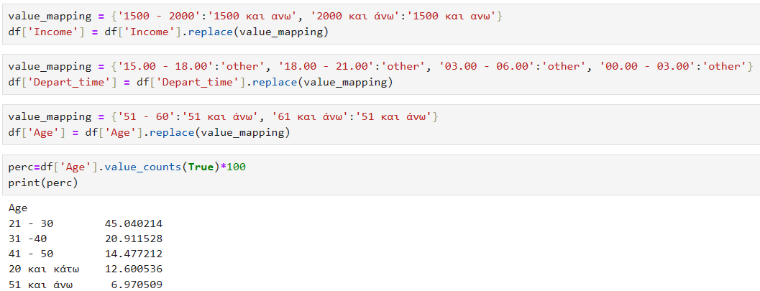

Now that the categories were grouped, the features were one-hot encoded using the following process.

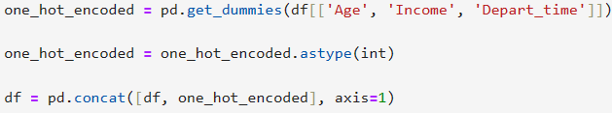

After all the encoding process, the resulting dataset comprises 373 samples and 34 features.

The next step was to display the correlation matrix. It is crucial to examine correlations among various features to determine which ones to retain and which ones to drop prior to the modelling application. These decisions rely on the correlation coefficient values, which can range from -1 to 1. Values of -1 and 1 indicate a perfect correlation (positive or negative) between variables, potentially leading to multicollinearity issues that could hinder the performance of the models. Hence, highly correlated features should be eliminated before the application process.

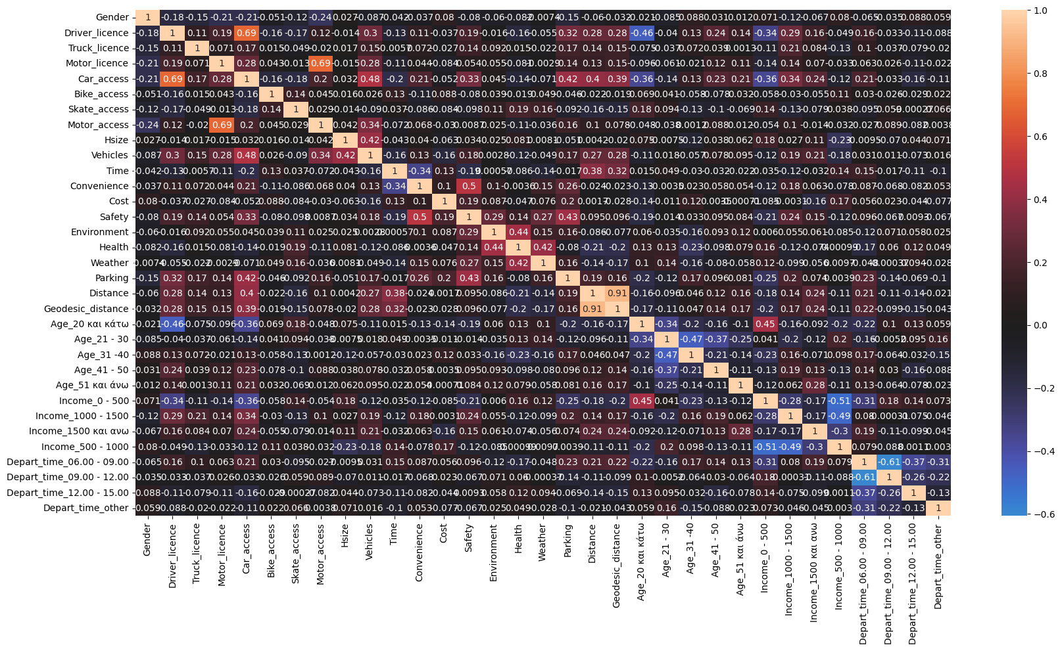

From the figure above, it is identified that there are strong correlations in a few cases. Distance and Geodesic_distance with a value of 0.91, Motor_access and Motor_licence with a value of 0.69 and Car_access and Driver_licence with value of 0.69. Hence only one of the distances will be kept (either optimal distance or geodesic one, depending on experimentation), while the 4 correlated features of Motor_access, Motor_license, Car_access, Driver_licence will be dropped. The "vehicles" feature will also be excluded because, when it takes a value of 0 (indicating no household vehicles), it introduces a bias in the classifier, making it easier to classify non-private vehicle observations. The remaining features to be input into the models amount to 28 and are depicted below. Note that the target variable y is “Mode” while the remaining features constitute the dependent variables X.

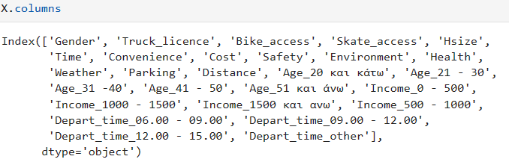

The next step of the preprocess includes data scaling. Specifically, the StandardScaler() function from the sklearn library was employed to standardise the data, effectively transforming them to possess a mean of 0 and a standard deviation of 1. This standardisation process ensures that the data share the same range and distribution, easing the handling of machine learning models.

The following step was to split the data into train and test sets. The train set will be used for training the classification models, while the remaining test set will be used to evaluate the performance of the trained models. The data split ratio was 60:40, indicating that 60% (223 instances) of the data would be used for training, and 40% (150 instances) would be used for testing. The "stratify=y" setting was employed during the split to ensure that both the training and testing sets maintain the same distribution as the original dataset. More specifically, the value counts for each class in the train set was: 78 for “private vehicle”, 75 for “bus” and 72 for “walk”. To balance the counts, random samples from “private vehicle” and “bus” were removed ensuring that all classes have an equal count of 72 instances and avoiding training bias. Therefore, the final shapes of the train and test sets are 216 and 150 respectively.

### 4.1.4. Logistic Regression

The initial model employed was that of logistic regression. The **LogisticRegression()** function of sklearn was used to create the model. The multiclass parameter was set to ‘ovr’ referring to OnevsRest scenario. The model was then fitted to the training set using the fit() command. Finally, the model was evaluated on the test set using the predict() command. The default model results, without modifying any of the hyperparameters, are illustrated below on the classification report and the confusion matrix.

|  |  |  |  |  |
| --- | --- | --- | --- | --- |
|  | Precision | Recall | F1 | Accuracy |
| Private Vehicle | 0.89 | 0.92 | 0.91 | 0.89 |
| Bus | 0.95 | 0.84 | 0.89 |
| Walk | 0.83 | 0.90 | 0.86 |
| Macro Average | 0.89 | 0.89 | 0.89 |

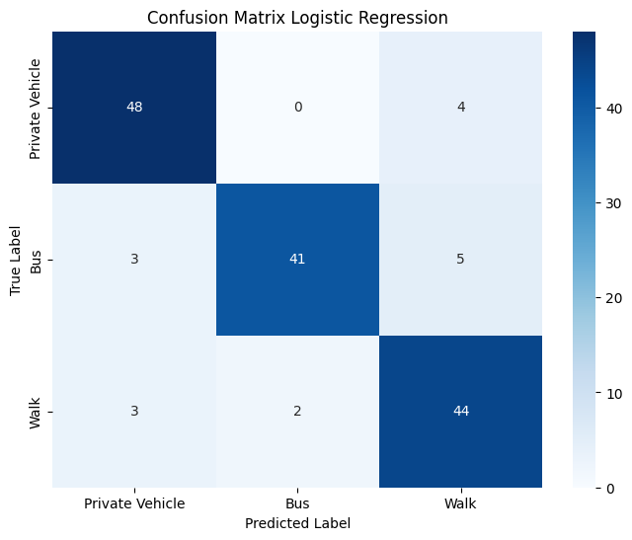

The overall accuracy of the model was 0.89, correctly predicting 133 out 150 predictions made. Taking a closer look at the predictions, for classes 0 (private vehicle) and 2 (walk), recall was 0.92 for both, indicating that for "private vehicle," the model accurately predicted 48 out of 52 cases where the true label was "private vehicle," and for "walk," the model accurately predicted 44 out of 49 cases where the true label was "walk." The most significant confusion occurred between ‘bus’ and ‘walk’, where the model misclassified 5 cases as "walk" when the real label was "Bus." In contrast, in terms of precision, “bus” has the highest with 0.95, implying that of the 43 predictions that the model made as “bus”, 41 belonged in that class.

The second step was to experiment with different parameter values to increase the overall performance of the model. The **GridSearchCV()** function was implemented so different parameter values could be tested. Grid search is a cross validation method used to find the optimal hyperparameters of the model. It works by assigning predefined values, while for each possible combination of parameters cross validation is applied meaning that the training data is split into k folds. One-fold is kept aside each time, while the other k-1 folds are used to train the model. The process is then repeated k times for a different fold to be the validation set each time. The scores (depending on scoring choice) are then averaged for a more robust estimate of the performance. The whole process is repeated for every possible combination of hyperparameters. The parameters that were tuned for the Logistic Regression model were the following:

**C: [0.6, 0.8, 0.9, 1],**

**Max_iter: [50, 70, 90, 100, 200]**

The C parameter refers to the inverse of the Regularization Strength. Regularisation adds a penalty to the training of the data to reduce the risk of Overfitting. Since C is the inverse of that, lower values of C prioritise the simplicity of the model avoiding extreme parameter values on the coefficients, while high values emphasise fitting on the data. The max iter parameter refers to the maximum number of iterations the solver uses to converge. It is essentially the iterations that the model uses to find the optimal solution. Generally, smaller datasets require a lower number of iterations compared to large datasets. It is possible though, that without tuning the number of iterations to miss on a possible optimal solution for the problem.

Following the configuration of hyperparameters, the GridSearch function was executed utilising accuracy as the scoring metric and employing a 10-fold cross-validation. The optimal parameters were found to be: **C = 0.6**, and **max_iter = 50**. The model with the best parameters was then retrieved from GridSearch using the **best_estimator_** command, which was consequently used for evaluation on the test set. The results are illustrated below.

|  |  |  |  |  |
| --- | --- | --- | --- | --- |
|  | Precision | Recall | F1 | Accuracy |
| Private Vehicle | 0.89 | 0.94 | 0.92 | 0.89 |
| Bus | 0.95 | 0.84 | 0.89 |
| Walk | 0.85 | 0.90 | 0.87 |
| Macro Averrage | 0.90 | 0.89 | 0.89 |

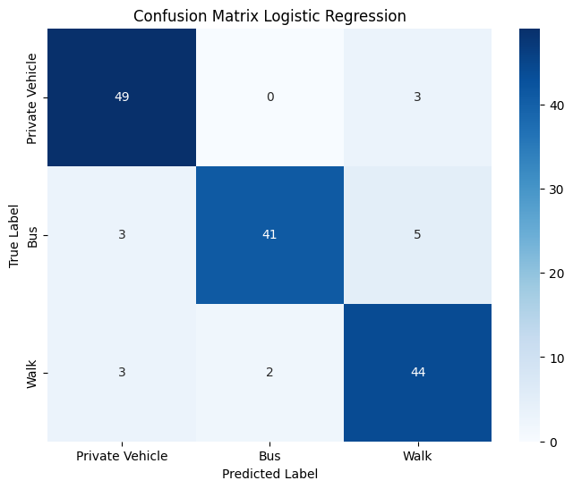

Using the tuned model, the overall accuracy remained the same at 0.89%. Examining the individual class performances more closely, the recall for "private vehicle" increased from 0.92 to 0.94, indicating that 49 out of 52 cases where the true label was "private vehicle" were correctly retrieved. Precision was also increased for class ‘walk’ as it increased from 0.83 to 0.85. Performance for class “bus” remained the same. Overall, the tuned model is slightly improved in terms of class-specific metrics. Also, to check the generalisability of the model, the training accuracies were computed for both the default and the tuned model. The accuracies were found 0.93 and 0.92 respectively. It is identified though that for the tuned model the training accuracy dropped while the test one remained intanct (0.92 and 0.89) compared to (0.93 and 0.89) indicating better generalisability to new unseen data.

Furthermore, using the **LogisticRegression.coef_** the feature coefficients for the tuned model were retrieved. Contrary to the standard binomial logistic regression model, in the multiclass setting, each class is assigned different feature coefficients. The coefficients show the average change in the log odds of the target variable in retention to a one-unit increase in the predictor variable, providing that all the other variables remain unchanged. Since it is more common to use the actual odds instead of the log odds, the formula for the calculation is : **odds = e^β**, where β represents the respective coefficient.

**Class 0 = Private Vehicle,**

**Class 1 = Bus**

**Class 2 = Walk**

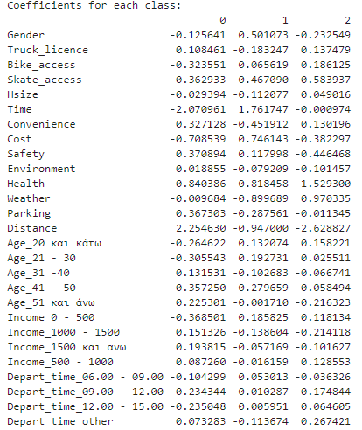

Looking at bus (class 1) and time feature, the coefficient is 1.76. This essentially indicates that for a 1-minute increase, providing that all other features remain constant, the log odds of taking the bus are increased by 1.76. Consequently, the odds for taking the bus are increased by e1.76 **= 5.81.** Looking at “walk” (class 2) and distance feature, the coefficient is -2.63. The negative value indicates that for every increase of 1 unit in distance the log odds of walking to work are decreased by 2.63. Consequently, the odds for walking are decreased by e-2.63 **= 0.072**. The same procedure could be followed for every coefficient available. It is identified that time and distance have high coefficients regardless of the class implying a significance for predicting the class. Following are the impact factors that differentiate for each class. For instance, the coefficient of health when the class is “walk” is equal to 1.53. In contrast, when the class is “bus” the cost coefficient is equal to 0.75.

The second experimentation was to drop most of the features and repeat the hyperparameter grid search. The new set of features that were selected are illustrated below.

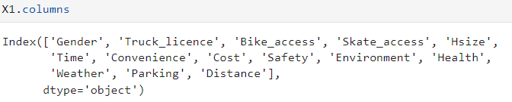

After rerunning GridSearchCV() function using the predefined values, the new hyperparameters were found to be: **C = 0.6** and **max_iter = 50**. The best tuned model with the new set of features was then evaluated on the test set. The results of the classification report and the confusion matrix are illustrated below:

|  |  |  |  |  |
| --- | --- | --- | --- | --- |
|  | Precision | Recall | F1 | Accuracy |
| Private Vehicle | 0.82 | 0.88 | 0.85 | 0.85 |
| Bus | 0.91 | 0.88 | 0.90 |
| Walk | 0.83 | 0.80 | 0.81 |
| Macro Average | 0.86 | 0.85 | 0.85 |

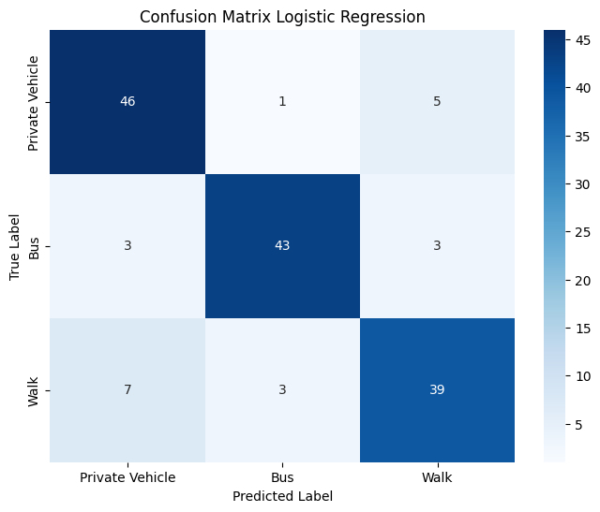

The overall accuracy of the revised model, featuring fewer features, decreased from 0.89 to 0.85. For the "bus" class, the model accurately predicted 43 instances out of 49 (88%) when the true label was "bus". In contrast, for the "private vehicle" class, the model correctly predicted 46 out of 52 true labels, a slight drop from the previous model that accurately predicted 49 out of 52. The significant difference is for “walk” class where precision dropped from 0.85 to 0.83, while recall also dropped from 0.90 to .80. This is also evident from the confusion matrix where the model predicted 7 instances as “private vehicle” when the true label was “walk”. The new feature coefficients for each class are depicted below.

Overall, reducing the features did not improve the performance of the model.

The last experimentation was swapping the Distance feature with the Geodesic_distance. Again, a grid search was run to tune the parameters for the new model. The new optimal parameters were found to be **C = 0.7** and **max_iter = 50** with a **validation accuracy of 0.834**. The best model was then evaluated on the test set. The results are illustrated below.

|  |  |  |  |  |
| --- | --- | --- | --- | --- |
|  | Precision | Recall | F1 | Accuracy |
| Private Vehicle | 0.83 | 0.83 | 0.83 | 0.82 |
| Bus | 0.87 | 0.82 | 0.84 |
| Walk | 0.77 | 0.82 | 0.79 |
| Macro Average | 0.82 | 0.82 | 0.82 |

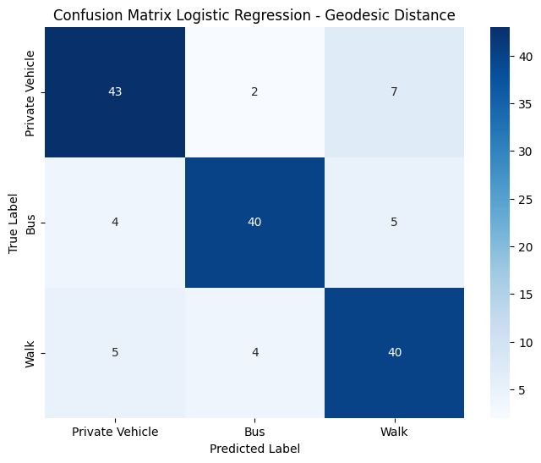

The overall accuracy of the model, compared to the best Logistic Regression model, has dropped from 0.89 to 0.82. The performance for class “walk” has also decreased as both precision and recall dropped at 0.77 and 0.82 respectively. The metrics for classes “private vehicle” and “bus” have also slightly dropped using the Geodesic distance. The biggest misclassification occurs between “walk” and “private vehicle” as the model predicted 7 instances as “walk” while their true label was “private vehicle”. Overall, swapping the distance features dropped the performance of the classifier significantly.

### 4.1.5. Decision Tree

The second model that was applied was that of the decision tree. The DecisionTreeClassifier(random_state = 42) function was used to create the model. The random_state parameter controls the randomness and ensures reproducibility in the results. The model was fitted on the training set using the fit() command and consequently evaluated on the test set using the predict() command. The results are illustrated below.

|  |  |  |  |  |
| --- | --- | --- | --- | --- |
|  | Precision | Recall | F1 | Accuracy |
| Private Vehicle | 0.96 | 0.85 | 0.90 | 0.88 |
| Bus | 0.87 | 0.84 | 0.85 |
| Walk | 0.82 | 0.96 | 0.89 |
| Macro Average | 0.88 | 0.88 | 0.88 |

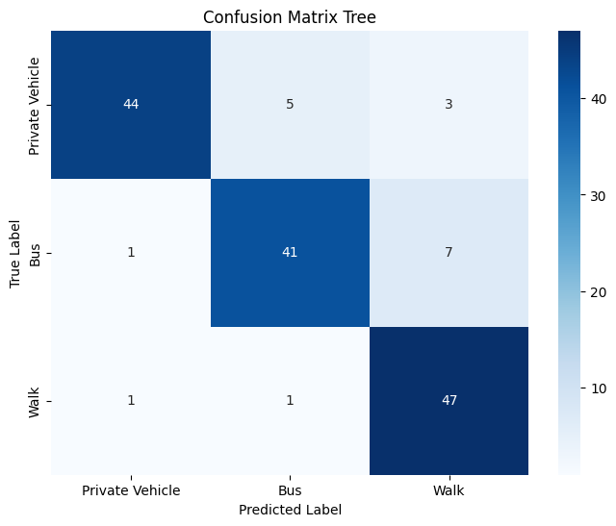

The overall accuracy of the model is 0.88 while the max_depth of the tree was found to be 7. The max depth parameter controls the maximum possible length of the path from the root node to a leaf node. The model correctly predicted 47 out of 49 (0.96) instances as “walk” when the true label was “walk”. For classes “private vehicle” and “bus” recall was found 0.85 and 0.84 respectively. The highest precision is for class “private vehicle” (0.96) indicating that of the 46 predictions the model made as “private vehicle” 44 belonged in that class. The biggest misclassification occurs between walk and bus categories, where the model predicted 7 instances as “walk” while the true label was “bus”. However, although the model's performance appears satisfactory, the training accuracy is 1 (100%), suggesting an overfitting issue. To address this concern, a 10-fold cross-validation was implemented to assess whether tree pruning, which involves reducing the size of the tree, enhances the model's performance. The results of cross validation are presented below.

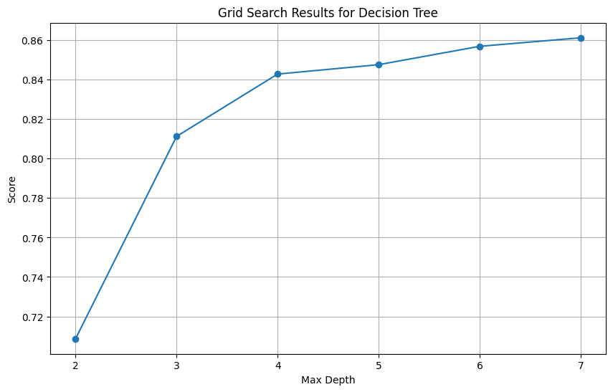

The results from the cross-validation process does not seem to improve with lower max_depth values lower than 7, which was the original depth of the tree. Hence, additional parameters were tested. More specifically, min_samples_split and min_samples_leaf parameters were also tuned via GridSearchCV() function. Min_samples_split refers to the number of samples required to split an internal node. In contrast, min_samples_split refers to the number of samples required to be in a leaf mode. The set of parameters for the validation process are depicted below:

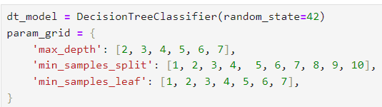

The validation process wielded the following results:

**max_depth = 7**, **min_samples_split = 8**, **min_samples_leaf = 3**, with the validation score being at **0.889 overall accuracy**. The best model was then retrieved and evaluated on the test set. The results along with the pruned tree structure are depicted below.

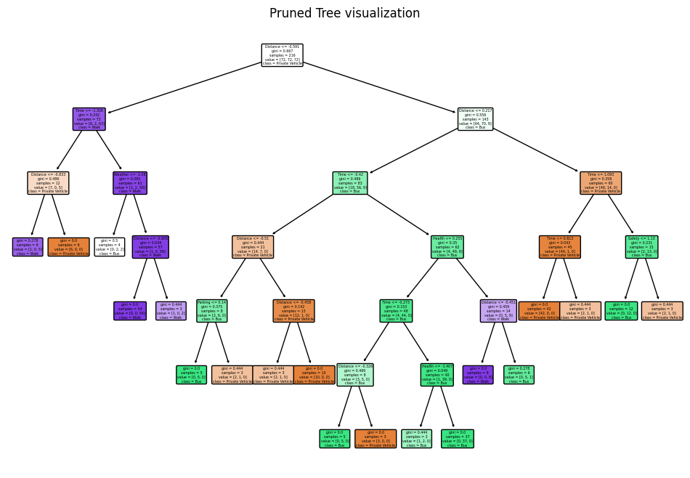

|  |  |  |  |  |
| --- | --- | --- | --- | --- |
|  | Precision | Recall | F1 | Accuracy |
| Private Vehicle | 0.96 | 0.87 | 0.91 | 0.89 |
| Bus | 0.88 | 0.86 | 0.87 |
| Walk | 0.85 | 0.96 | 0.90 |
| Macro Average | 0.90 | 0.89 | 0.89 |

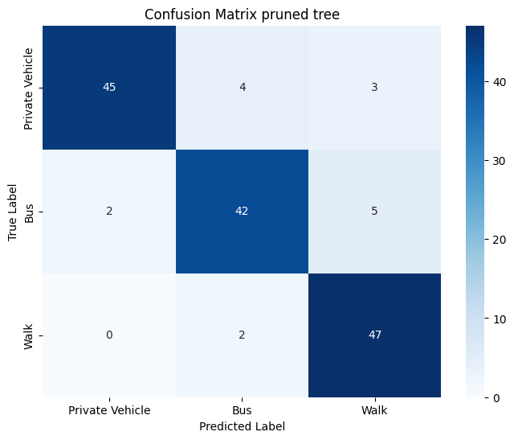

The overall accuracy of the decision tree increased from 0.88 to 0.89 (134 out of 150 instances). Simultaneously, the training accuracy decreased from 1 to 0.95. Compared to the original tree, recalls for both "private vehicle" and "bus" increased from 0.85 and 0.84, respectively, to 0.87 and 0.86. Furthermore, the precisions for "bus" and "walk" also increased from 0.87 and 0.82 to 0.88 and 0.85, respectively. The most significant misclassification occurred for "walk" and "bus" labels, where the model predicted 5 instances as "walk," but the true label was "bus."

Finally, the feature importances of the model were retrieved using the feature_importances_ function. Results are illustrated below:

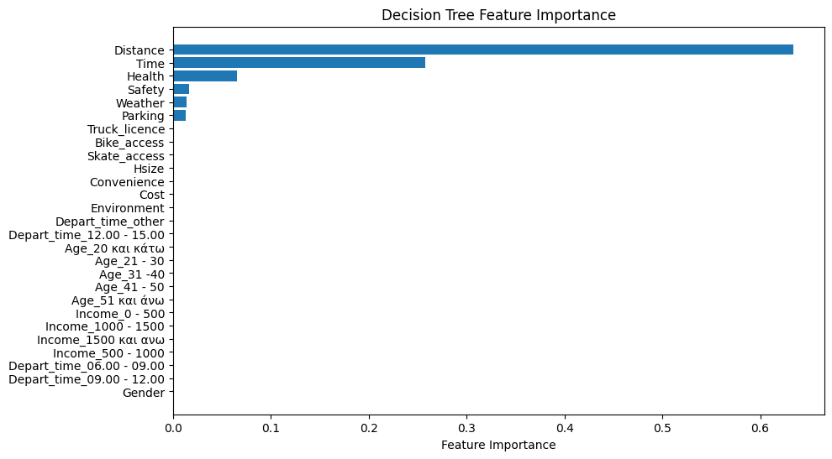

The feature importance essentially shows how much influence each feature has on prediction and more specifically, how much each feature contributed to the splits that the tree made. The plot above reveals that Distance and Time features are identified as the most crucial factors for the models, closely followed by Health. It is noteworthy that only six features out of the 27 available were selected to construct the decision tree.

The last experimentation was using the Geodesic_distance instead of the Distance feature.

A new grid search was run for the new tree to tune the parameters again. The optimal parameters for the new tree were **max_depth = 8**, **min_samples_leaf = 2**, **min_samples_split = 2** and a **validation accuracy of 0.773**. The model was then evaluated on the test set. The results are illustrated below.

|  |  |  |  |  |
| --- | --- | --- | --- | --- |
|  | Precision | Recall | F1 | Accuracy |
| Private Vehicle | 0.76 | 0.71 | 0.73 | 0.72 |
| Bus | 0.61 | 0.73 | 0.67 |
| Walk | 0.83 | 0.71 | 0.77 |
| Macro Average | 0.73 | 0.72 | 0.72 |

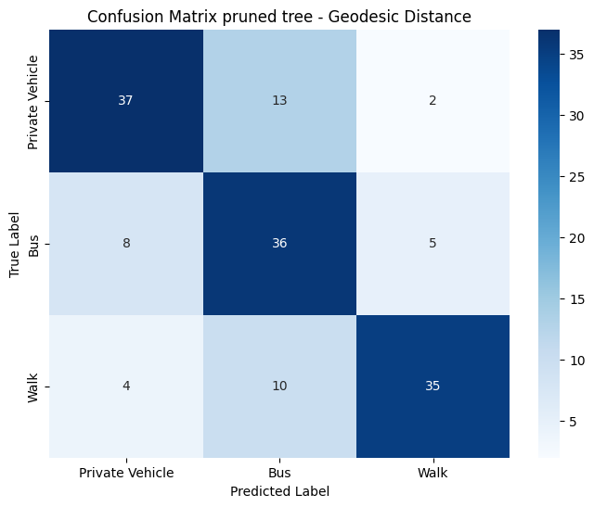

The accuracy of the model using the geodesic_distance significantly dropped from 0.89 down to 0.72. The performance for each individual class has also drastically dropped compared to the previous model. The biggest misclassification occurs between “bus” and “private vehicle” as the model predicted 13 instances as “bus” while the true label was “private vehicle”. High misclassification also occurs between “walk” and “bus” as the model predicted 10 instances as “bus” while the true label was “walk”. Overall swapping the distance metrics drastically reduced the performance of the decision tree. The feature importance was also retrieved to evaluate the differences with the previous model.

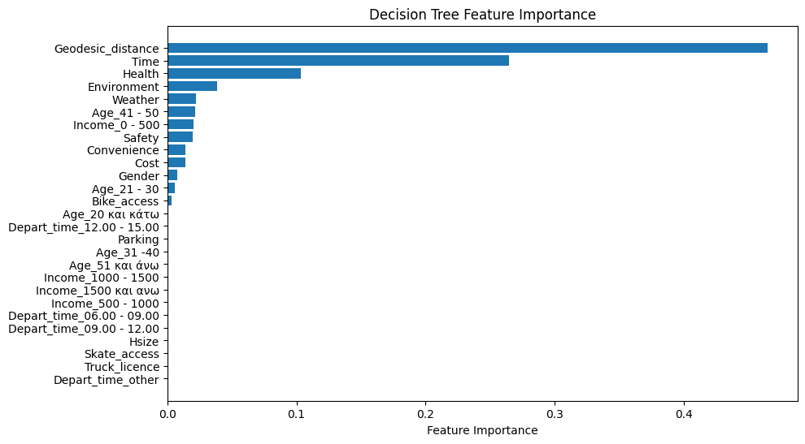

Comparing the feature importances, it is identified that while Geodesic distance is still the most important feature followed by Time and Health, 13 features were selected in total to construct this tree compared to 6 features that were selected for the previous tree construction.

### 4.1.6. Random Forest

The next model that was implemented was that of Random Forest. The RandomForestClassifier() function was used to create the model. The model was fitted on the training data, followed by evaluation on the test set. The results are illustrated below:

|  |  |  |  |  |
| --- | --- | --- | --- | --- |
|  | Precision | Recall | F1 | Accuracy |
| Private Vehicle | 0.80 | 0.87 | 0.83 | 0.84 |
| Bus | 0.88 | 0.78 | 0.83 |
| Walk | 0.84 | 0.88 | 0.86 |
| Macro Average | 0.84 | 0.84 | 0.84 |

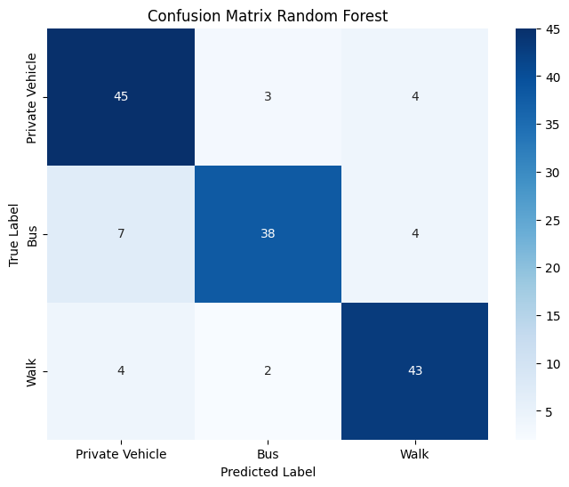

The overall accuracy of the basic model is 0.84, correctly predicting 126 out of 150 total instances. The most significant misclassification occurs between the "bus" and "private vehicle" classes, where the model predicted 7 instances as "private vehicle" while the true label was "bus." Additionally, the model accurately predicted 38 out of 49 cases as "bus" when the true label was "bus." The model appears to perform worse than the individual tree, while the training accuracy was found to be 1, indicating an overfitting problem. The default values of the model are max_features = "auto" and n_estimators = 100. The max_features parameter refers to the number of features considered each time a split occurs on the decision tree, while “auto” is the square root of the total number of features. In contrast, the n_estimators refer to the number of trees the model builds. Similar to the decision tree, the GridSearchCV() function was used to tune the model and find the optimal parameters. The process was run for each parameter individually to identify optimal area for a final grid search. For max features the range was set between 2 and 27. The validation results are depicted below.

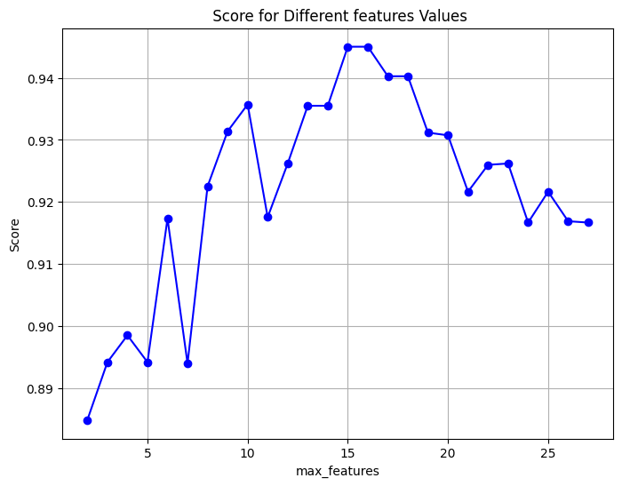

Looking at the plot above, it is evident that the validation accuracy improves when the number of features is set to 15 or 16. The next parameter tuned was the number of estimators. The range was set between 50 and 400 number of trees. The validation results are illustrated below.

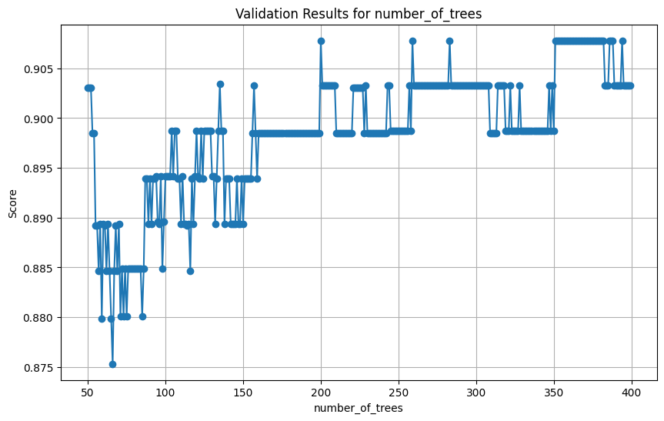

The optimal area, where the validation accuracy is higher, is between 200 and 400 number of trees. For tuning the final model, a final grid search was performed using the following parameters. Although the validation accuracy remains sufficiently high up until 400 trees, the upper limit for the number of estimators was set at 300 to mitigate the risk of overfitting.

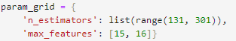

The results of the final grid search were **max_features = 16** and **n_estimators = 233** with **validation accuracy of 0.954**. The validated model was then evaluated on the test set. The results are illustrated below.

|  |  |  |  |  |
| --- | --- | --- | --- | --- |
|  | Precision | Recall | F1 | Accuracy |
| Private Vehicle | 0.96 | 0.94 | 0.95 | 0.92 |
| Bus | 0.95 | 0.86 | 0.90 |
| Walk | 0.85 | 0.96 | 0.90 |
| Macro Average | 0.92 | 0.92 | 0.92 |

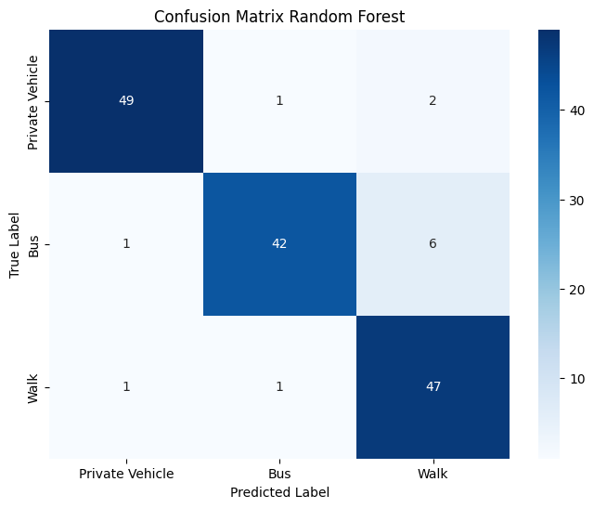

The overall accuracy of the tuned model increased from 0.84 to 0.92. Both recall and precision increased for each individual class. For “private vehicle” recall increased from 0.87 to 0.94, while precision increased from 0.80 to 0.96. For “bus” recall increased from 0.78 to 0.86, while precision increased from 0.88 to 0.95. Finally, for “walk” recall increased from 0.88 to 0.96, while precision increased from 0.84 to 0.85. The biggest misclassification is between “walk” and “bus”, where the model predicted 6 instances as “walk” while the true label was “bus”. Similarly with the decision tree, the feature importance was retrieved for the best model. The results are illustrated below.

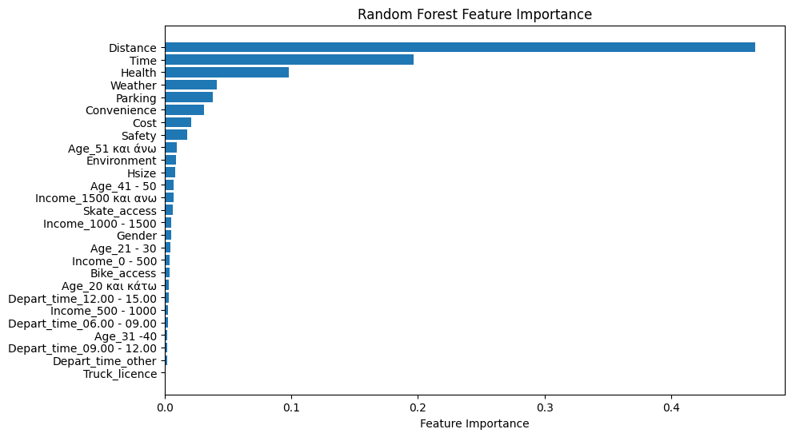

The model prioritises Distance, Time, Health, Weather, Parking, Convenience, Cost and Safety as the most crucial features. Unlike the simple tree model, the random forest has essentially utilised all parameters for split criteria, except for truck licence.

The last experimentation was swapping Distance with the Geodesic Distance feature. Again, max_features and n_estimators were the parameters that were tuned for the new model using the GridSearchCV() function. The validation results results are illustrated below.

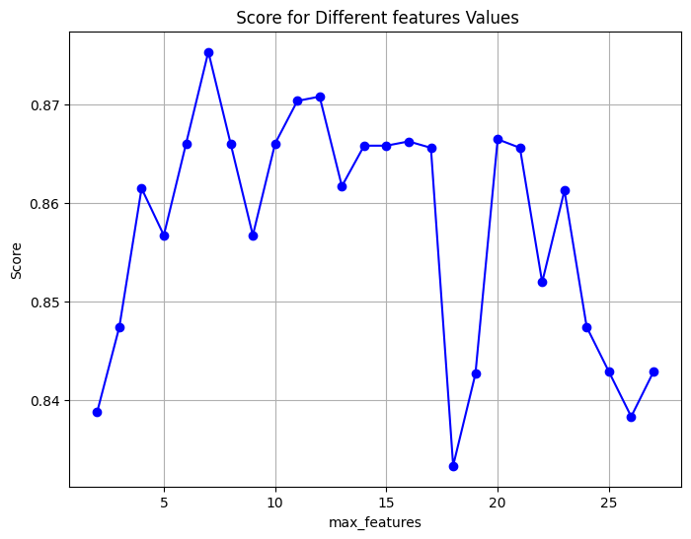

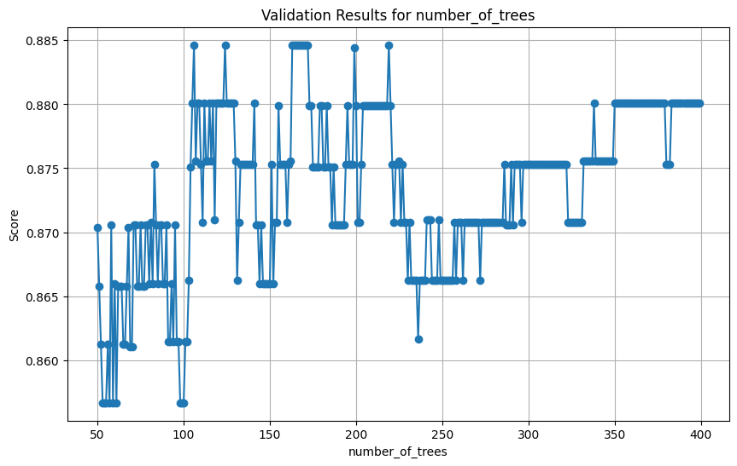

From the optimal areas identified on the plots above, a final grid search was run using the following parameter values.

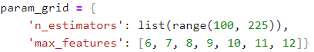

The optimal parameter values for the new model were **n_estimators = 152** and **max_features = 8** with a **validation accuracy of 0.88**. The tuned model was then evaluated on the test set. The results are depicted below.

|  |  |  |  |  |
| --- | --- | --- | --- | --- |
|  | Precision | Recall | F1 | Accuracy |
| Private Vehicle | 0.87 | 0.87 | 0.87 | 0.87 |
| Bus | 0.90 | 0.88 | 0.89 |
| Walk | 0.84 | 0.86 | 0.85 |
| Macro Average | 0.87 | 0.87 | 0.87 |

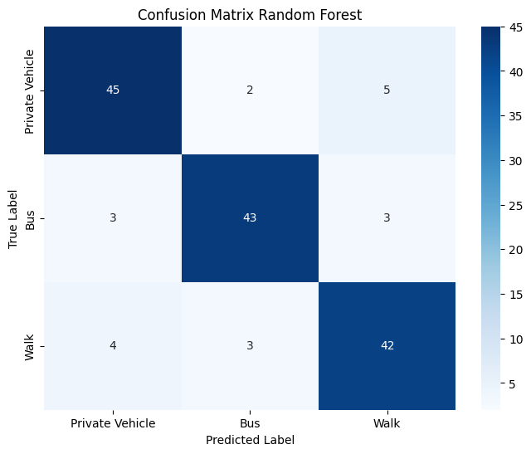

Using the geodesic distance, the overall accuracy of the model dropped from 0.92 to 0.87. Recall scores for “private vehicle” and “walk” dropped from 0.94 to 0.87, and 0.96 to 0.86 respectively. In contrast, recall for “bus” increased from 0.86 to 0.88, though precision for the same class dropped from 0.95 to 0.90. In summary, although the model exhibits superior performance compared to logistic regression and decision tree when utilising geodesic distance, it falls short in comparison to the random forest model that leverages the optimal travel distance, as demonstrated earlier. The feature importances for the model construction were also extracted. The results are illustrated in the plot below. The trend is like the previous Random Forest model, as both distances followed by time and Health are the most important features.

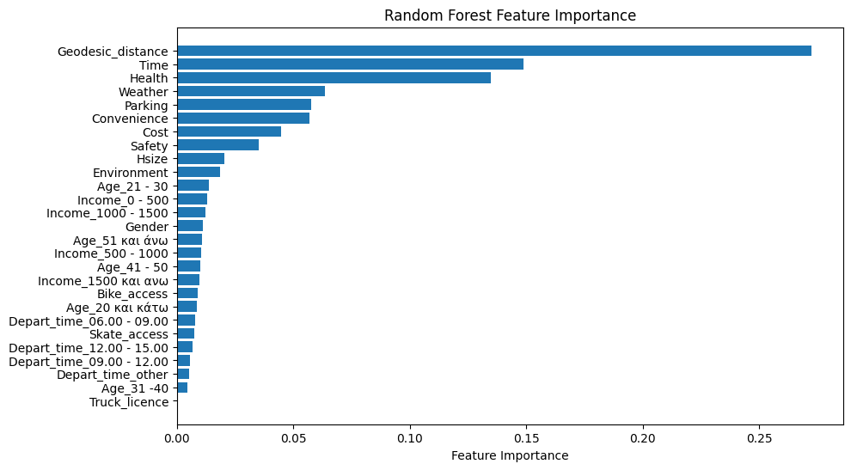

### 4.1.7. XGBoost

The next model applied was that of XGboost. The model was created using the **xgb.XGBClassifier(objective='multi:softmax', num_class=3, random_state=42)** function.

The objective=”multi:softmax” parameter indicates that the task of the model is to classify more than two classes, while the num_class = 3 parameter indicates the number of classes. Similarly to random forest, the random_state parameter is set to achieve reproducibility of the results. The model was then fitted on the training set and consequently evaluated on the test set. The results are depicted below.

|  |  |  |  |  |
| --- | --- | --- | --- | --- |
|  | Precision | Recall | F1 | Accuracy |
| Private Vehicle | 0.94 | 0.94 | 0.94 | 0.92 |
| Bus | 0.91 | 0.88 | 0.90 |
| Walk | 0.90 | 0.94 | 0.92 |
| Macro Average | 0.92 | 0.92 | 0.92 |

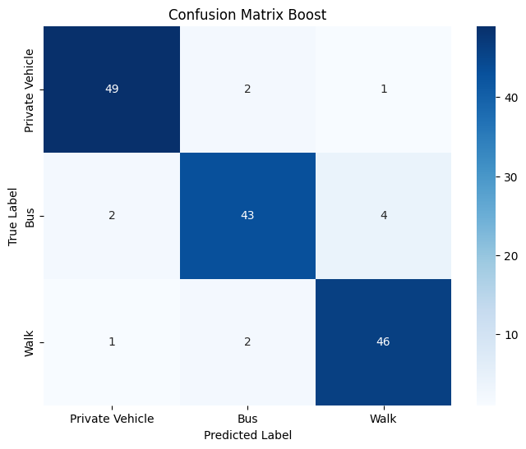

The overall accuracy of the model was 0.92, correctly predicting 138 out of 150 total instances. Recall for both “private vehicle” and “walk” was found 0.94 while precision was highest for “private vehicle” with 0.94 as well. The biggest misclassification occurs for “bus” and “walk”, as the model predicted 4 instances as “walk” while the true label was “bus”. Although the model's performance appears satisfactory, various sets of parameters were modified to assess if performance could be enhanced. The default values of the model are the following: **n_estimators = 100, subsample = 1, colsample_bytree =1 , learning_rate = 0.3**. The number of estimators refers to the number of trees built like Random Forest. The subsample parameter refers to the fraction of the training data that are sampled during the training phase. The colsample_bytree parameter refers to the fraction of features that are sampled for each tree. Finally, the learning_rate parameter refers to the contribution of each tree to the overall model, while affecting how quickly or slowly the model adapts to the patterns in the training data. Those parameters were configured through the GridSearchCV() function individually to create a final grid and evaluate the model.

Initially, a grid search was conducted to test the number of estimators within the range of 50 to 400 trees. The outcomes are illustrated below.

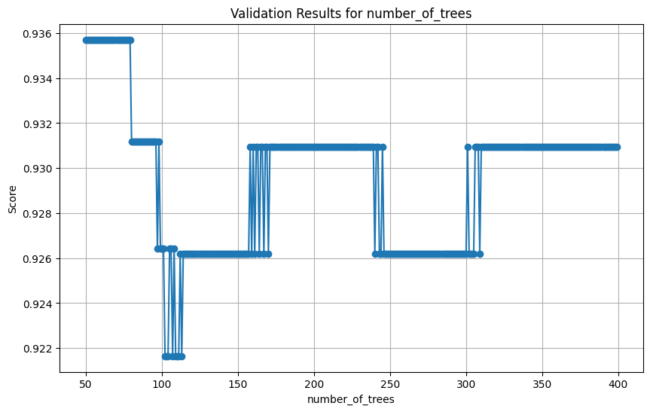

The overall validation accuracy is higher for fewer than 100 estimators between 50 and 80 number of trees. The next parameter that was tested was that of learning_rate with values from 0.1 up to 1. The results are illustrated below.

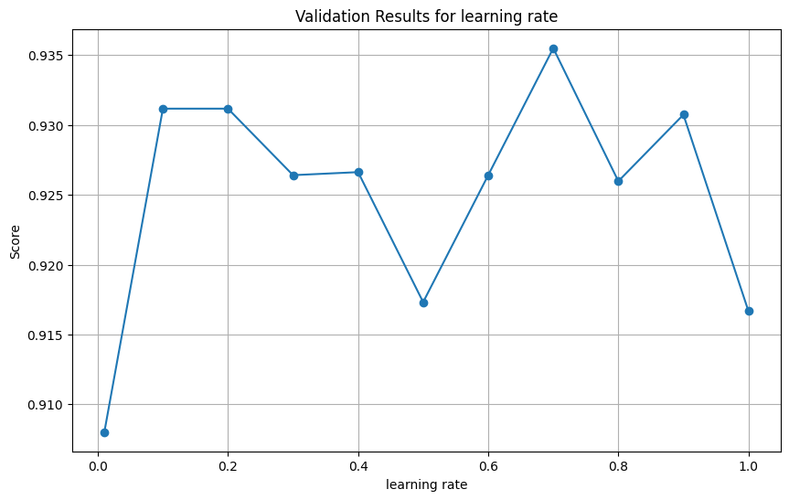

The results indicate best validation accuracy for learning_rate = 0.7, however it’s also high for learning rate values of 0.1 and 0.2. The next parameter tested was subsamples, with values from 0.1 to 1. The results are illustrated below.

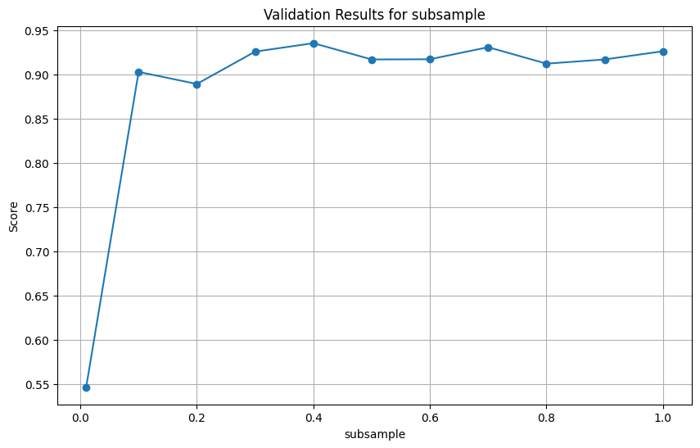

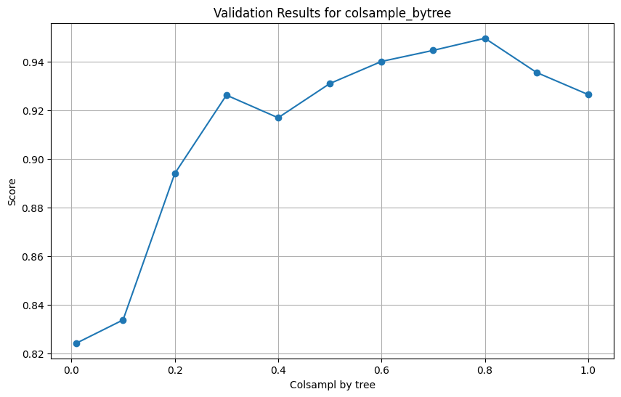It is identified that the validation accuracy is best for 0.4. However, accuracy is high for most values above 0.2. The last parameter tuned was that of colsample_bytree. The results are illustrated below.

The validation accuracy is best for colsample value of 0.8. After finding the ranges of the hyperparameters, a final grid search was performed with the following parameter values:

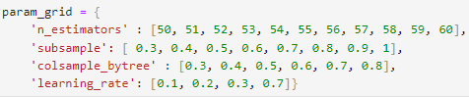

The optimal parameters values from grid search are the following: **n_estimators = 52, subsample = 0.7, colsample_bytree = 0.8, learning_rate = 0.1 and validation accuracy of 0.954**. The best model was then retrieved and evaluated on the test set. The results are depicted below.

|  |  |  |  |  |
| --- | --- | --- | --- | --- |
|  | Precision | Recall | F1 | Accuracy |
| Private Vehicle | 0.98 | 0.96 | 0.97 | 0.93 |
| Bus | 0.98 | 0.86 | 0.91 |
| Walk | 0.86 | 0.98 | 0.91 |
| Macro Average | 0.94 | 0.93 | 0.93 |

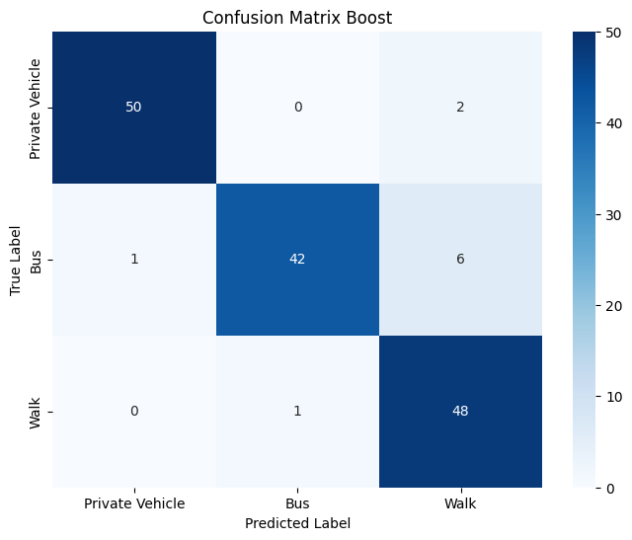

The overall accuracy of the tuned model increased from 0.92 to 0.93. For "Private Vehicle", all the metrics increased with precision (0.98), recall (0.96), and F1 score (0.97). This indicates that when the model predicts an instance as "Private Vehicle," it is highly likely to be correct, and the model effectively captures the majority of true "Private Vehicle" instances. For "Bus", precision increased from 0.91 to 0.98 while recall dropped from 0.88 to 0.86. For “walk”, precision dropped from 0.90 to 0.86, while recall increased from 0.94 to 0.98. Overall, the tuned model has slightly increased performance compared to the default model. The feature importances were also extracted for the tuned model. The results are illustrated below.

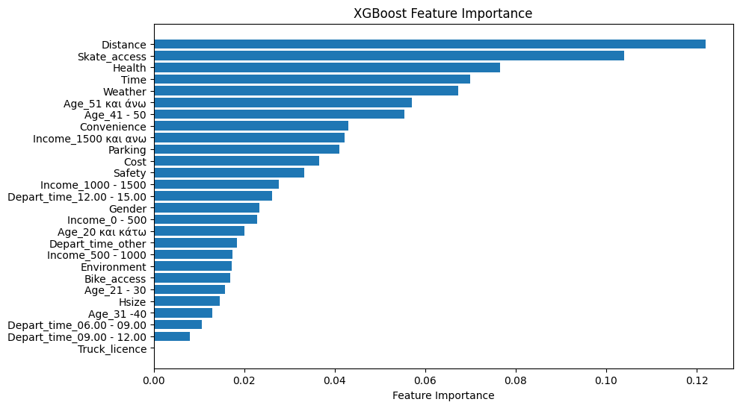

Surprisingly, the XGB model diverges from previous models in its assessment of feature importance. While Distance is still the most important factor, Skate_access is a close second followed by Health, Time and Weather. Like Random Forest, Truck_license was not used in any of the individual trees.

The last experimentation was swapping Distance with Geodesic_Distance. The same parameters were tuned for the new model using the GridSearchCV() function. The best results are illustrated below.

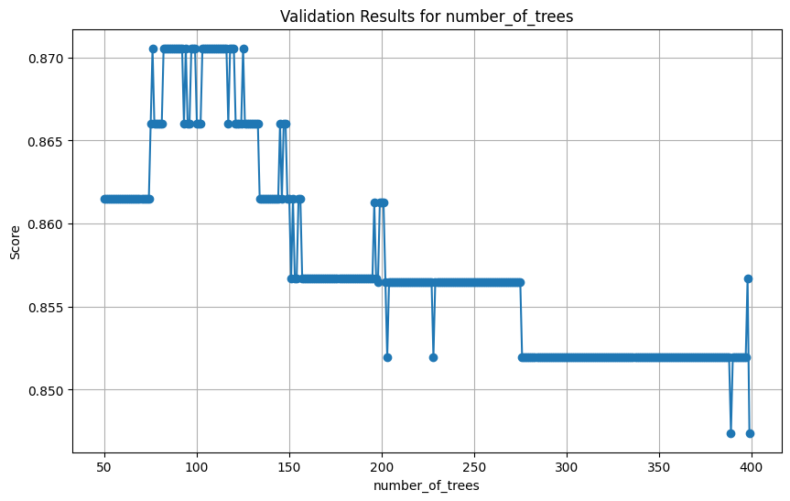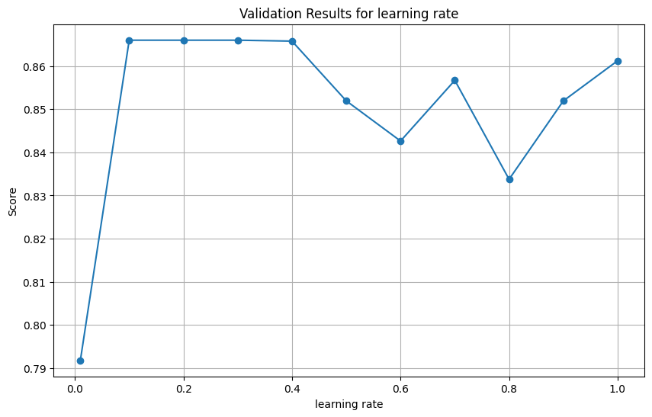

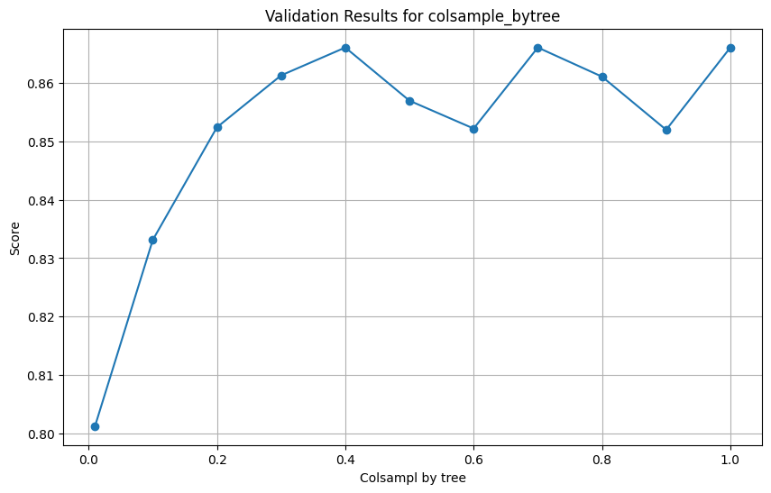

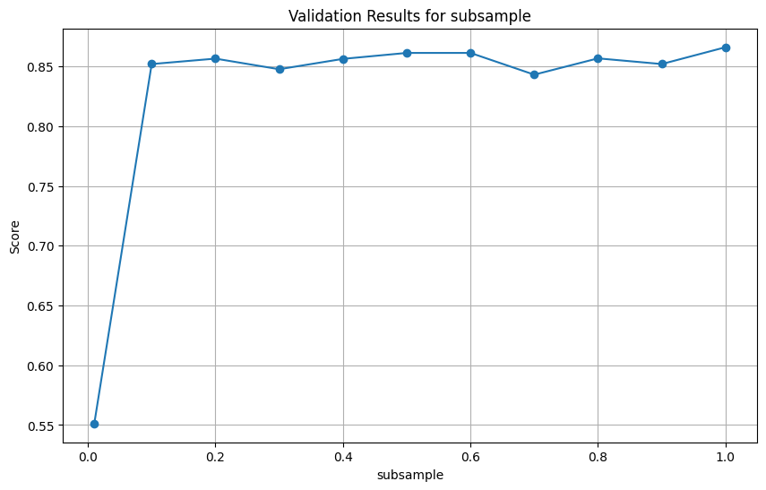

After finding the optimal areas from the plots above a final grid search was initiated to define the optimal parameters for the new model. The optimal values were **n_estimators = 69**, **subsample = 0.4**, **colsample_bytree = 0.6** and **learning_rate = 0.1** with a **validation accuracy of** **0.89**. The new model was then evaluated on the test set. The results are illustrated below.

|  |  |  |  |  |
| --- | --- | --- | --- | --- |
|  | Precision | Recall | F1 | Accuracy |
| Private Vehicle | 0.88 | 0.85 | 0.86 | 0.84 |
| Bus | 0.91 | 0.80 | 0.85 |
| Walk | 0.75 | 0.88 | 0..81 |
| Macro Average | 0.85 | 0.84 | 0.84 |

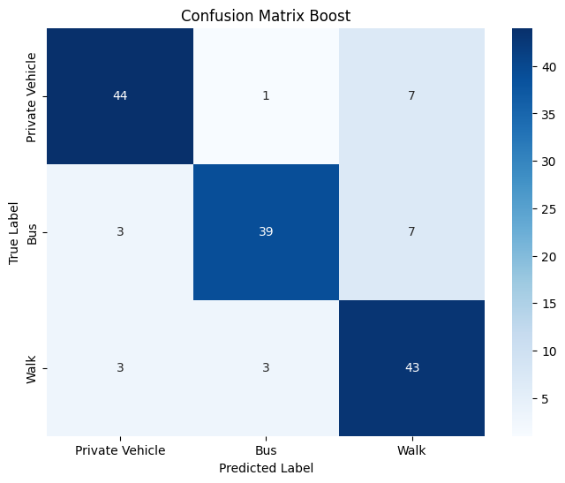

Using the Geodesic_distance, the overall accuracy significantly decreased from 0.93 to 0.84. For each individual class all the metrics also dropped indicating that the Model has problem distinguishing between classes using the geodesic distance instead of the optimal travel distance.

### 4.1.8. Stacked Model

The last model applied was a Stacked Model. Stacking occurs when multiple models are combined to create an enhanced classifier. For the stacked model to be constructed, base classifiers and a “meta” learner need to be defined. The tree-based models (Decision Tree, Random Forest and XGBoost) were used as the base estimators while Logistic Regression was used as the final estimator. The mlxtend library was used to create the model. As a first experimentation the default values for all estimators were used. The configuration of the model is illustrated below.

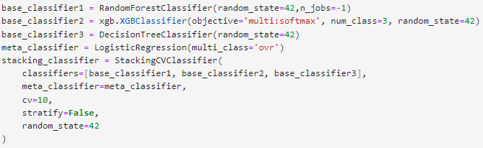

The model was initially fitted on the training set and was evaluated on the test set afterwards. The results from the test set are illustrated on the classification report and the confusion matrix below.

|  |  |  |  |  |
| --- | --- | --- | --- | --- |
|  | Precision | Recall | F1 | Accuracy |
| Private Vehicle | 0.88 | 0.96 | 0.92 | 0.91 |
| Bus | 0.95 | 0.80 | 0.87 |
| Walk | 0.90 | 0.96 | 0.93 |
| Macro Average | 0.91 | 0.91 | 0.90 |

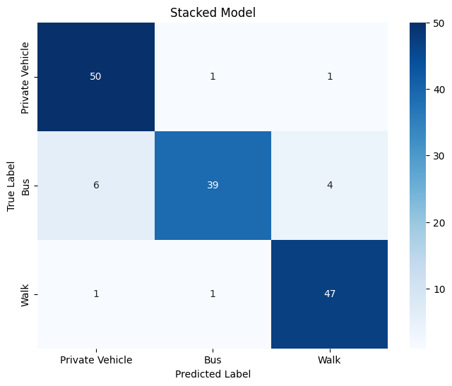

The overall accuracy of the model was 0.91. For "Private Vehicle," the model achieves high recall (0.96) and a precision of 0.88. In the "Bus" category, the precision is excellent at 0.95, while recall drops at 0.80. In contrast, walk exhibits high precision and recall with values of 0.90 and 0.96 respectively. The biggest misclassification is bus and private vehicle, where the model predicted 6 instances as private vehicle while the true label was bus.

Comparing the results to Random Forest and XGBoost models the stacked model seems to be performing worse overall and especially for the “bus” class. To improve the performance of the classifier, the optimal parameter values that were found from the previous models were used to construct the stacked one. The configuration of the new stacked model is illustrated below.

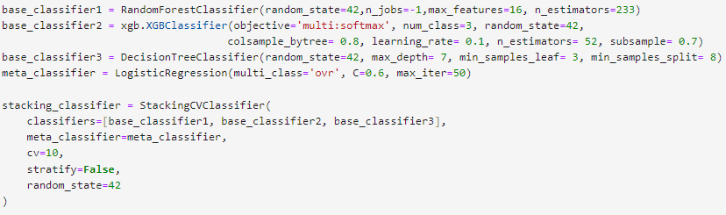

The model was initially fitted on the training set and was evaluated on the test set afterwards. The results from the test set are illustrated on the classification report and the confusion matrix below.

|  |  |  |  |  |
| --- | --- | --- | --- | --- |
|  | Precision | Recall | F1 | Accuracy |
| Private Vehicle | 0.96 | 0.94 | 0.95 | 0.92 |
| Bus | 0.95 | 0.84 | 0.89 |
| Walk | 0.86 | 0.98 | 0.91 |
| Macro Average | 0.92 | 0.92 | 0.92 |

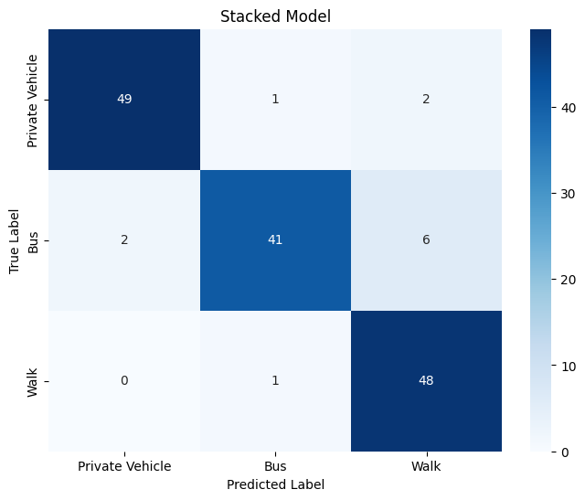

The overall accuracy of the new stacked model increased from 0.91 to 0.92. For class “private vehicle”, precision highly increased from 0.88 to 0.96, in the cost of a slight decrease in recall from 0.96 to 0.94.

For “bus”, recall increased from 0.80 to 0.84, while it also increased for “walk” from 0.96 to 0.98. In contrast precision for “walk” decreased from 0.90 to 0.86. The biggest misclassification error is between walk and bus, where the model predicted 6 instances as walk when the true label was bus. Overall, the tuned stacked model has slightly improved over the default stacked one.

### 4.1.9. Model Selection

Before assessing the model performance, the ROC curves for the best models were constructed. The ROC curve is a graphical representation that evaluates the trade-off between true positive rate and false positive rate. The curve is generated by calculating true positive rate and false positive rate values across various probability thresholds. Although these curves are typically created for binary classification scenarios, in a multi-classification task, curves are generated for each individual class using a "One vs Rest" approach. For example, in the case of the "private vehicle" class, the true positive rate signifies the ratio of correctly predicted observations belonging to that class. Conversely, the false positive rate for "private vehicle" indicates the ratio of observations falsely predicted as belonging to that class when they actually belong to any of the other classes (bus or walk). The metric representing the model's performance is the area under the curve (AUC), calculated for each class individually in a multiclass task. The AUC macro score is then derived by averaging the AUC scores for each class. This score ranges from 0 to 1, providing an overall assessment of the model's performance. The curves for the best models that were found in the previous chapters are illustrated below.

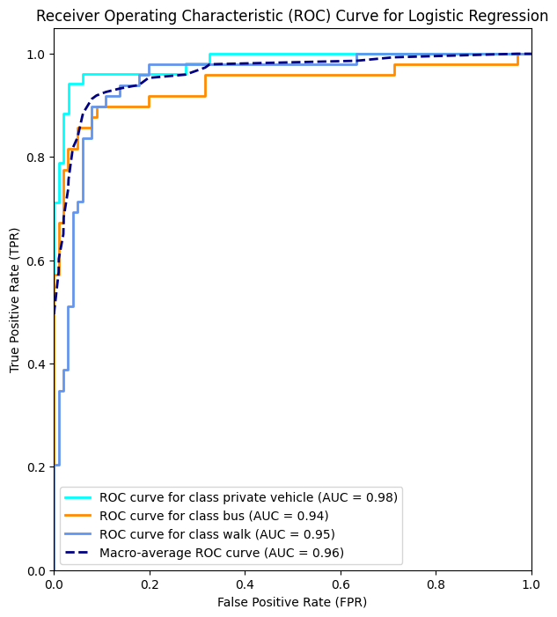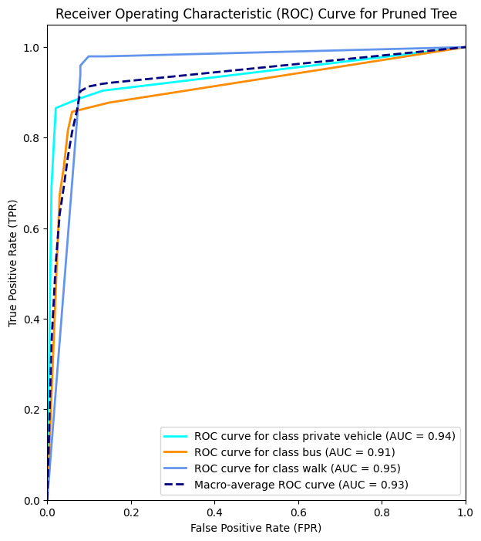

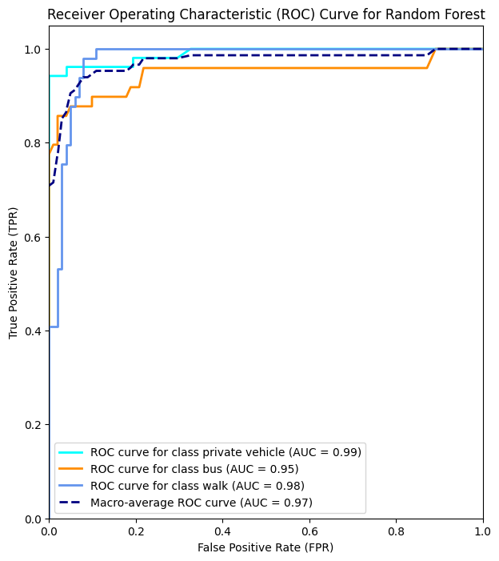

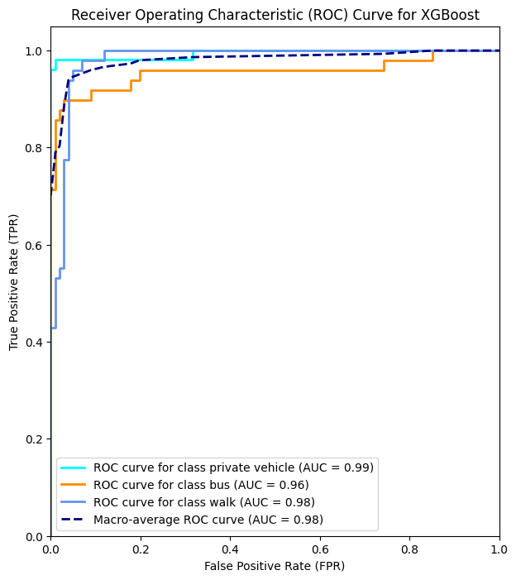

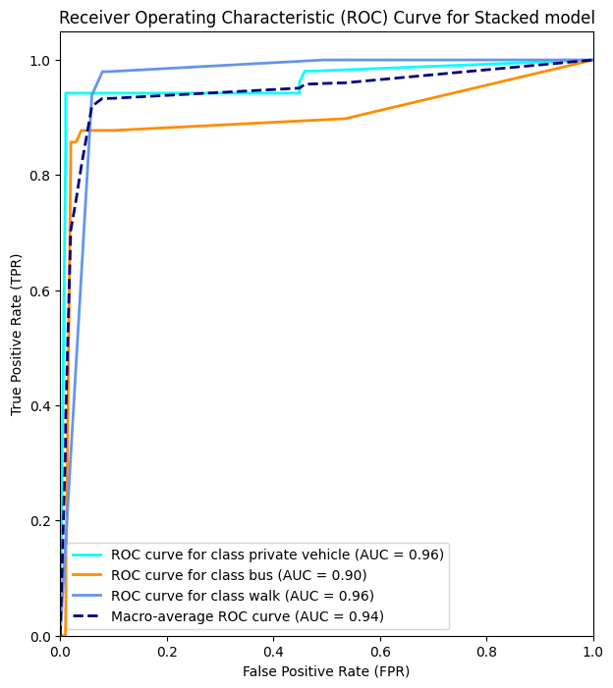

After applying the 5 models to the training set and evaluating their predicting performance on the test set, while also constructing their ROC curves, a concrete decision must be made on which model performs the best and can be trusted for prediction on new unseen data. For that purpose, a comparative table was constructed highlighting the averages of Precision, Recall, F-score, AUC between classes and the overall accuracy of the best models that were constructed.

|  |  |  |  |  |  |
| --- | --- | --- | --- | --- | --- |
|  | **Logistic Regression** | **Decision Tree** | **Random Forest** | **XGBoost** | **Stacked Model** |
| **Precision (Average)** | 0.90 | 0.90 | 0.92 | **0.94** | 0.92 |
| **Recall (Average)** | 0.89 | 0.89 | 0.92 | **0.93** | 0.92 |
| **F-Score (Average)** | 0.89 | 0.89 | 0.92 | **0.93** | 0.92 |
| **AUC (Average)** | 0.961 | 0.931 | 0.972 | **0.98** | 0.944 |
| **Accuracy** | 0.89 | 0.89 | 0.92 | **0.93** | 0.92 |

In evaluating the performance of the models, XGBoost emerges as the one with the best performance on the test set, yielding the highest precision, recall, F1-score, AUC, and accuracy. The stacked model, incorporating multiple models' predictions, closely follows XGBoost, demonstrating competitive metrics across the board. Random Forest also showcases strong performance, particularly excelling in terms of AUC compared to the stacked model. Notably, both logistic regression and decision tree models deliver respectable results, although they fall behind XGBoost, Random Forest, and the stacked model. As such, XGBoost is the model of choice for handling new, unseen data and making predictions about the transit mode for commuting to work in the city of Thessaloniki.

## 4.2. Results for case 2 - Netherlands

In this section of the Thesis, the results from the Netherlands drip diary will be presented. The initial part covers data preparation and cleaning, followed by exploratory data analysis and data preprocessing. The final segment focuses on model application, mode classification, and the selection of the best model.

### 4.2.1. Data preparation and cleaning

The initial step is to drop the “OPID” feature storing the IDs of the household, since they have no value. The values for each feature were in numerical form so it was essential to encode them back to categorical form. The procedure was followed using the Codebook guideline at: <https://ssh.datastations.nl/dataset.xhtml?persistentId=doi:10.17026/dans-zwz-fq8t> .

After categorical features were encoded, the dataset was checked for null values and duplicates to drop. Looking at the features individually, additional cleaning was required. The following picture represents the descriptive statistics for the numerical variables.

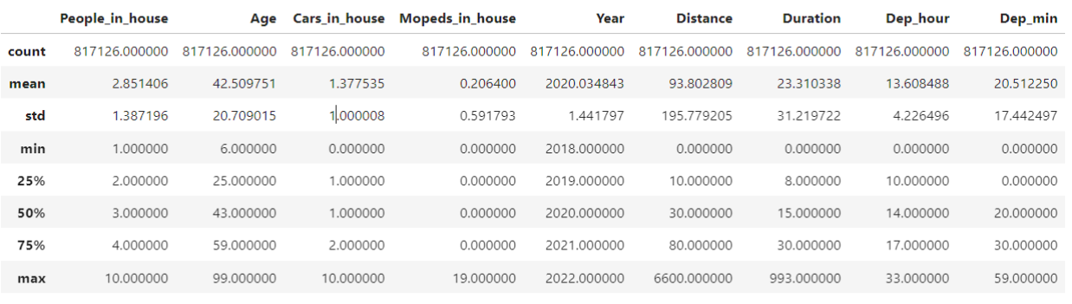

For the "Dep_hour" feature, indicating the departure hour of the trip, a maximum value of 33 was identified as erroneous. Subsequently, samples with a departure hour exceeding 23 were removed. To consolidate information about departure time, considering both hours and minutes, a new column was generated. However, to maintain consistency, it was essential to address cases where "Dep_min" had values below 10. The specific command used ensured that, for instance, if "Dep_min" had a value of 05, the new departure time column reflected this as 05 rather than 50.

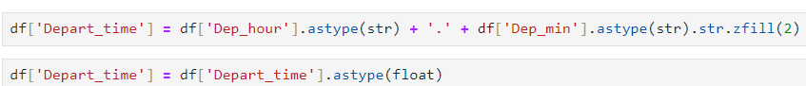

After Depart_time was created, Dep_hour and Dep_min columns were dropped.

Additionally, the Distance column measures the trip distance in hectometres. Therefore, the column values were transformed in kilometres for better handling using the following command.



From the descriptive statistics table, it was observed that the "Distance_in_kms" and "Duration" features had a minimum value of 0, indicating an error. Consequently, those specific samples were excluded from the dataset. Furthermore, only samples where the age of the trip respondent was 18 years old or older were taken into consideration.

The following picture illustrates the histograms for all the numeric variables. Also, the descriptive statistics for those features were computed again.

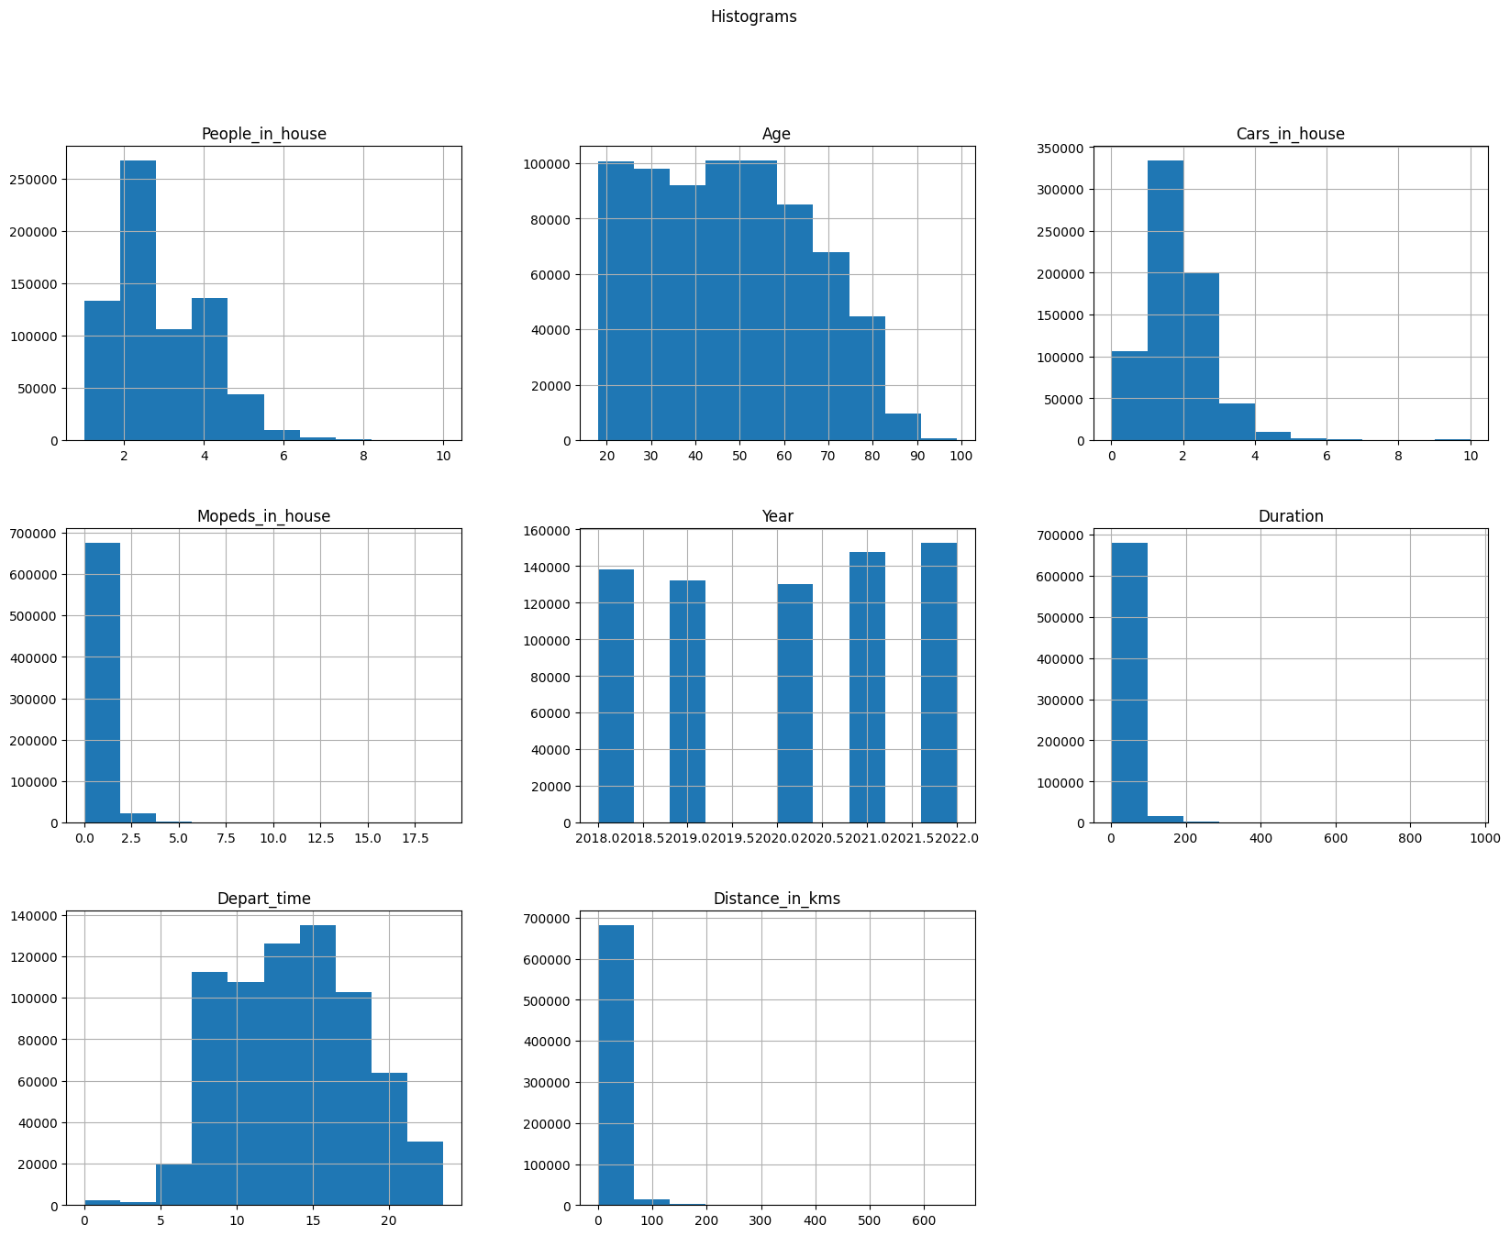

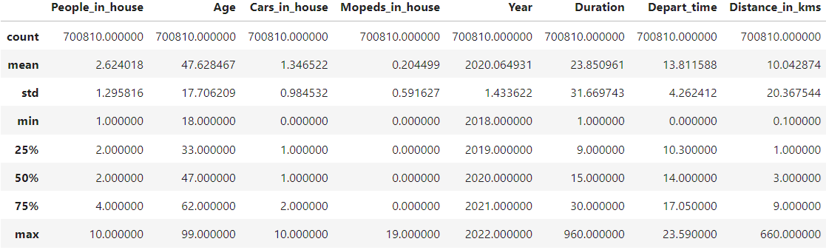

Observing both at the descriptives and the histograms, it is identified that for Distance_in_kms, Duration and Mopeds_in_house there is a presence of outliers. Therefore, samples were dropped when the Distance was above 120 kilometres. Samples were also removed when the duration of the trip was above 200 minutes. Last, samples were removed when the respondent of the trip had more than 5 mopeds in the house. The final dataset, after processing and cleaning, consists of **692055** samples and **22** features.

### 4.2.2. Exploratory Data Analysis

In this section of the Thesis the descriptive statistics for this case, along with visualisation for each feature will be presented to better understand the dataset. The first feature is about the target variable containing the transportation mode of the trip. Most trips were undertaken using a car (45,82%), either as a passenger or driver, followed by those made on a bike or on foot. Public transportation trips were significantly lower compared to other means, accounting for only 3.56%.

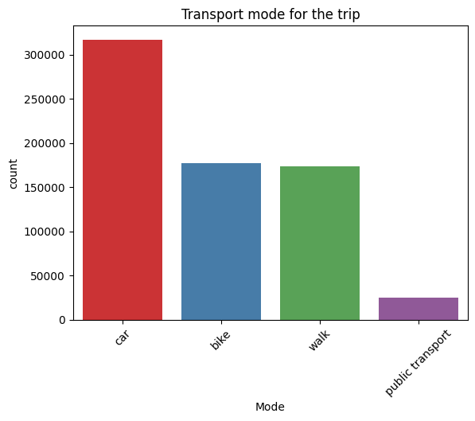

**Mode**

**car 45.82%**

**bike 25.55%**

**walk 25.07%**

**public transport 3.56%**

The next feature is about the month that the trip occurred. The outcome exhibits a balanced pattern, indicating that the trip count is consistently above 50,000 observations for each month. September stands out with the highest number of trips, representing 9.16%. In contrast, April recorded fewer trips, constituting 7.53% of the observations.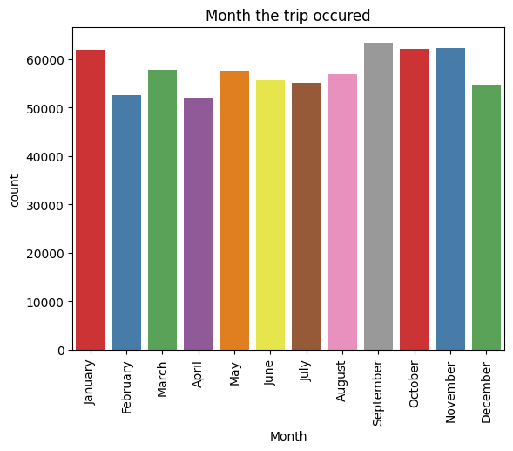

**Month**

**September 9.15%**

**November 9.00%**

**October 8.96%**

**January 8.95%**

**March 8.34%**

**May 8.32%**

**August 8.22%**

**June 8.05%**

**July 7.96%**

**December 7.89%**

**February 7.61%**

**April 7.52%**

The following feature refers to the day of the week that the trip occurred, with the trip count exceeding 90,000 observations on nearly every day. The sole exception lies in trips made on Sundays, totaling just under 80,000 observations, and representing 10.71%.

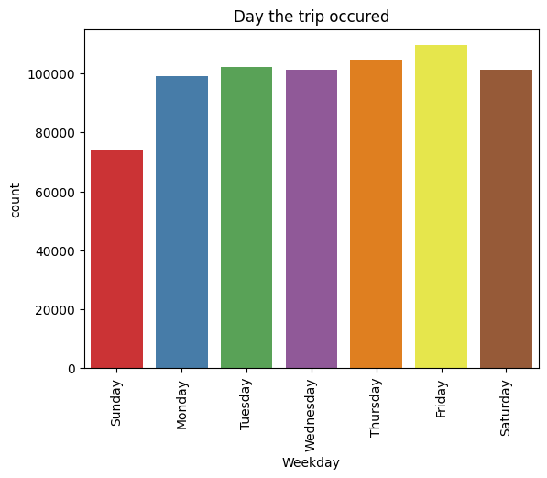

**Weekday**

**Friday 15.84%**

**Thursday 15.11%**

**Tuesday 14.76%**

**Saturday 14.62%**

**Wednesday 14.62%**

**Monday 14.34%**

**Sunday 10.71%**

The subsequent feature is about the gender of the respondent. Males account for 51.97 % of the total trips while females account for the remaining 48.03 %. 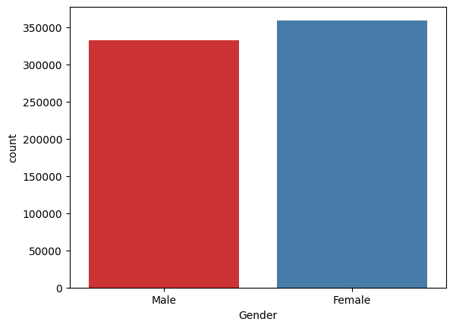

**Gender**

**Female 51.97%**

**Male 48.03%**

The following feature refers to whether the respondent of the trip has access to an electric bike. The majority of respondents account for “no” with 69.85%, while the remaining 30.15% indicates that they have access in some capacity.

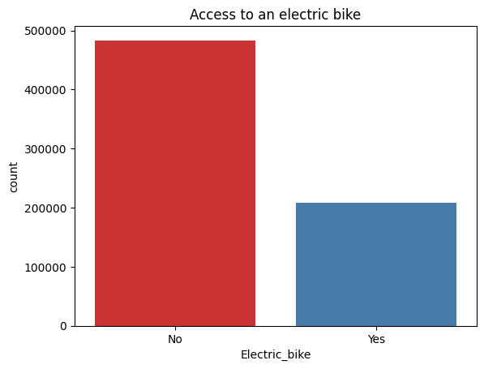

**Electric_bike**

**No 69.85%**

**Yes 30.15%**

The next feature refers to the reason for the trip. Most trips were undertaken for shopping and grocery purposes, succeeded by trips to and from work. Additionally, a substantial proportion was attributed to social and recreational activities. The least frequent observations were associated with purposes related to education, business, and personal care, each totalling around 20,000 counts. Other motives also refer to visits, tours or hiking related.

**Motive**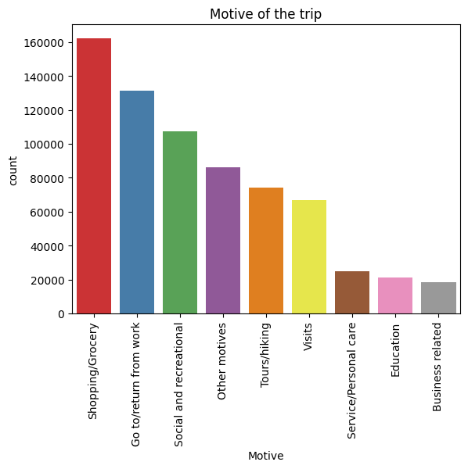

**Shopping/Grocery 23.43%**

**Go to/return from work 18.94%**

**Social and recreational 15.49%**

**Other motives 12.42%**

**Tours/hiking 10.74%**

**Visits 9.64%**

**Service/Personal care 3.58%**

**Education 3.07%**

**Business related 2.68%**

The next two features refer to the departure and arrival areas of the trip, specifically denoting various provinces in the Netherlands. Most trips occurred in the South Holland province, encompassing municipalities such as Rotterdam, The Hague, Delft, and Leiden. Many trips were also recorded in the North Holland province, including locations like Amsterdam, Haarlem, and Alkmaar. In contrast, there was a small proportion of trips where either the departure or arrival area extended outside of the country.

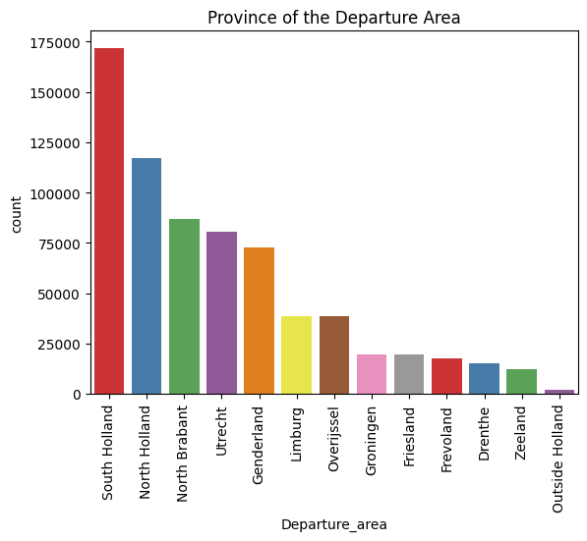

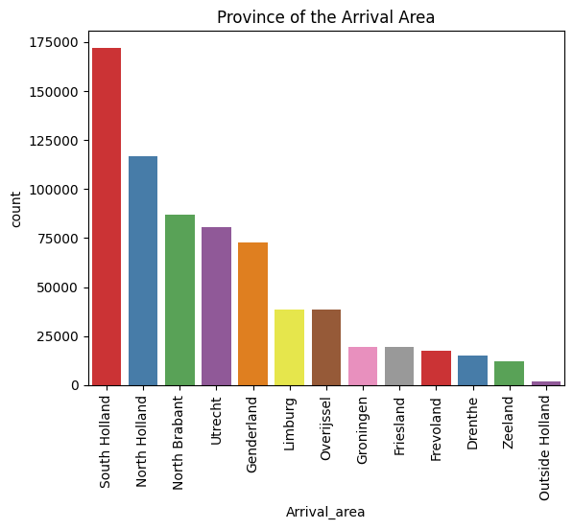

Related to the departure and arrival provinces, the subsequent features imply whether the respondent made a round trip or not. A round trip refers to a scenario where the initial point is the same as the destination point. For example, this situation arises when the respondent commences the trip from home and concludes it at home as well. Such activities may likely involve physical exercise. The plot reveals that a minimal proportion of trips were genuinely round, constituting 12.21%. Hence, most trips had distinct starting and ending locations.

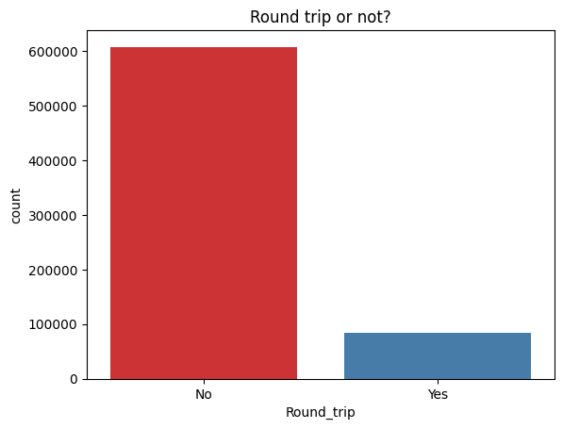

**Round_trip**

**No 87.79%**

**Yes 12.21%**

The next feature refers to the number of mopeds that the respondent of the trip has in his household. The moped is considered a motorised bicycle offering a sustainable transportation option that often involves less stringent licensing requirements compared to conventional motorcycles and automobiles. (Wikipedia, 2024). The overwhelming majority of the trips were made by respondents that had 0 mopeds in their household (84.97%).

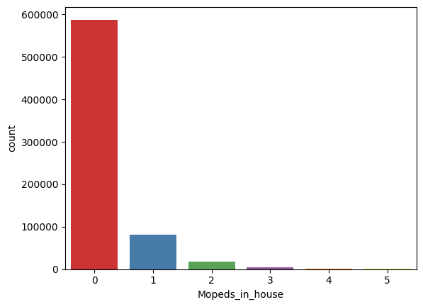

**Mopeds_in_house**

**0 84.97%**

**1 11.61%**

**2 2.56%**

**3 0.60%**

**4 0.19%**

**5 0.07%**

The following feature, same as mopeds, pertains to the count of cars in the household of the trip respondent. Most trips were undertaken by respondents with 1 or 2 cars in their homes. A substantial number of trips also involved respondents with zero cars in their households, while a smaller percentage comprised respondents with three or more cars.

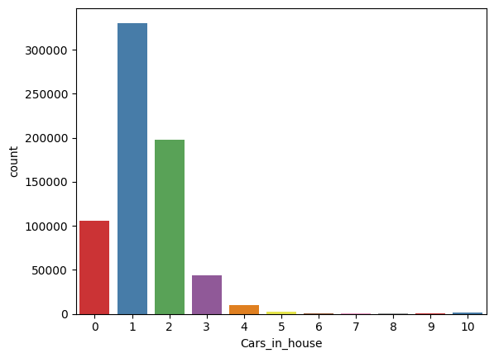

**Cars_in_house**

**1 47.74%**

**2 28.56%**

**0 15.21%**

**3 6.29%**

**4 1.48%**

**5 0.35%**

**10 0.17%**

**6 0.11%**

**7 0.04%**

**9 0.02%**

**8 0.02%**

The next feature is about whether the trip was made by respondents with a driving licence or not. The biggest proportion of trips was conducted by respondents with an active car driving licence (87.33 %).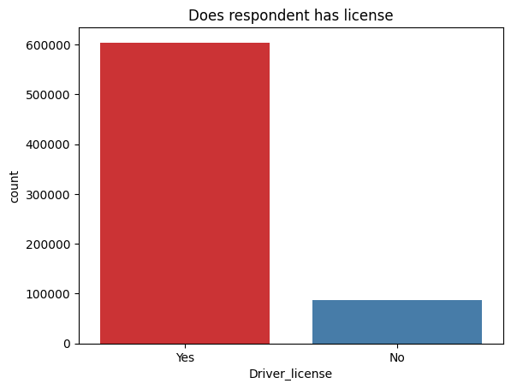

**Driver_license**

**Yes 87.33%**

**No 12.67%**

The next feature pertains to the count of people in the households of the respondents who undertook the trip. The graphical representation indicates that most of the trips were carried out by respondents with 2 household members (38.12%), including themselves. Additionally, a significant proportion reported being part of a single-member family (18.99%). The proportion diminishes for trips made by respondents with 5 or more family members in their homes.

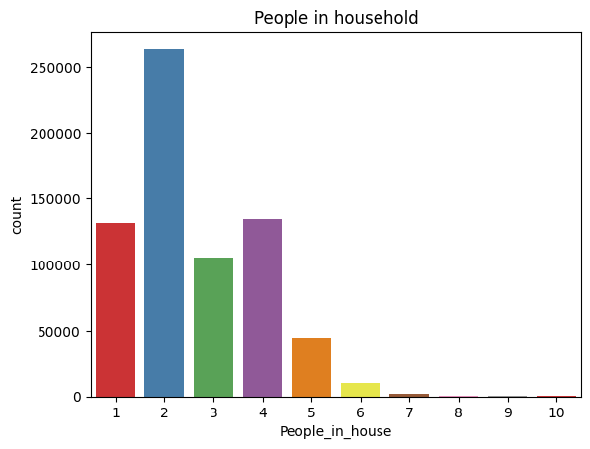

**People_in_house**

**2 38.12%**

**4 19.43%**

**1 18.99%**

**3 15.20%**

**5 6.33%**

**6 1.43%**

**7 0.33%**

**8 0.09%**

**9 0.4%**

**10 0.02%**

The graphic below illustrates the composition of households for the respondents undertaking the trips. Many trips were conducted by individuals with kids (38.86%), followed by trips conducted by individuals without kids (34.76%), in both situations living with their partners. Fewer observations occur for households with additional members beyond just the couple and kids.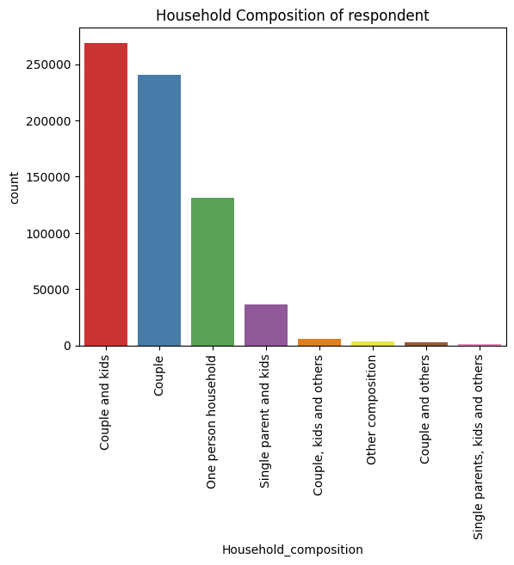

**Household_composition**

**Couple and kids 38.86%**

**Couple 34.76%**

**One person household 18.99%**

**Single parent and kids 5.28%**

**Couple, kids and others 0.88%**

**Other composition 0.57%**

**Couple and others 0.47%**

**Single parents, kids and others 0.19%**

The subsequent feature pertains to the educational background of the respondent who conducted the trip. Most respondents have completed a higher education degree (48.56%), followed by those who completed secondary education (38.85%). A smaller proportion of respondents have completed other types of education, including vocational, primary, and other forms.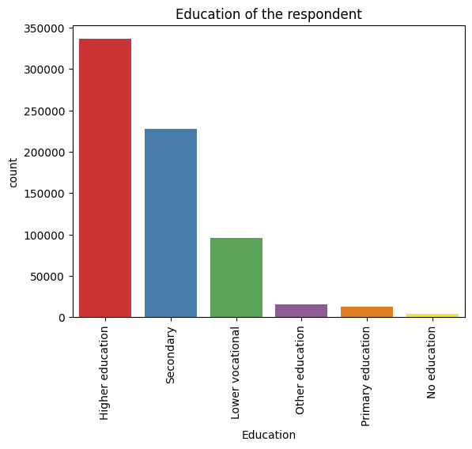

**Education**

**Higher education 48.56%**

**Secondary 32.85%**

**Lower vocational 13.80%**

**Other education 2.34%**

**Primary education 1.79%**

**No education 0.66%**

The final categorical variable pertains to the background of the respondent. The largest proportion involves trips conducted by Dutch native residents (80.14%). Other categories include trips conducted by Western immigrants (10.02%) and non-Western immigrants (9.85%). 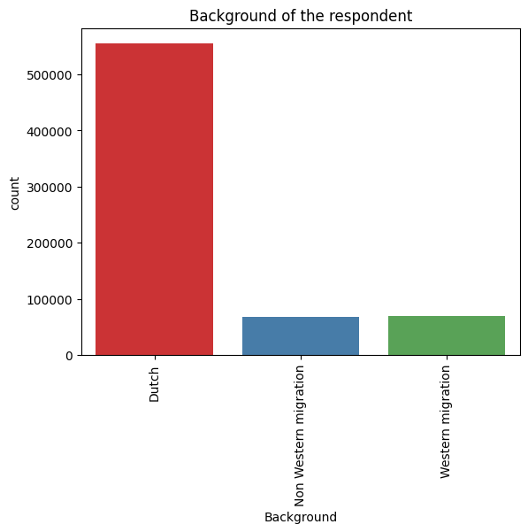

**Background**

**Dutch 80.14%**

**Western migration 10.01%**

**Non Western migration 9.85%**

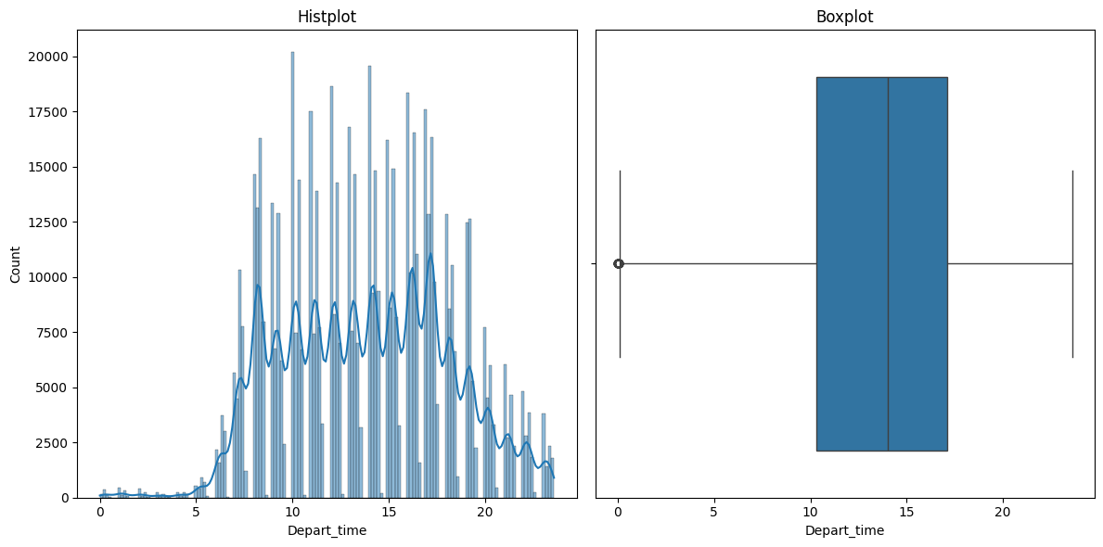

The figure depicted above showcases the histogram and boxplot of the Departure_time feature. It shows an approaching normal distribution, with most trips occurring between 10:00 and 17:00. This is further confirmed by the 25% and 75% quartiles, which were determined to be 10:30 and 17:10, respectively, as outlined in the descriptive table below.

|  |  |
| --- | --- |
|  | **Departure_time** |
| **Mean** | **13.83** |
| **std** | **4.26** |
| **min** | **00.00** |
| **25 %** | **10.30** |
| **50 %** | **14.00** |
| **75 %** | **17.10** |
| **max** | **23.59** |

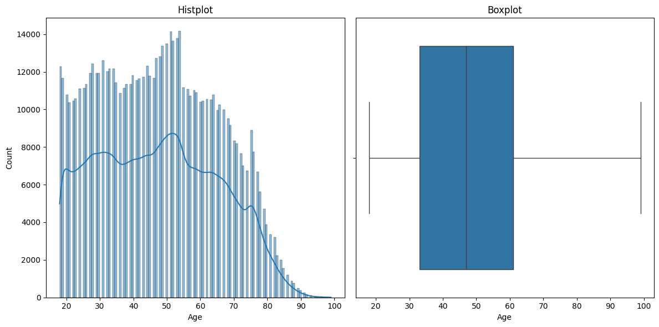

The Age of the respondents that conducted the trip reveals a mean age of 47.58, with a standard deviation of 17.71, suggesting some variability in ages. The age distribution spans from a minimum of 18 to a maximum of 99, indicating a wide range of ages in the dataset. The 1st quartile is 33, while the 3rd quartile is 61. This implies that most ages are concentrated around the median, while the interquartile range extends from 33 to 61, encompassing the middle 50% of the data.

|  |  |
| --- | --- |
|  | **Age** |
| **Mean** | **47.58** |
| **std** | **17.71** |
| **min** | **18** |
| **25 %** | **33** |
| **50 %** | **47** |
| **75 %** | **61** |
| **max** | **99** |

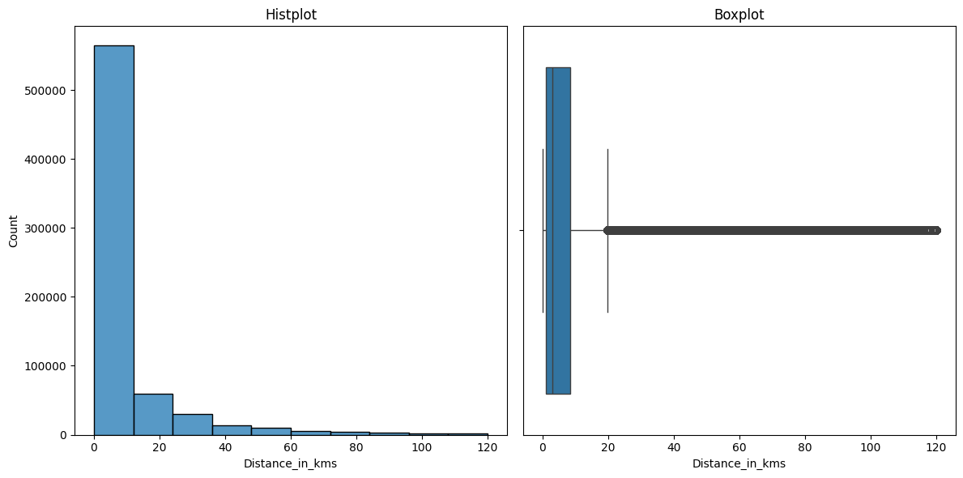

The distance (in kms) is characterised by a mean of 8.86 and a standard deviation of 15.54, revealing a broad range of values. The minimum distance is 0.1, and the maximum distance extends to 120, indicating a substantial variability in the dataset. Percentiles further delineate the distribution: the 25th percentile is 1, the median is 3, and the 75th percentile is 8.5. The interquartile range of 7.5 signifies the spread of the middle 50% of the distances. While the mean provides an average distance, the presence of a notably higher maximum value of 120 may suggest potential outliers that could influence the mean. The skew of the distribution is positive, meaning a concentration of observations on the left of the plot.

|  |  |
| --- | --- |
|  | **Distance_in_kms** |
| **Mean** | **8.86** |
| **std** | **15.54** |
| **min** | **0.1** |
| **25 %** | **1** |
| **50 %** | **3** |
| **75 %** | **8.5** |
| **max** | **120** |

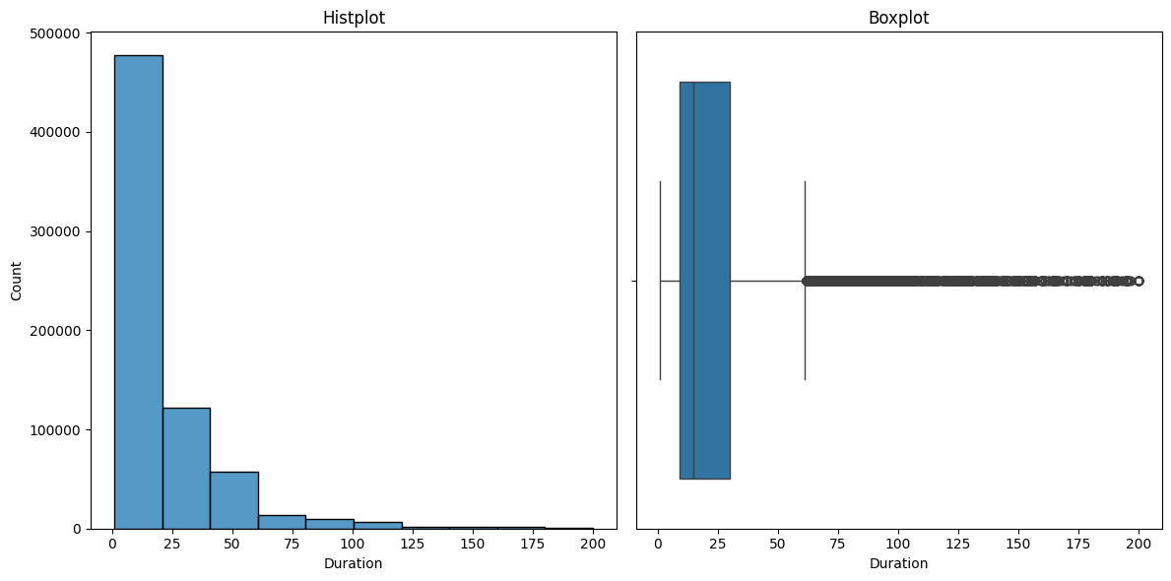

Duration (in minutes) reveals a mean duration of 21.89, accompanied by a standard deviation of 23.39, indicating a notable degree of variability in the durations. With a range from a minimum of 1 to a maximum of 200, the dataset exhibits considerable diversity in duration values. Percentiles provide additional insights into the distribution: the 25th percentile is 9, the median is 15, and the 75th percentile is 30. The interquartile range extends from 9 to 30, capturing the middle 50% of the data. The distribution is like the Distance feature with a positive skew.

|  |  |
| --- | --- |
|  | **Duration** |
| **Mean** | **21.89** |
| **std** | **23.39** |
| **min** | **1** |
| **25 %** | **9** |
| **50 %** | **15** |
| **75 %** | **30** |
| **max** | **200** |

### 4.2.3. Data Preprocess

Initially, categories with low frequencies in certain features were grouped. For instance, the percentage distribution for Household composition is presented, demonstrating the processing undertaken to reduce the overall categories. The results illustrate that the possible categories consolidated from eight to four.

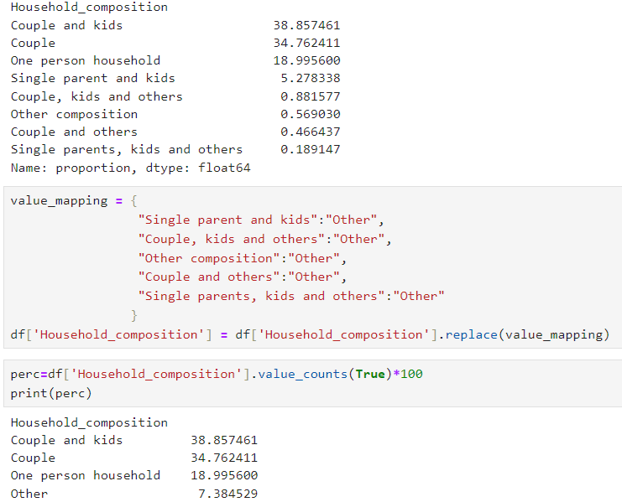

The same procedure was implemented for Departure_area. The categories were consolidated from 13 down to 6. The process is illustrated below.

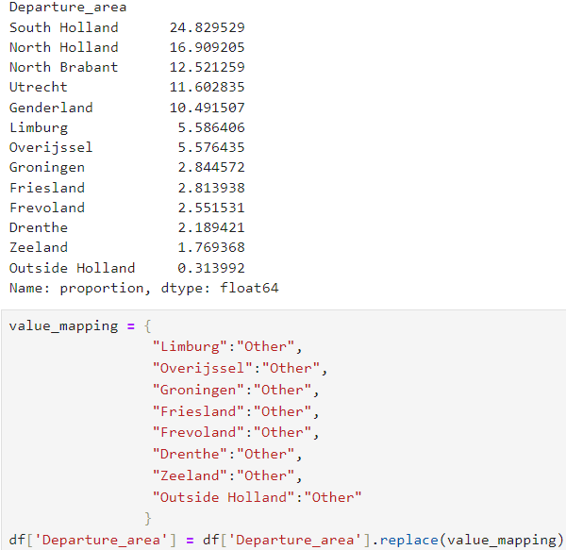

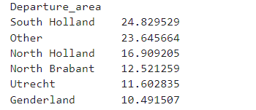

The subsequent feature subjected to the same procedure was education, with the categories condensed from six to three.

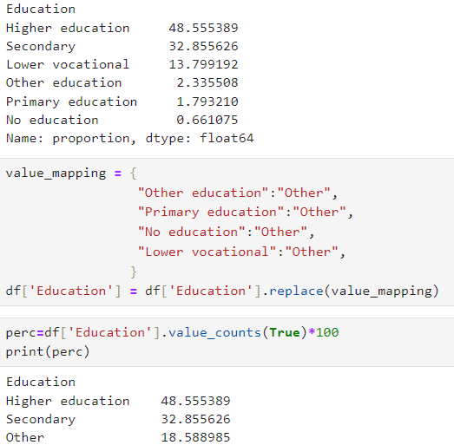

The last feature was that of motive, with categories consolidated from nine down to 6. The process is illustrated below.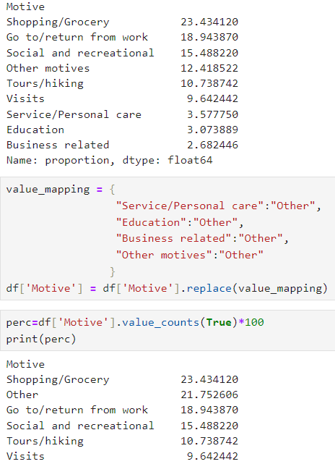

The next step was to one hot encode the following variables: Departure_area, Motive, Household_composition, Background and Education. The one-hot encoding process generates extra binary features corresponding to the potential categories for each feature, representing 0 for the absence in that row and 1 for its presence in that row. The process is depicted below.

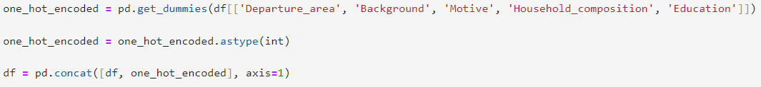

Additionally, all of the other binary features were encoded using Label Encoder replacing values with 0 and 1. Those features are: Gender, Electric_bike, Driver_licence, Round_trip, Holiday. Last, the target variable along with Month and Weekday were encoded in an ordinal scale. For mode, the classes were mapped like this: **car = 0, bike = 1, walk = 2 and public transport = 3**. For Month and Weekday the inherit order was kept.

After the feature preprocessing, the shape of the dataset is now: 692055 rows and 39 features.

The next step of the preprocess was to check for correlations among features. Correlations range from -1 to 1 indicating the strength of the correlation between two features. High correlation values may increase a multicollinearity problem, which consequently reduces the performance of the models. Therefore, it is essential to drop some of the features with values above 0.7 and lower than -0.7. The correlation matrix is illustrated below.

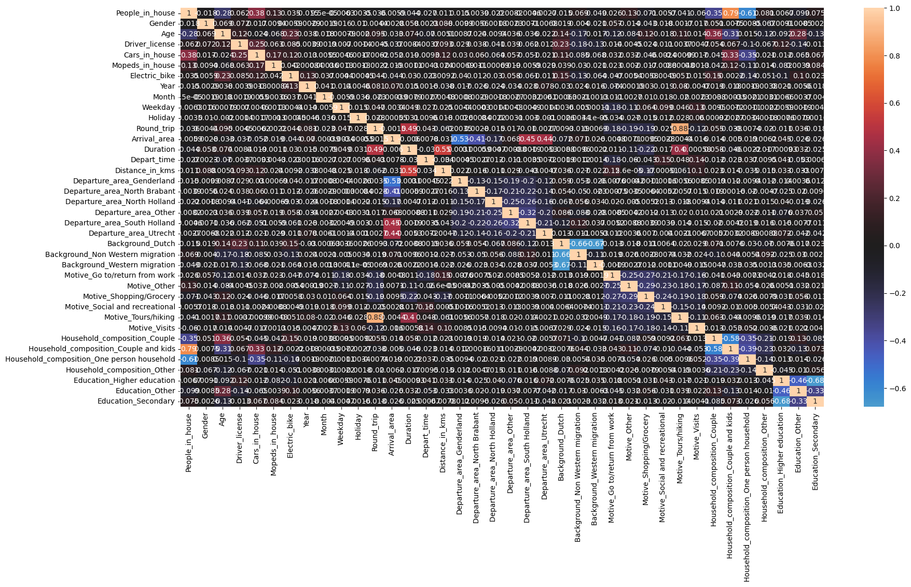

It is identified from the picture above that high correlations exist on those occasions: Round_trip and Motive_Tours/Hiking with correlation of 0.88. People_in_house and Household_composition_Couple_and_kids with 0.79 correlation. Therefore, Household_composition_Couple_and_kinds, Motive_Tours/Hiking, Household_composition_One person household and Education_Secondary will not be included in the models. Year and Arrival_area features will also be excluded from the models. Hence, the target variable y is mode, while the predictor variables X are depicted below:

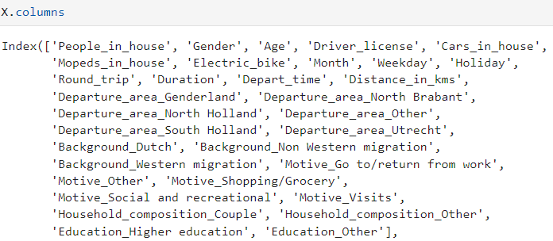

The next step was to split the dataset into training and test sets. A split ratio of 90:10 was used, meaning that 90% of the data will be used for training the models, while 10% will be used for testing. Since there is a huge imbalance on the dataset explicitly for class 3-Public transportation, the stratify=y parameter was set on the split so that the distribution is similar for training and test sets. The class counts for both train and test sets are depicted below.

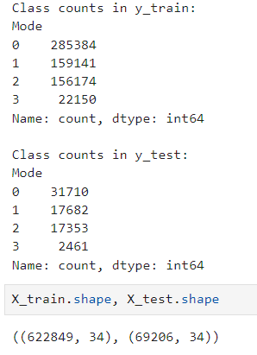

### 4.2.4. Logistic Regression

The first model that was applied was that of logistic regression. To address class imbalance and avoid bias for the minority class, an undersampling strategy was integrated into the training set randomly removing samples from the majority classes to match that of the minority. However, instead of directly applying undersampling to the training set, it was combined with GridSearchCV and the imblearn pipeline functions. This approach was implemented to ensure that the resampling strategy took place within the cross-validation process, while also incorporating hyperparameter tuning. The pipeline ensured that each time the folds were divided for the training set, the resampling process occurred for only the k-1 folds, leaving the validation fold untouched, so it could better represent the test set. This iterative process was repeated for all possible parameter combinations configured in the grid search function. The same approach was applied for both undersampling and oversampling techniques across all the models used. The steps used in the pipeline for the undersampled Logistic Regression model, along with the configured parameter values are illustrated below:

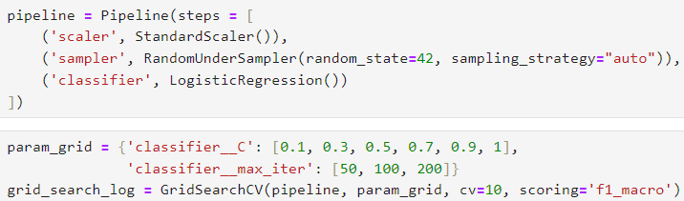

Since both precision and recall are desirable for each class, f1-macro was selected as the evaluation metric of grid search, representing the mean of f1 scores across all classes. The use of "macro" in the f1 score implies that the average is calculated with equal weight assigned to each class, irrespective of any imbalance in the dataset. C parameter is the inverse of the regularisation strength, while max_iter is the number of iteration for the solver convergence. The best parameters found were **C=1** and **max_iter = 50**, with validation **f1-macro of 0.60**. The best model was then evaluated on the test set. The results are depicted below. 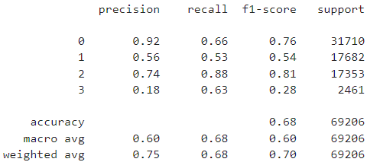

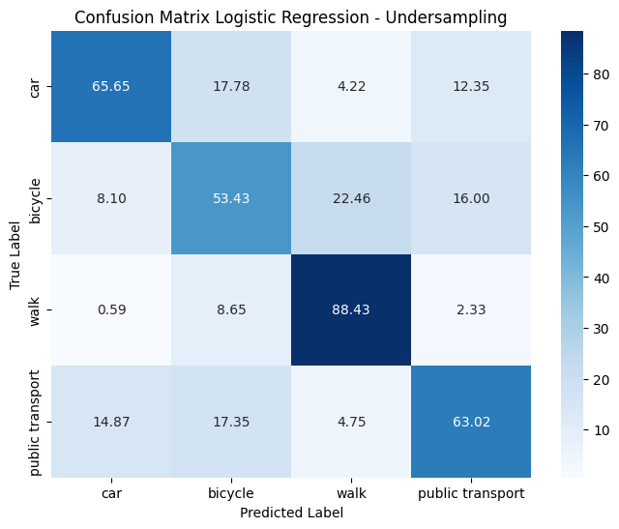

The overall model accuracy stands at 0.68, representing an average performance. For the minority class "public transport," recall is 0.63, indicating that the model captured 63% of the relevant labels for the class. However, this comes with a precision trade-off, as it stands at 0.18—indicating that only 18% of the predictions made by the model as “public transport” actually belonged to that class. The f1 score for this specific class is 0.28, further highlighting unsatisfactory performance. The best-performing class is "walk" with a recall of 0.88 and an f1 score of 0.81. The f1 score for "bike" remains low at 0.54, suggesting mediocre performance for the class. Finally, "car" exhibits an average performance with a recall of 0.66, a very high precision of 0.91, and an f1 score of 0.76.

The second experimentation was using an oversampling technique, duplicating samples from the minority class. Similarly, the process of oversampling was implemented using the pipeline and Gridsearchcv() functions. The configuration for the model is illustrated below.

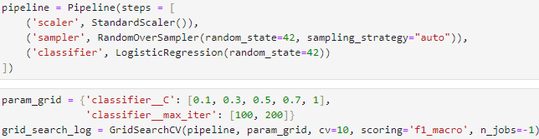

After the process was run the best parameters were found to be, **C = 1** and **max_iter = 100**, with a validation **f1-macro of 0.60**. The model was then evaluated on the test set. The results are depicted below.

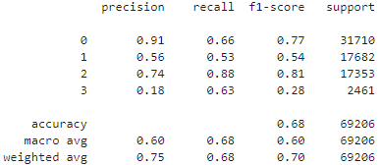

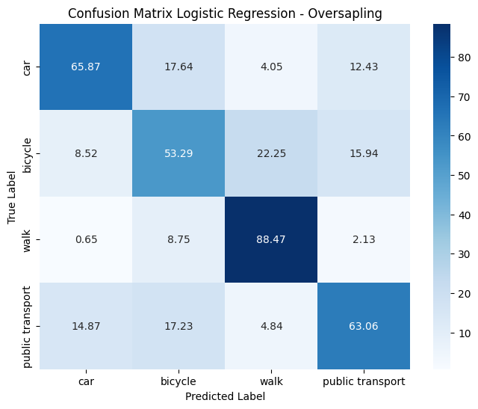

Comparing the performance with the undersampled model, results are almost identical. The only change occurs for car where the f1 score increased from 0.76 to 0.77. Other than that, the performance for bike is still mediocre with an f1 score of 0.54, while the f1 score for public transport is still low at 0.28. The only satisfactory performance occurs for walk, with an f1 score of 0.81. Also, from the confusion matrix, the most significant misclassification occurs between bicycle and walk, where the model incorrectly predicted 22.25% of instances, whose true label was bicycle, as walk.

As a last evaluation for the model, the precision - recall (PR) curves were constructed for the undersampled and oversampled models. Like the ROC curve, the PR curve shows the trade-off of precision and recall for different probability thresholds. The PR is most suitable for cases with a severe class imbalance. To assess the model's performance and the classes, the area under the curve (average precision) is calculated, ranging from 0 to 1. Higher values indicate better class performance. The micro-AP is also computed which is the harmonic average of the area for all the classes.

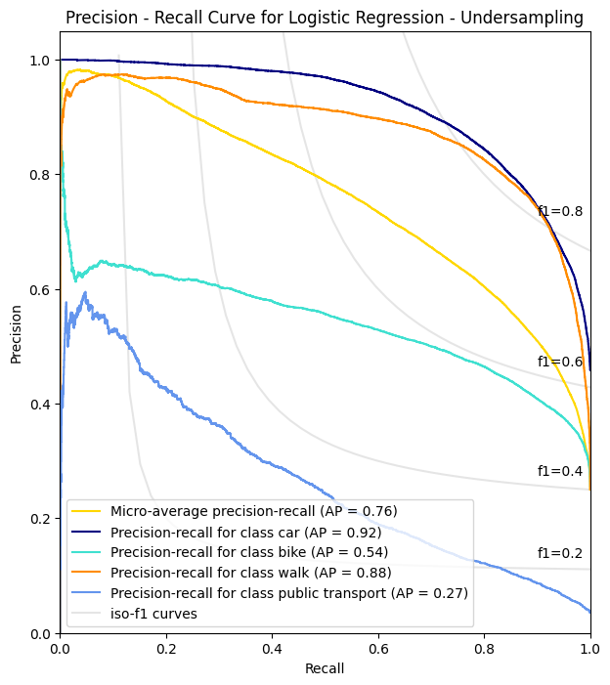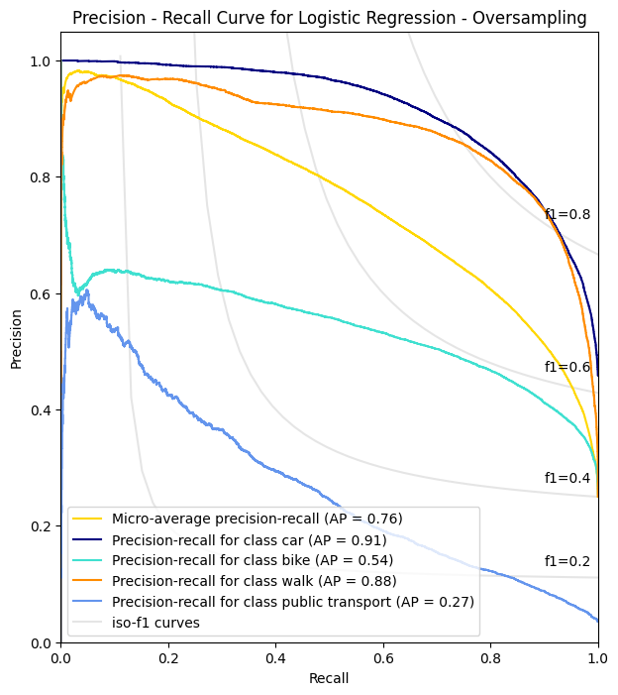

The plots reveal minimal differences between the undersampled and oversampled models. Satisfactory performances are observed for both models in the "car" and "walk" classes. However, the performance is subpar for "public transport" and mediocre for "bike." The undersampling model exhibits a slight advantage, with an AP area of 0.92 for "car" compared to 0.91 for the oversampled model. Apart from this, the performance for the other classes remains identical in terms of AP.

Both models were also evaluated with the corresponding models proposed by Kashifi et al. (2022) using trip diary data from the Netherlands but for years 2010-2012, while also experimenting with different features. The results are illustrated at the tables below.

|  |  |  |  |  |
| --- | --- | --- | --- | --- |
| **Logistic Regression - Undersampling**  **Model proposed by Kashifi et al. (2022)** | | | | |
|  | Car | Bike | Walk | Public Transport |
| Precision | 0.87 | 0.42 | 0.43 | 0.26 |
| Recall | 0.56 | 0.45 | 0.70 | 0.66 |
| F1 - score | 0.68 | 0.43 | 0.54 | 0.38 |
| AP | 0.88 | 0.45 | 0.55 | 0.32 |
| Micro-AP | 0.60 | | | |
| F1 - Macro | 0.5075 | | | |
| Accuracy | 0.566 | | | |

|  |  |  |  |  |
| --- | --- | --- | --- | --- |
| **Logistic Regression - Undersampling**  **Thesis Model** | | | | |
|  | Car | Bike | Walk | Public Transport |
| Precision | **0.92** | **0.56** | **0.74** | 0.18 |
| Recall | **0.66** | **0.53** | **0.88** | 0.63 |
| F1 - score | **0.76** | **0.54** | **0.81** | 0.28 |
| AP | **0.92** | **0.54** | **0.88** | 0.27 |
| Micro-AP | **0.76** | | | |
| F1 - Macro | **0.60** | | | |
| Accuracy | **0.68** | | | |

Looking at the results, there is an increase in the performance for all classes except “public transport” where the model has a lower AP and F1 score compared to the model proposed by Kashifi et al (2022). Micro AP, F1 macro and overall accuracy are all higher for the undersampled model.

|  |  |  |  |  |
| --- | --- | --- | --- | --- |
| **Logistic Regression - Oversampling**  **Model proposed by Kashifi et al. (2022)** | | | | |
|  | Car | Bike | Walk | Public Transport |
| Precision | 0.89 | 0.43 | 0.44 | 0.24 |
| Recall | 0.58 | 0.46 | 0.73 | 0.69 |
| F1 - score | 0.70 | 0.44 | 0.55 | 0.35 |
| AP | 0.89 | 0.46 | 0.60 | 0.35 |
| Micro-AP | 0.62 | | | |
| F1 - Macro | 0.51 | | | |
| Accuracy | 0.58 | | | |

|  |  |  |  |  |
| --- | --- | --- | --- | --- |
| **Logistic Regression - Oversampling**  **Thesis Model** | | | | |
|  | Car | Bike | Walk | Public Transport |
| Precision | **0.91** | **0.56** | **0.74** | 0.18 |
| Recall | **0.66** | **0.53** | **0.88** | 0.63 |
| F1 - score | **0.77** | **0.54** | **0.81** | 0.28 |
| AP | **0.91** | **0.54** | **0.88** | 0.27 |
| Micro-AP | **0.76** | | | |
| F1 - Macro | **0.60** | | | |
| Accuracy | **0.68** | | | |

Compared to the model of Kashifi (2022), there is a lower performance for class “public transport”. In contrast there is a huge performance gap for class “walk” with all the metrics being higher. This also occurs for the metric for classes “car” and “bike” with metrics being slightly higher.

### 4.2.5. Decision Tree

The next model that was applied was that of the decision tree. Similarly to the previous model, both undersampling and oversampling techniques were used. The pipeline and GridSearchCV() functions were used again to ensure the resampling strategy occurs within the cross validation process and hyperparameter tuning. The parameter that was tuned for both resampling methods was that of the max depth, which controls the overall tree size. First the undersampling technique was used. The configuration of the model is depicted below.

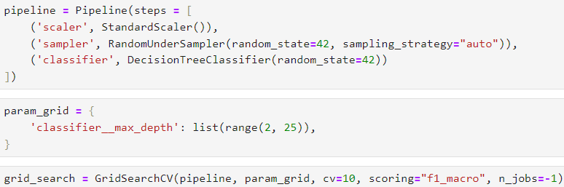

The cross-validation results for the undersampled tree are shown on the plot below.

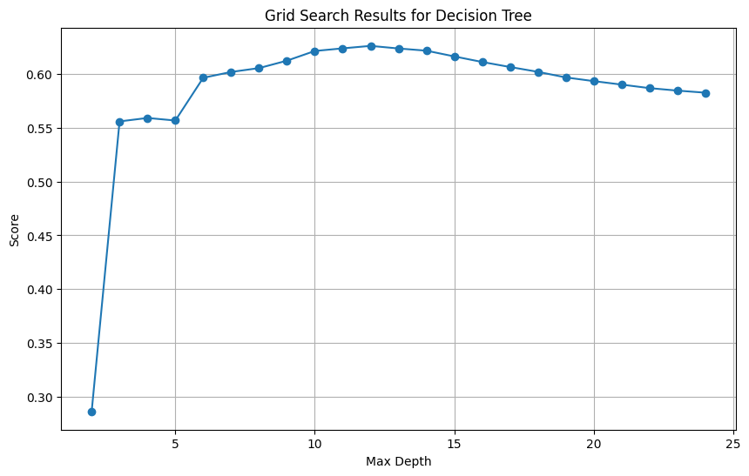

The optimal **max_depth was found to be 12**, with a validation **F1- macro of 0.626**. The optimal tree was then evaluated on the test set. The results are illustrated on the classification report and the confusion matrix below.

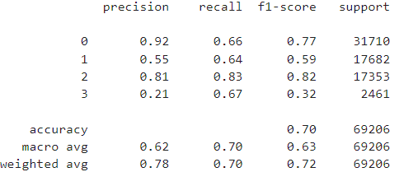

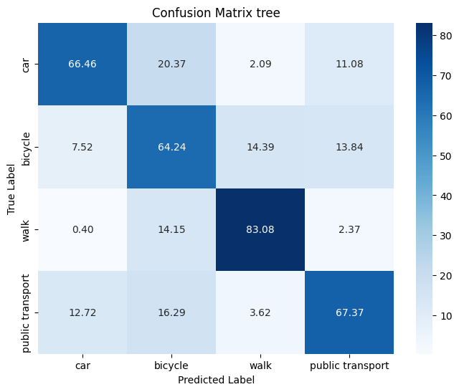

The best model performance is for class “walk” with a precision of 0.81, recall of 0.83 and an f1 score of 0.82. For the minority class, public transport, the model has a recall score of 0.67, capturing 67.37% of the true labels for the class. However, precision is low with 0.21 indicating, implying that of all the predictions the model made as public transport only 21% belonged in that class. F1 is also low for public transport with 0.32. For car there is an average performance, with precision, recall and f1 score of 0.92, 0.66 and 0.77 respectively. Results are also average for “bike” with a f1 score of 0.59. The highest misclassification is between car and bike, since the model predicted 20.37% of instances where the true label was car, as bike.

The second experimentation was using the oversampling strategy in the pipeline. Similarly, the max_depth of the tree was tuned in the grid search function, however setting the possible max depth of the tree up to 16. The configuration for the oversampled tree can be viewed below.

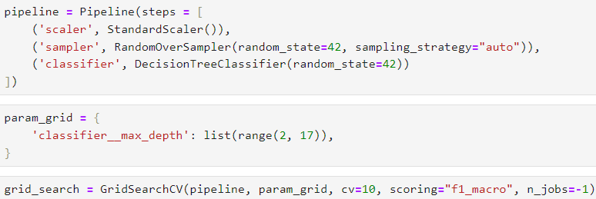

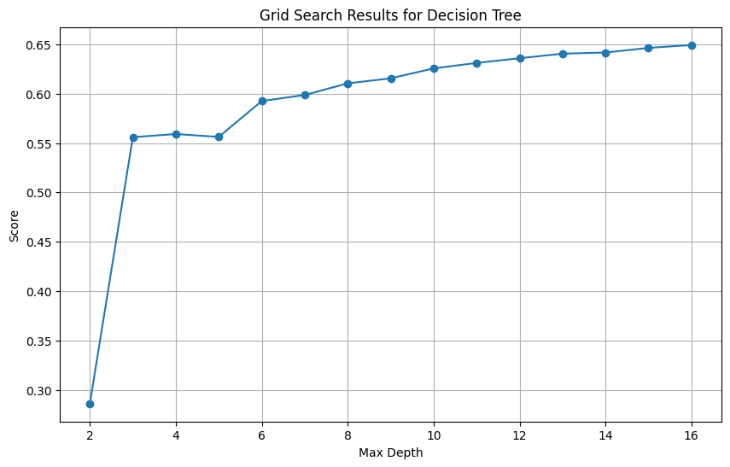

The tree with **max_depth=16** yielded the best results for the oversampling strategy with a validation **F1-macro of 0.65**. The optimal tree was then evaluated on the test set. The classification report and the confusion matrix are illustrated below.

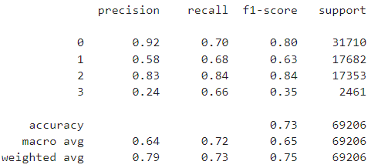

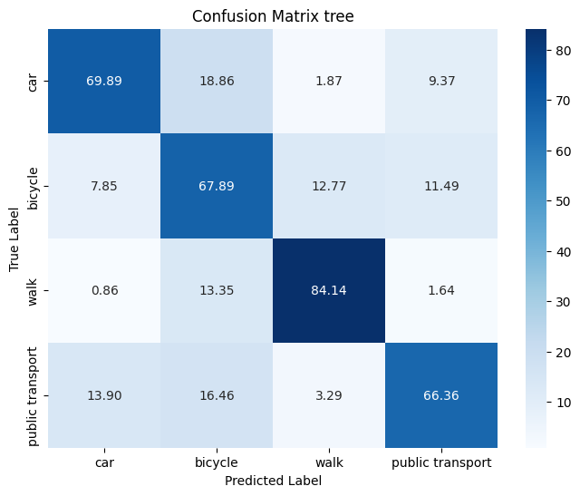

After implementing an oversampling strategy, the overall model accuracy improved from 0.70 to 0.73 compared to the undersampled model. The F1-macro also saw an increase from 0.63 to 0.65. All metrics exhibited improvements for each class, except for the recall in the "public transport" class, which experienced a minor decrease from 0.67 to 0.66. However, the F1 score remains at 0.35, indicating a low performance for the class. To further assess the performance of the resampled models, precision-recall curves were constructed, as depicted below.

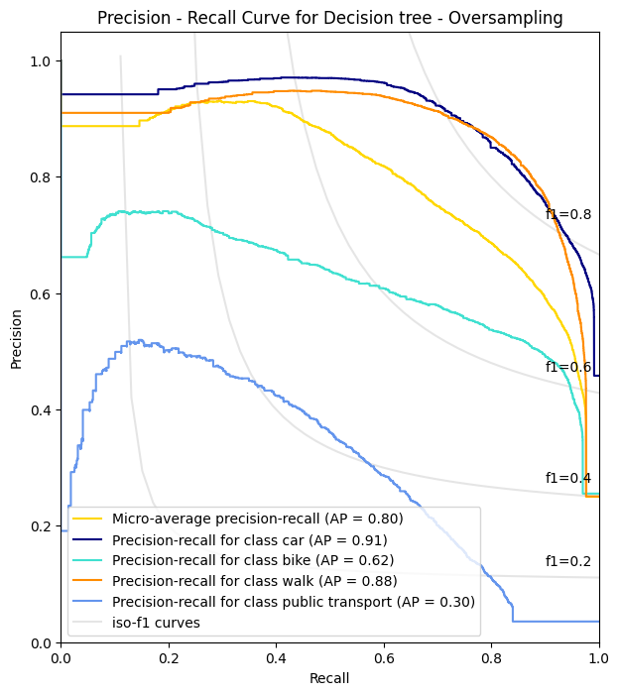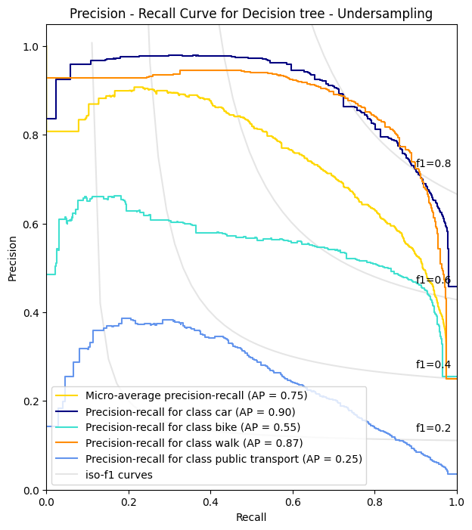

As evident from the corresponding graphs, employing an oversampling strategy led to an enhancement in the tree's performance. The areas under the curve improved across all classes. The most notable performances are observed for "car" and "walk," while "bike" exhibits an average performance. Despite the improvement in terms of F1 score and the area under the precision-recall curve for "public transportation" compared to the undersampled model, the performance of this class remains subpar.

Like logistic regression models, the resampled Decision Trees were evaluated against the corresponding models proposed by Kashifi et al. (2022). The tables displaying the performance metrics are presented below.

|  |  |  |  |  |
| --- | --- | --- | --- | --- |
| **Decision Tree - Undersampling**  **Model proposed by Kashifi et al. (2022)** | | | | |
|  | Car | Bike | Walk | Public Transport |
| Precision | 0.83 | 0.47 | 0.47 | 0.22 |
| Recall | 0.52 | 0.53 | 0.63 | 0.76 |
| F1 - score | 0.66 | 0.49 | 0.54 | 0.34 |
| AP | 0.70 | 0.36 | 0.34 | 0.16 |
| Micro-AP | 0.43 | | | |
| F1 - Macro | 0.51 | | | |
| Accuracy | 0.56 | | | |

|  |  |  |  |  |
| --- | --- | --- | --- | --- |
| **Decision Tree - Undersampling**  **Thesis - Model** | | | | |
|  | Car | Bike | Walk | Public Transport |
| Precision | **0.92** | **0.55** | **0.81** | 0.21 |
| Recall | **0.66** | **0.64** | **0.83** | 0.67 |
| F1 - score | **0.77** | **0.59** | **0.82** | 0.32 |
| AP | **0.90** | **0.55** | **0.87** | **0.25** |
| Micro-AP | **0.75** | | | |
| F1 - Macro | **0.63** | | | |
| Accuracy | **0.70** | | | |

In the case of the undersampled model, the metrics for Accuracy, F1-macro, and Micro-Ap are consistently higher compared to the model proposed by Kashifi et al. (2022). Except for public transport, where metrics are slightly lower, the performance for the other classes is significantly superior, particularly for "car" and "walk."

|  |  |  |  |  |
| --- | --- | --- | --- | --- |
| **Decision Tree - Oversampling**  **Model proposed by Kashifi et al. (2022)** | | | | |
|  | Car | Bike | Walk | Public Transport |
| Precision | 0.87 | 0.73 | 0.74 | 0.50 |
| Recall | 0.87 | 0.75 | 0.71 | 0.49 |
| F1 - score | 0.87 | 0.74 | 0.72 | 0.50 |
| AP | 0.83 | 0.62 | 0.59 | 0.27 |
| Micro-AP | 0.70 | | | |
| F1 - Macro | 0.71 | | | |
| Accuracy | 0.80 | | | |

|  |  |  |  |  |
| --- | --- | --- | --- | --- |
| **Decision Tree - Oversampling**  **Thesis - Model** | | | | |
|  | Car | Bike | Walk | Public Transport |
| Precision | **0.92** | 0.58 | **0.83** | 0.24 |
| Recall | 0.70 | 0.68 | **0.84** | 0.66 |
| F1 - score | 0.80 | 0.63 | **0.83** | 0.35 |
| AP | **0.91** | 0.62 | **0.88** | **0.30** |
| Micro-AP | **0.80** | | | |
| F1 - Macro | 0.65 | | | |
| Accuracy | 0.73 | | | |

The oversampled model exhibits lower performance in terms of Accuracy and F1-macro. On an individual class basis, the model proposed by Kashifi et al. (2022) outperforms in the "car," "bike," and "public transport" classes. However, the "walk" class shows significantly superior performance in the oversampled model, with all metrics of Precision, Recall, and F1 being higher for that class compared to the paper. Overall, the model of decision tree performs well for “car” and “walk” classes, while the performance is still low for “public transport”.

The feature importances for both undersampled and oversampled models are illustrated below.

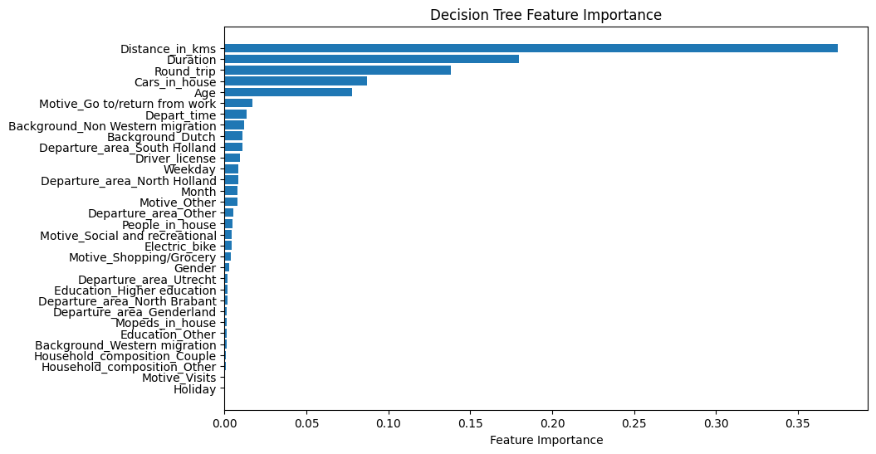 **Decision tree - Undersampling**

**Decision tree - Oversampling**

**Decision tree - Oversampling**

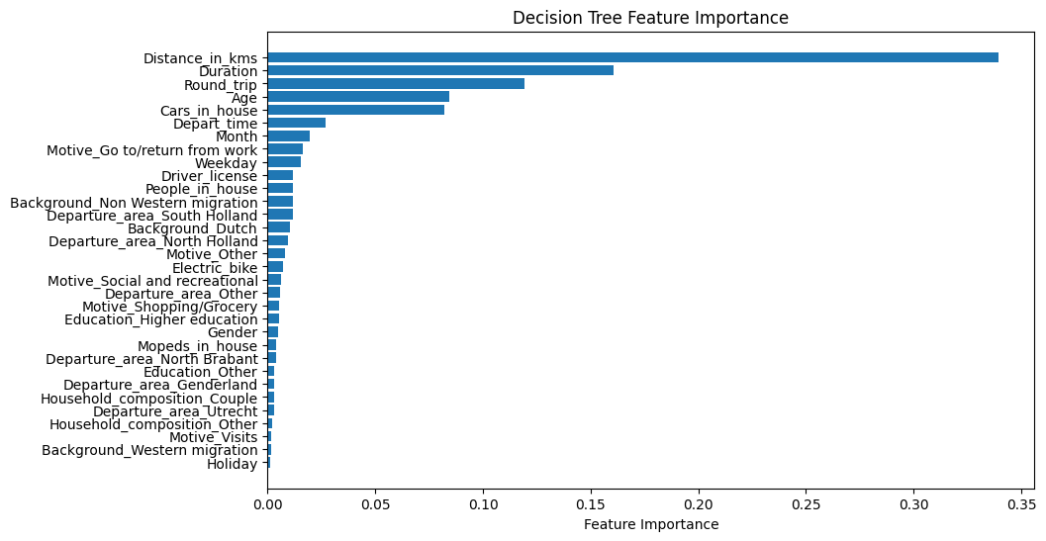

In both models, whether undersampling or oversampling was employed, the tree construction highlighted Distance, Duration, Round trip, Age, and the number of cars in a household as the most crucial features. On the contrary, the least influential features include whether the trip occurred on a national holiday, if the trip was made by a west-migrated resident, if the purpose of the trip was a visit, and the household composition of the trip respondent.

### 4.2.6. Random Forest

The next model employed was Random Forest, with the initial experiment involving an undersampling strategy. As with previous models, a pipeline was utilised in conjunction with GridSearch, ensuring that the model underwent resampling during the cross-validation process while parameter tuning took place. The first parameter subject to tuning was max_features, referring to the number of features considered in each split of the individual decision tree, with the value range set from 2 to 20 max features. The configuration of the undersampled model inside the pipeline is illustrated below.

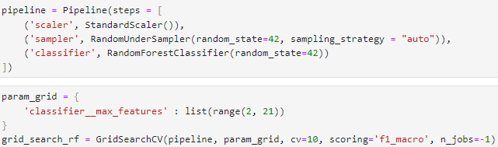

The pipeline was then fitted on the training set. The results of the validation process are illustrated in the plot below.

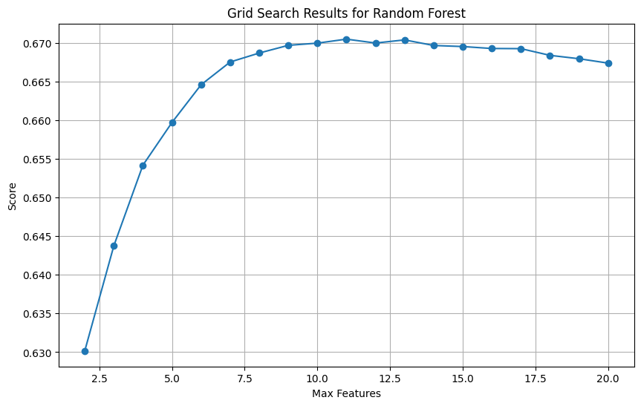

The optimal validation score was achieved with **max_features = 11**, yielding a validation **F1-macro of 0.671**. Subsequently, a new grid search was conducted to explore combinations of both max_features and the number of estimators. The max features parameter varied between [9, 10, 11], while the number of trees ranged from [100, 200, 300, 400, 500]. The best model was identified with **n_estimators = 500**, **max_features = 11**, resulting in a validation **F1-macro of 0.6723**. The undersampled model was then evaluated on the test set. The results from the classification report and the confusion matrix are illustrated below.

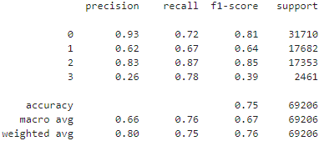

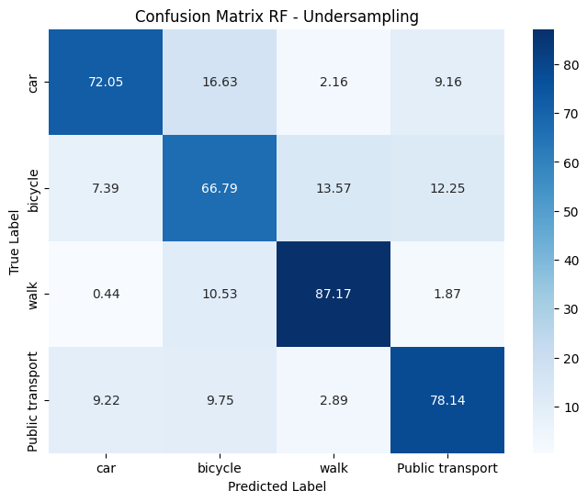

The best performance is for “walk” class with a precision of 0.83, recall of 0.87 and an F1 score of 0.85. “Car” also performs fairly well with a high precision of 0.93, 0.72 recall and an F1 score of 0.81. “Bike” has an average performance with 0.67 recall and 0.64 F1 score. The minority class, "Public transport," exhibits a high recall of 0.78, indicating that the model accurately identified 78.14% of the true labels for that class. However, precision is low at 0.26, signifying that only 26% of the predictions made by the model as public transport truly belong to that class. Consequently, the F1 score is also modest at 0.39. The overall accuracy of the model stands at 0.75, while the F1 macro reaches 0.67. The biggest misclassification ocurred between bike and car as the model erroneously predicted 16.63% of instances labelled as "car" to be "bike.". Although the performance of the undersampled model surpasses that of the Decision Tree and Logistic Regression, the effectiveness for the "public transport" class remains low.

For the second experiment, an oversampling strategy was employed. The pipeline, along with grid search for parameter tuning and resampling within cross-validation, was utilised once again. The initial parameter tuned was max_features, and the configuration is outlined below.

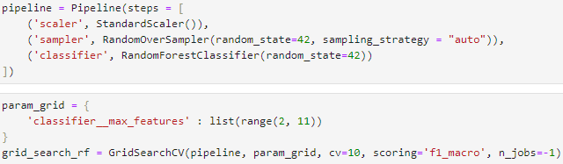

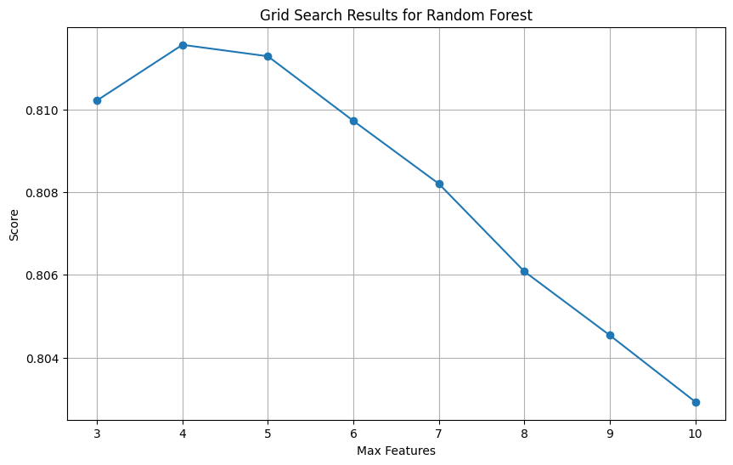

The best score was found for **max_features = 4** and a validation **F1-macro of 0.81**. Following that, a subsequent grid search was carried out to investigate various combinations of both max_features and the number of estimators. The max_features parameter was kept at 4, identified as optimal in the prior search, while the number of trees varied within the range of [450, 500, 550]. The decision to explore a reduced number of parameter combinations was driven by the substantial increase of the dataset resulting from the oversampling strategy. This expansion introduced computational challenges in training the random forest, particularly when combined with the cross-validation process. The best score of the validation process was found for **max_features = 4** and **n_estimators = 550** with a validation **F1-macro of 0.83**. The oversampled model was then evaluated on the test set. The results are illustrated below.

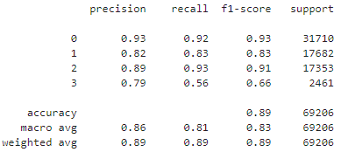

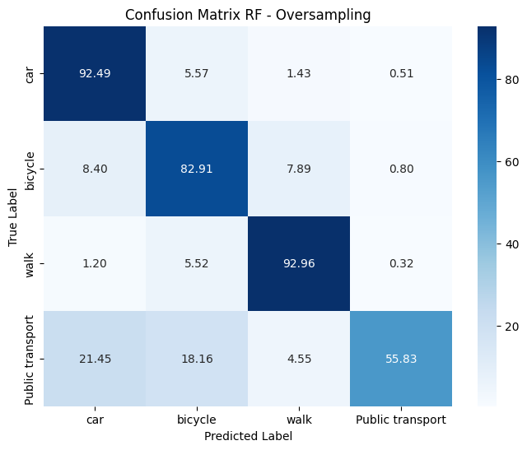

The oversampled model exhibits an overall accuracy of 0.89, accompanied by an F1-macro of 0.83. Exceptional performances are observed for classes "car" and "walk," attaining F1 scores of 0.93 and 0.91, respectively. Notably, the metrics for class "bike" show a considerable improvement compared to the undersampled model, with precision, recall, and F1 scores reaching 0.82, 0.83, and 0.83, respectively. However, for the minority class, recall experiences a decrease from 0.78 to 0.56 compared to the undersampled model. In contrast, precision sees a significant increase from 0.26 to 0.79, and the F1 score rises from 0.39 to 0.66. Overall, the performance of random forest exhibits a substantial enhancement compared to the decision tree and logistic regression. Additionally, precision-recall curves were constructed as a supplementary evaluation metric for the models, as depicted below.

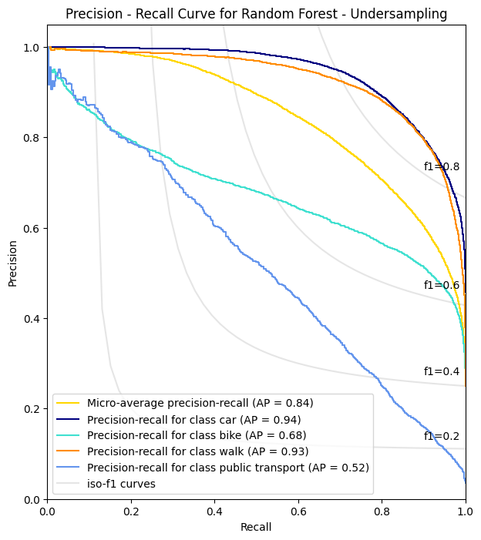 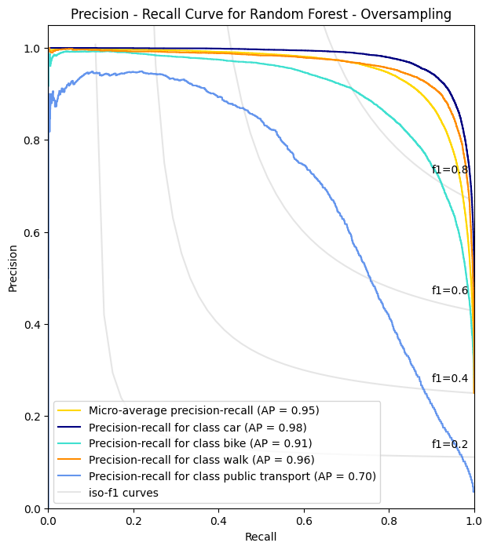

Upon examination of the curves, it is evident that the oversampling strategy has positively influenced the area under the curve (AP) for each class. The most substantial improvement is observed for "bike," where AP has surged from 0.68 to 0.91. Similarly, for the minority class, AP has shown an increase from 0.52 to 0.70. In summary, the oversampled random forest model showcases the most robust performance in terms of AP, particularly for the minority class compared to the previous models regardless of resampling strategy. The models were also compared to the ones proposed by Kashifi et al. (2022).

|  |  |  |  |  |
| --- | --- | --- | --- | --- |
| **Random Forest - Undersampling**  **Model proposed by Kashifi et al. (2022)** | | | | |
|  | Car | Bike | Walk | Public Transport |
| Precision | 0.88 | 0.54 | 0.56 | 0.31 |
| Recall | 0.63 | 0.63 | 0.70 | 0.84 |
| F1 - score | 0.74 | 0.58 | 0.63 | 0.45 |
| AP | 0.91 | 0.64 | 0.72 | 0.58 |
| Micro-AP | 0.73 | | | |
| F1 - Macro | 0.60 | | | |
| Accuracy | 0.654 | | | |

|  |  |  |  |  |
| --- | --- | --- | --- | --- |
| **Random Forest - Undersampling**  **Thesis - Model** | | | | |
|  | Car | Bike | Walk | Public Transport |
| Precision | **0.93** | **0.62** | **0.83** | 0.26 |
| Recall | **0.72** | **0.67** | **0.87** | 0.78 |
| F1 - score | **0.81** | **0.64** | **0.85** | 0.39 |
| AP | **0.94** | **0.68** | **0.93** | 0.52 |
| Micro-AP | **0.84** | | | |
| F1 - Macro | **0.67** | | | |
| Accuracy | **0.75** | | | |

The undersampled model performs better for all of the classes except for “public transport” where the metrics are slightly lower than that of the paper. The overall accuracy and F1-macro are higher, while also there is a huge increase of performance for “walk” class for all the evaluation metrics.

|  |  |  |  |  |
| --- | --- | --- | --- | --- |
| **Random Forest - Oversampling**  **Model proposed by Kashifi et al. (2022)** | | | | |
|  | Car | Bike | Walk | Public Transport |
| Precision | 0.90 | 0.83 | 0.83 | 0.84 |
| Recall | 0.94 | 0.84 | 0.77 | 0.57 |
| F1 - score | 0.92 | 0.84 | 0.80 | 0.68 |
| AP | 0.97 | 0.90 | 0.86 | 0.74 |
| Micro-AP | 0.93 | | | |
| F1 - Macro | 0.81 | | | |
| Accuracy | 0.87 | | | |

|  |  |  |  |  |
| --- | --- | --- | --- | --- |
| **Random Forest - Oversampling**  **Thesis - Model** | | | | |
|  | Car | Bike | Walk | Public Transport |
| Precision | **0.93** | 0.82 | **0.89** | 0.79 |
| Recall | 0.92 | 0.83 | **0.93** | 0.56 |
| F1 - score | **0.93** | 0.83 | **0.91** | 0.66 |
| AP | **0.98** | **0.91** | **0.96** | 0.70 |
| Micro-AP | **0.95** | | | |
| F1 - Macro | **0.83** | | | |
| Accuracy | **0.89** | | | |

The overall accuracy of the oversampled model, compared to the paper, increased from 0.87 to 0.89 and F1-macro increased from 0.81 to 0.83. Again, the significant difference is for “walk class” with 0.91 F1-macro compared to 0.80 score for the model of the paper. For the minority class, the metrics are slightly lower, like the undersampled model. Finally, the feature importance was extracted for both undersampled and oversampled model. The results are illustrated below.

**Random Forest - Undersampling**

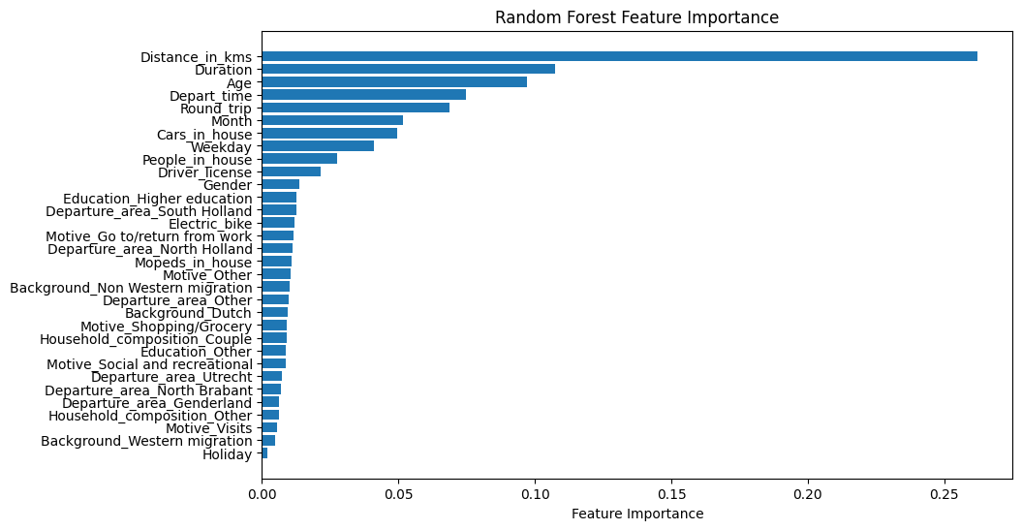

**Random Forest – Oversampling**

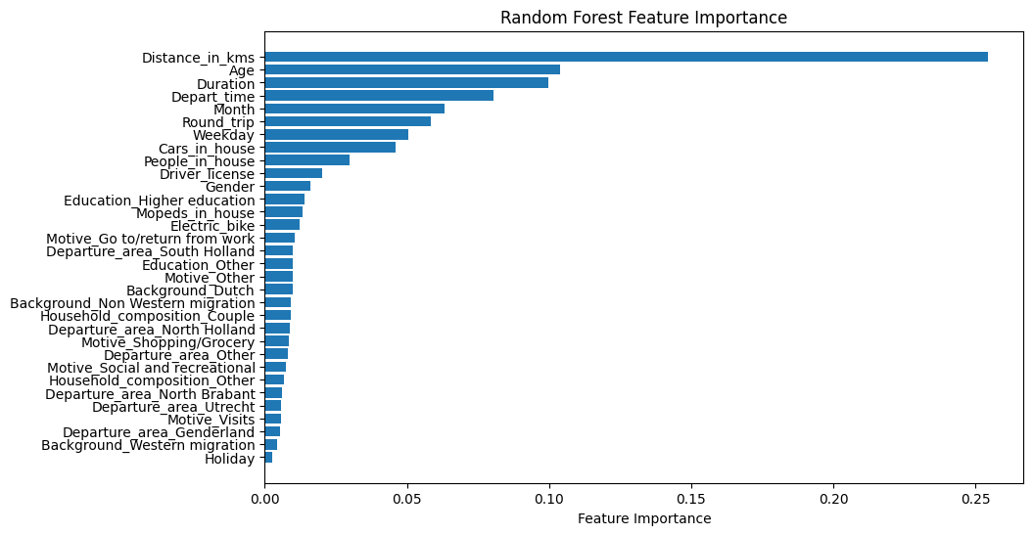

In both models Distance emerges as the primary factor influencing the construction of individual trees, succeeded by Age, Duration, and Departure Time. Also notable are features such as whether the trip was round and the month of the trip. Conversely, the Holiday feature ranks lowest on the list for both models.

### 4.2.7. XGBoost

The next model that was applied was XGBoost, experimenting with the undersampling strategy. The parameters that were tuned for the model were the learning_rate (the contribution of each tree), the subsample (the fraction of data for training) and the colsample_bytree (fraction of features used for each tree). For each of the parameters the value range was set within the interval [0.1 – 1]. The pipeline was then created so for resampling to take place within the cross-validation process of grid search. The tuning for each of the parameters is illustrated on the plots below.

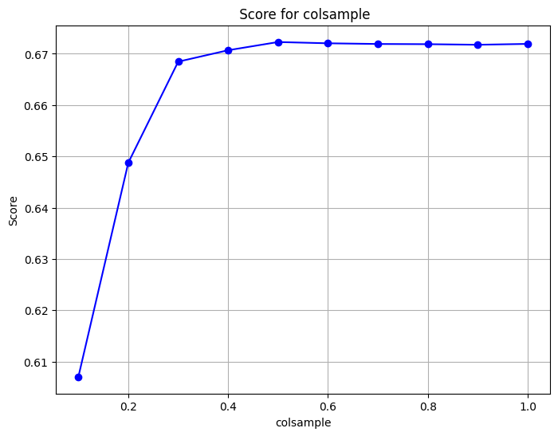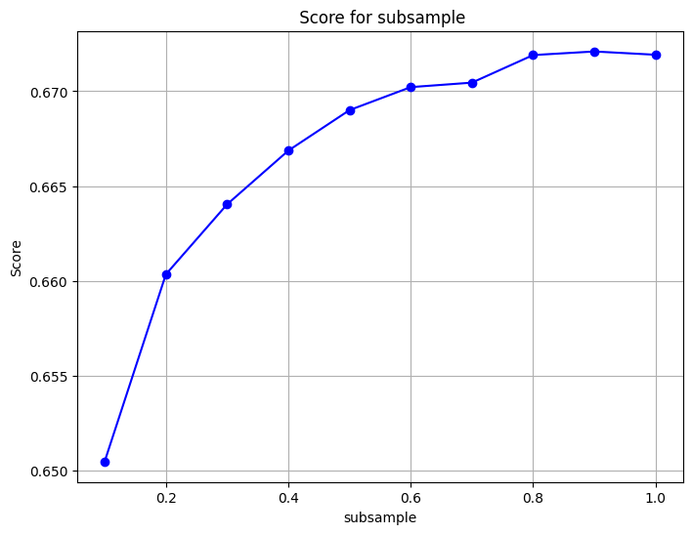

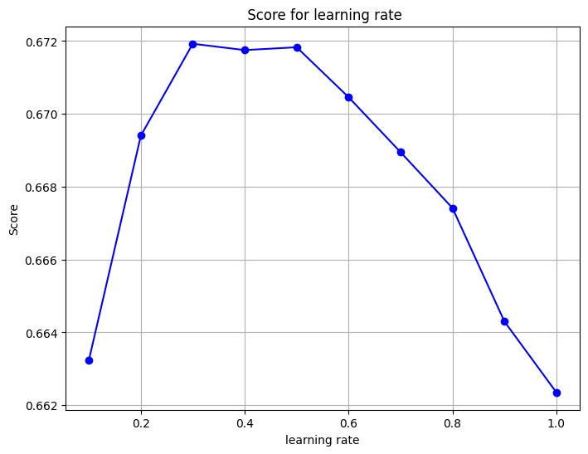

After reviewing the optimal areas, where the f1-macro score is higher, a final grid search was initiated while also increasing the number of estimators (trees). The parameter values are depicted below.

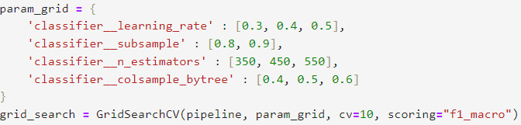

The optimal parameter values were **learning_rate = 0.3**, **colsample_bytree = 0.4**, **subsample = 0.9** and **n_estimators = 350.** The model was then evaluated on the test set. The results are illustrated on the classification report and the confusion matrix below.

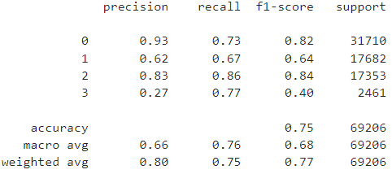

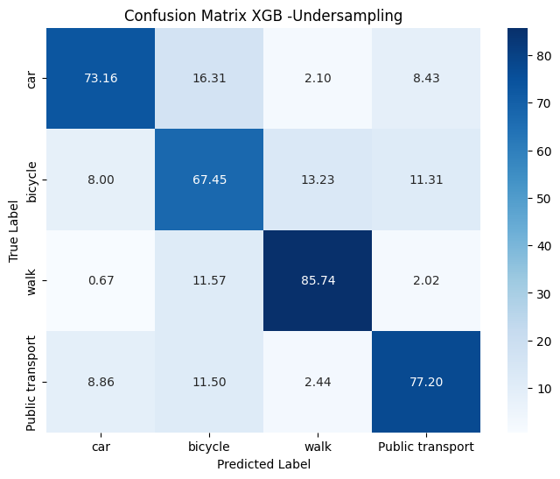

The overall accuracy of the model is 0.75 while the f1-macro is 0.68. For “car”, the model demonstrates high precision (0.93), suggesting that when it predicts this class, it is accurate 93% of the time. However, the recall is relatively lower at 0.73, indicating that it misses 27% of actual car instances. “Bike” has a precision of 0.62, indicating moderate accuracy in positive predictions, while the recall is 0.67, suggesting it captures 67% of actual bike instances. Class “walk” exhibits high precision (0.83) and recall (0.86), resulting in a balanced F1-score of 0.84. In contrast, “public transport” has a precision of 0.27, indicating a high rate of false positives. However, it demonstrates high recall (0.77), suggesting it captures a significant portion of actual public transport instances. The F1-score is low at 0.40.

The second experimentation was with the oversampling strategy. The same parameters were tuned as the previous model. The grid search results for the new oversampled model are depicted below.

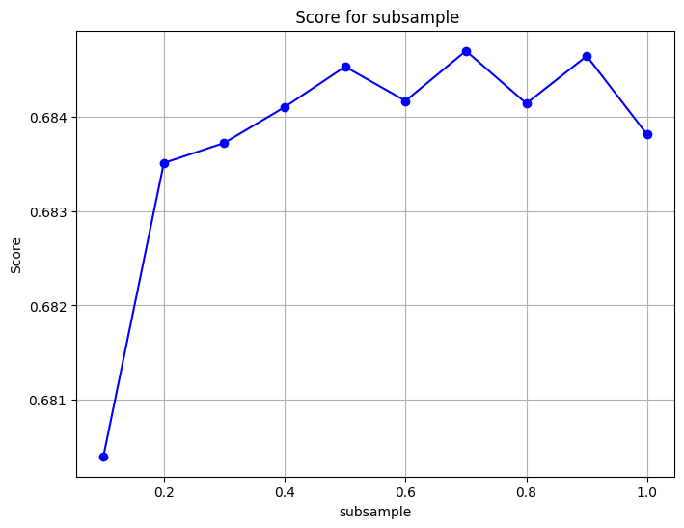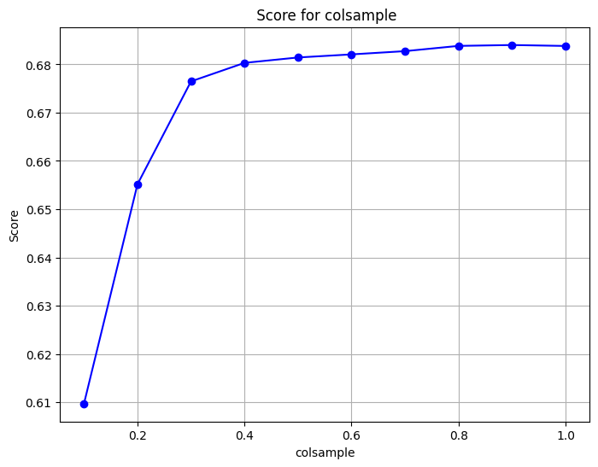

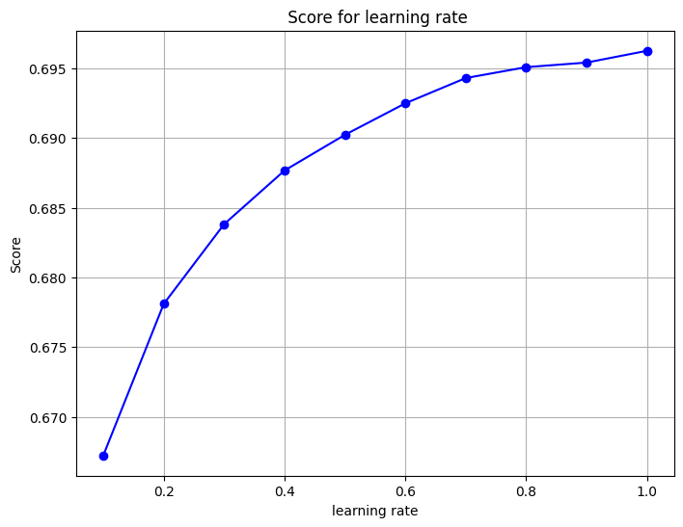

After getting the optimal areas, where the f1-macro score is higher, a final grid search was initiated while also increasing the number of estimators (trees). The parameter values are depicted below.

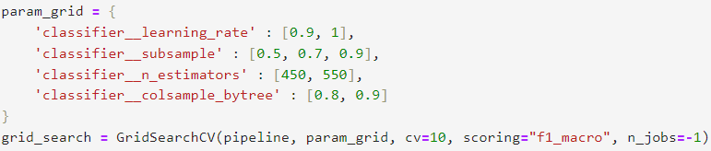

The optimal parameter values were **learning_rate = 1**, **colsample_bytree = 0.9**, **subsample = 0.9** and **n_estimators = 550.** The model was then evaluated on the test set. The results are illustrated on the classification report and the confusion matrix below.

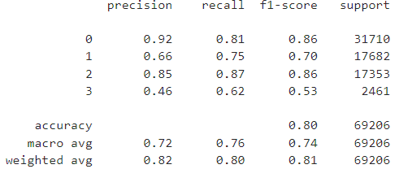

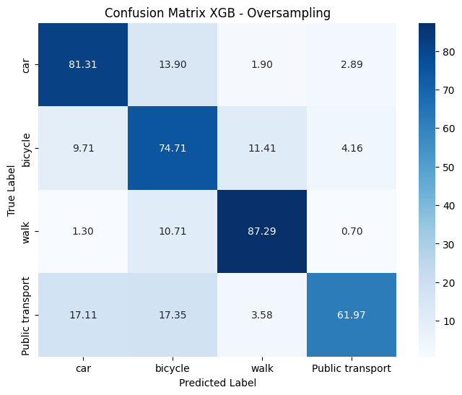

The overall accuracy of the model is 0.80 while the F1-macro is 0.84. For “car”, the model excels with a high precision of 0.92, while a recall of 0.81 suggests capturing a substantial portion of actual instances, resulting in an overall balanced F1-score of 0.86. “Bike” demonstrates a decent balance between precision (0.66) and recall (0.75), yielding an F1-score of 0.70. “Walk” showcases strong performance with high precision (0.85) and recall (0.87), contributing to an impressive F1-score of 0.86. In contrast, “public transport” exhibits a trade-off, featuring a lower precision (0.46) with a moderate recall (0.62), leading to an F1-score of 0.53. To further assess the performance of the resampled models, precision-recall curves were constructed, as depicted below.

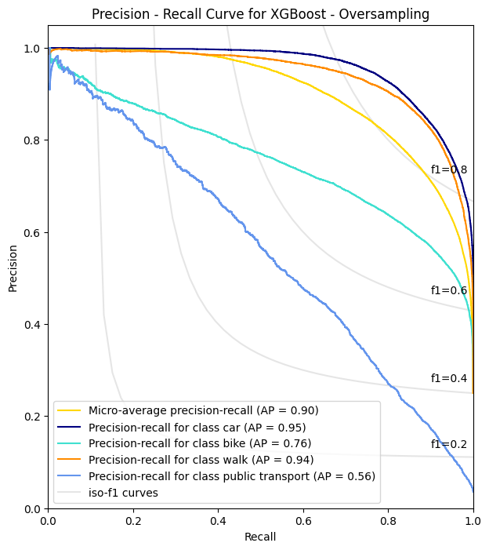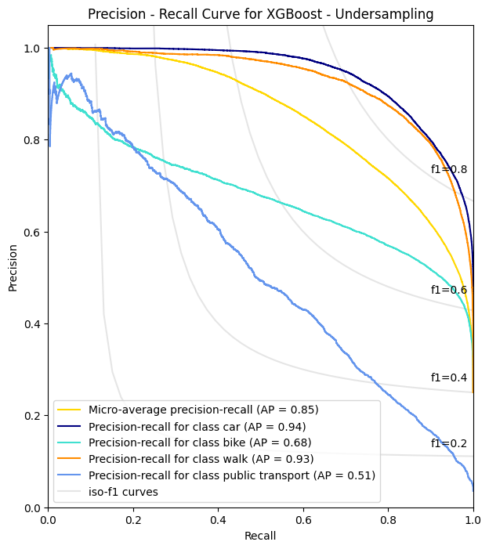

By observing the curves, it is evident that the oversampling strategy has positively influenced the area under the curve (AP) for each class. The most substantial improvement is observed for "bike," where AP has increased from 0.68 to 0.76. Similarly, for the minority class, AP has shown an increase from 0.51 to 0.56. XGBoost showcases better performance compared to Logistic regression and Decision Tree, though it is outperformed by the oversampled Random Forest model.

The feature importances were also extracted for both resampled models. The results are illustrated below.

**XGBoost - Undersampling**

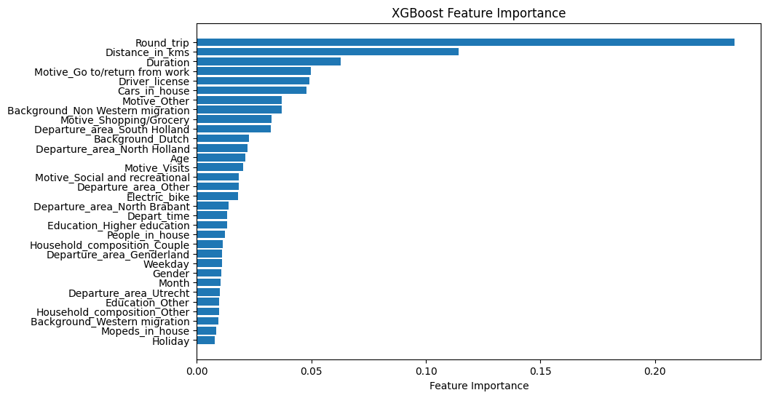

**XGBoost – Oversampling**

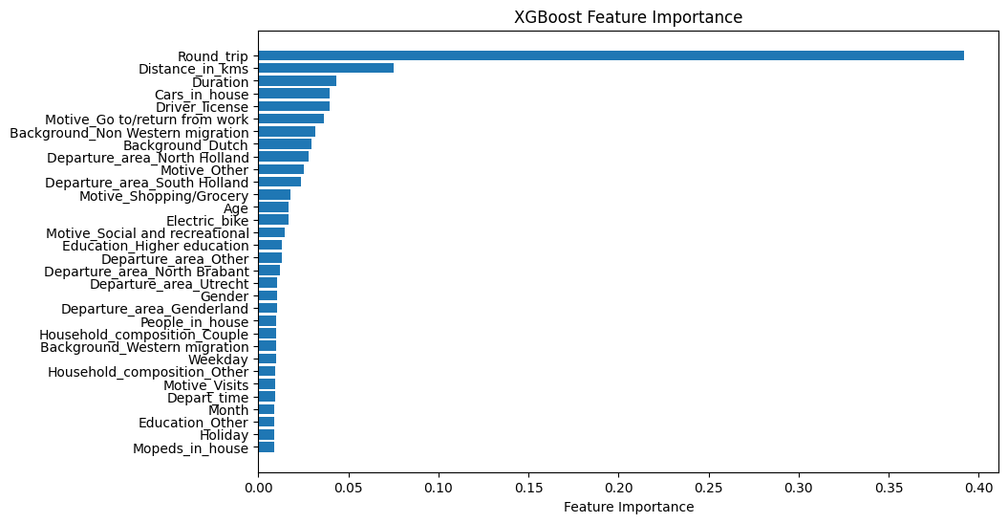

A notable difference compared to all the previous models is that XGBoost prioritizes Round_trip feature as the most important followed by distance and duration.

### 4.2.8. Model selection

To determine the best model, a comparative table was created, showcasing the average values of Precision, Recall, F-score across all classes, as well as Micro-Average Precision (Micro-AP) and accuracy for both undersampling and oversampling strategies.

|  |  |  |  |  |
| --- | --- | --- | --- | --- |
| **Undersampling Strategy** | | | | |
|  | **Logistic Regression** | **Decision Tree** | **Random Forest** | **XGBoost** |
| **Precision (Average)** | 0.60 | 0.62 | **0.66** | **0.66** |
| **Recall (Average)** | 0.67 | 0.70 | **0.76** | **0.76** |
| **F1-Macro** | 0.60 | 0.63 | 0.67 | **0.68** |
| **Micro-AP** | 0.76 | 0.75 | 0.84 | **0.85** |
| **Accuracy** | 0.68 | 0.70 | **0.75** | **0.75** |

|  |  |  |  |  |
| --- | --- | --- | --- | --- |
| **Oversampling Strategy** | | | | |
|  | **Logistic Regression** | **Decision Tree** | **Random Forest** | **XGBoost** |
| **Precision (Average)** | 0.59 | 0.64 | **0.86** | 0.72 |
| **Recall (Average)** | 0.67 | 0.72 | **0.81** | 0.76 |
| **F1-Macro** | 0.60 | 0.65 | **0.83** | 0.74 |
| **Micro-AP** | 0.76 | 0.80 | **0.95** | 0.90 |
| **Accuracy** | 0.68 | 0.73 | **0.89** | 0.80 |

Delving deeper into the analysis, the classification metrics provide valuable insights into the performance of the models under different strategies. The consistently superior performances of the Random Forest and XGBoost algorithms are notable, showcasing its effectiveness in handling imbalanced datasets. Random Forest demonstrates higher precision, recall, F1-Macro score, Micro-AP, and accuracy across the oversampling strategy, while XGBoost demonstrates better metrics for undersampling. Overall, the oversampled Random Forest model outperforms all the other models in terms of metrics showcasing a more balanced performance for the classes. This robust performance is likely attributed to its ensemble nature, which leverages multiple decision trees to make more accurate predictions. On the other hand, while the Decision Tree model also performs well, its metrics are below those of the Random Forest and XGBoost. Logistic Regression struggles comparatively to the tree-based models, while the resampling strategy does not seem to influence the performance results.

# References

Ababio-Donkor, A., Saleh, W. & Fonzone, A. 2020, "Understanding transport mode choice for commuting: the role of affect", *Transportation planning and technology,*vol. 43, no. 4, pp. 385-403.

Amiri, I.S., Akanbi, O.A. and Fazeldehkordi, E. (2014) *A Machine-Learning Approach to Phishing Detection and Defense*. 1st edn. Rockland, MA: Elsevier Science.

Amor, N.B., Benferhat, S. and Elouedi, Z. (2006) “Qualitative Classification with Possibilistic Decision Trees,” in *Modern Information Processing*. Elsevier B.V, pp. 159–169.

Bei, H. et al. (2023) “Joint prediction of travel mode choice and purpose from travel surveys: A multitask deep learning approach,” Travel, behaviour & society, 33, p. 100625.

Bellini, T. (2019) *IFRS 9 and CECL credit risk modelling and validation a practical guide with examples worked in R and SAS*. London: Academic Press.

Bhuiya, M.M.R. et al. (2022) “Application of Machine Learning Classifiers for Mode Choice Modeling for Movement-Challenged Persons,” Future transportation, 2(2), pp. 328–346.

Böcker, L., Dijst, M. and Faber, J. (2016) “Weather, transport mode choices and emotional travel experiences,” Transportation research. Part A, Policy and practice, 94, pp. 360–373.

Brownlee, J. (2021) Random oversampling and undersampling for imbalanced classification, MachineLearningMastery.com. Available at: https://machinelearningmastery.com/random-oversampling-and-undersampling-for-imbalanced-classification/ (Accessed: 12 January 2024).

Cunningham, P. and Delany, S.J. (2021) “k-Nearest Neighbour Classifiers - A Tutorial,” *ACM computing surveys*, 54(6), pp. 1–25.

Das, S. *et al.* (2021) “Impact of COVID-19: A radical modal shift from public to private transport mode,” *Transport policy*, 109, pp. 1–11.

Hagenauer, J. and Helbich, M. (2017) “A comparative study of machine learning classifiers for modeling travel mode choice,” Expert systems with applications, 78, pp. 273–282.

Kettle, S. (2014) Geodesic distances: How long is that line again?, Esri Community. Available at: https://community.esri.com/t5/coordinate-reference-systems-blog/geodesic-distances-how-long-is-that-line-again/ba-p/902188 (Accessed: 25 January 2024).

Kubat, M. (2021) An Introduction to Machine Learning. 3rd edn. Cham: Springer International Publishing AG.

Kufel, J. et al. (2023) “What Is Machine Learning, Artificial Neural Networks and Deep Learning?-Examples of Practical Applications in Medicine,” Diagnostics (Basel), 13(15), p. 2582.

Lee, E. and Kim, S. (2023) *Geographic Information Systems for Intermodal Transportation*. Elsevier.

Lopez, F. (2021) Ensemble learning: Bagging & boosting, Medium. Available at: https://towardsdatascience.com/ensemble-learning-bagging-boosting-3098079e5422 (Accessed: 12 January 2024).

Mayo, F.L. & Taboada, E.B. 2020, "Ranking factors affecting public transport mode choice of commuters in an urban city of a developing country using analytic hierarchy process: The case of Metro Cebu, Philippines", *Transportation research interdisciplinary perspectives,*vol. 4, pp. 100078.

McCarthy, L., Delbosc, A., Currie, G. & Molloy, A. 2017, "Factors influencing travel mode choice among families with young children (aged 0-4): a review of the literature", *Transport reviews,*vol. 37, no. 6, pp. 767-781.

McFadden, D. (1972). Conditional logit analysis of qualitative choice behavior.

McFadden, D. (1974) “The measurement of urban travel demand,” *Journal of public economics*, 3(4), pp. 303–328.

McFadden, D. and Train, K. (2000) “Mixed MNL models for discrete response,” *Journal of applied econometrics (Chichester, England)*, 15(5), pp. 447–470.

Misra, S., Li, H. & He, J. 2019, Machine Learning for Subsurface Characterization, 1st edn, Elsevier Science & Technology, San Diego.

*Moped* (2024) *Wikipedia*. Available at: https://en.wikipedia.org/wiki/Moped (Accessed: 30 January 2024).

Mussone, L. & Changizi, F. 2023, "A study on the factors that influenced the choice of transport mode before, during, and after the first lockdown in Milan, Italy", *Cities,*vol. 136, pp. 104251-104251.

Omrani, H. (2015) ‘Predicting travel mode of individuals by machine learning’, *Transportation Research Procedia*, 10, pp. 840–849. doi:10.1016/j.trpro.2015.09.037.

Polamuri (2023) 7 most popular boosting algorithms to improve machine learning model’s performance, Dataaspirant. Available at: https://dataaspirant.com/boosting-algorithms/ (Accessed: 12 January 2024).

Rocca, J. (2019) Ensemble methods: Bagging, boosting and stacking, Medium. Available at: https://towardsdatascience.com/ensemble-methods-bagging-boosting-and-stacking-c9214a10a205 (Accessed: 11 January 2024).

Shanmugam, L. and Ramasamy, M. (2021) “Study on mode choice using nested logit models in travel towards Chennai metropolitan city,” Journal of ambient intelligence and humanized computing, pp. Journal of ambient intelligence and humanized computing, 2021.

Souza, G.F.M.de *et al.* (2021) *Reliability Analysis and Asset Management of Engineering Systems*. 1st edn. San Diego: Elsevier (Advances in Reliability Science).

Statistics Netherlands (2024) *Dutch National Travel Survey*, *Statistics Netherlands*. Available at: https://www.cbs.nl/en-gb/onze-diensten/methods/surveys/korte-onderzoeksbeschrijvingen/dutch-national-travel-survey (Accessed: 29 January 2024).

Stefan Trueck, S.T.R. (2009) Rating Based Modeling of Credit Risk. 1st edn. San Diego: Elsevier Science.

Tamim Kashifi, M. et al. (2022) “Predicting the travel mode choice with interpretable machine learning techniques: A comparative study,” Travel, behaviour & society, 29, pp. 279–296.

Wang, S., Mo, B. and Zhao, J. (2021) “Theory-based residual neural networks: A synergy of discrete choice models and deep neural networks,” *Transportation research. Part B: methodological*, 146, pp. 333–358.

Willis, K.G. (2014) “The Use of Stated Preference Methods to Value Cultural Heritage,” *Handbook of the Economics of Art and Culture*, 2, pp. 145–181.

XGBoost (2023) GeeksforGeeks. Available at: https://www.geeksforgeeks.org/xgboost/ (Accessed: 12 January 2024).

Yang, C., Fridgeirsson, E.A., Kors, J.A., Reps, J.M. & Rijnbeek, P.R. 2024, "Impact of random oversampling and random undersampling on the performance of prediction models developed using observational health data", Journal of big data, vol. 11, no. 1, pp. 1-17.

Zhang, Z. et al. (2020) “A Customized Deep Neural Network Approach to Investigate Travel Mode Choice with Interpretable Utility Information,” Journal of advanced transportation, 2020, pp. 1–11.

Zhao, X. et al. (2020) “Prediction and behavioral analysis of travel mode choice: A comparison of machine learning and logit models,” Travel, behaviour & society, 20(C), pp. 22–35.

Zhou, ZH. (2021). Introduction. In: Machine Learning. Springer, Singapore. https://doi.org/10.1007/978-981-15-1967-3_1